September 11, 2014

Olwen Fouéré’s One-Woman Show, riverrun, Comes to Princeton
Leading Irish Theater Artist in Her Acclaimed Production based on
James Joyce’s Finnegans Wake
presented by Lewis Center for the Arts’ Performance Central

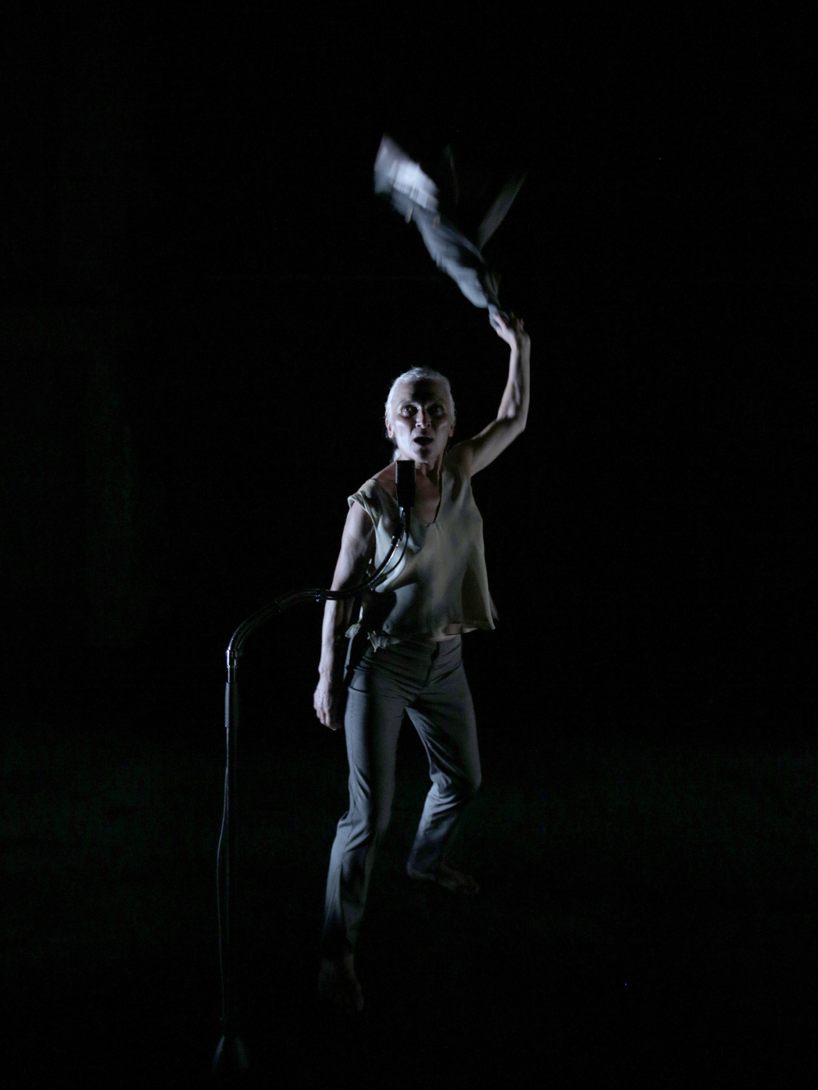
Photo caption: Olwen Fouéré in riverrun, her one-woman show on the voice of the river in James Joyce’s Finnegans Wake
Photo credit: Photo by Colm Hogan

Who: Leading Irish theater artist Olwen Fouéré
What: riverrun, Olwen Fouéré’s one-woman show based on James Joyce’s Finnegans Wake
When: Performances on Thursday and Friday, September 25 and 26 at 8:00 p.m.
Olwen Fouéré in conversation with Lewis Center for the Arts Chair Michael Cadden and Irish theater critic Fintan O’Toole September 24 at 4:30 p.m.
Where: Performances in Marie and Edward Matthews ’53 Acting Studio; talk will be held in the James M. Stewart ’32 Theater. Both venues at 185 Nassau St., Princeton
Free and open to the public; advance reserved tickets for performances available starting Sept. 17. No tickets needed for the conversation event

(Princeton, NJ) The Lewis Center for the Arts’ Performance Central series will present the award-winning Irish theater artist Olwen Fouéré in her acclaimed one-woman show, riverrun, based on James Joyce’s Finnegans Wake. Performances will be held September 25 and 26 at 8:00 p.m. at the Marie and Edward Matthews ’53 Acting Studio. Fouéré will also talk about her work in a conversation with Lewis Center Chair Michael Cadden and Irish theater critic Fintan O’Toole on September 24 at 4:30 p.m. in the James M. Stewart ’32 Theater as part of Princeton University’s Fund for Irish Studies Series. Both venues are located at 185 Nassau Street. All events are free and open to the public. Advance reserved tickets for the performances will be available after September 17; no tickets are needed for the conversation event.
Finnegans Wake, Joyce’s last work of prose and widely noted as one of the English language’s most difficult works of fiction, is highly experimental, written mostly in idiosyncratic language with no conventional plot or characters.
Fouéré, who adapted, performs and directs the hour-long riverrun, uses the final section of the novel as a springboard along with randomly chosen excerpts to follow the path of the river “Life” as embodied by the book’s character Anna Livia Plurabelle as it flows into the ocean of time.
“Standing for the city is what Olwen Fouéré does, almost literally, in riverrun, her astounding swim in the swirling, eddying, endlessly babbling waters of Finnegans Wake,” noted O’Toole in a review of the production. “Here there is no questioning of what theatre can do, just a fearless plunge into pure performance."

riverrun premiered in Ireland in July 2013 at the Galway International Arts Festival and was subsequently presented at the Kilkenny Arts Festival, Dublin Theatre Festival, the Edinburgh Fringe Festival, and by The National Theater of London earlier this year. Before coming to Princeton the production will receive a run at the Brooklyn Academy of Music.
A review of the London production in Time Out London observed, “It’s a long-held argument that Finnegans Wake makes more sense spoken aloud and Fouéré proves it so.” Echoing the value of experiencing Joyce’s epic as a performed work, Jane Shilling of The Daily Telegraph noted, “But for those of us who have repeatedly stopped at the fence of Finnegans Wake, Fouéré’s bold, funny and eloquent drama might just be life-changing: I left The Shed charmed, exhilarated and convinced that the time had come to tackle Joyce’s great masterpiece of intractable modernism.”
Fouéré’s career spans over 30 years as an award-winning actor, writer and theater artist. Her work includes the primary creation of image, text and personae, and her extensive practice navigates the performance contexts of mainstream theater, the visual arts, music, dance and literature and has been performed throughout Europe and in the U.S. She has played scores of roles on stage from classical to contemporary to new and experimental works, as well as appeared in numerous films and television series. She served as artistic director of Ireland’s avant-garde theater company, Operating Theater, and recently founded TheEmergencyRoom dedicated to the development of new work.
The conversation between Fouéré, Cadden and O’Toole on September 24 is the second in this year’s Fund for Irish Studies Series. Future guests include: Daithi O’Ceallaigh, former Irish ambassador to the United Kingdom, on “From the Belfast Bunker: Behind the Scenes in the Peace Process” on October 10; Charles Fanning on “Banish the Bushwah! Why We Ought to Read James T. Farrell” on November 14; Fintan O’Toole delivering the Robert Fagles Memorial Lecture on “Unspeakable Horror: How Ireland Fought the Great War” on February 13; a reading by Glenn Patterson, the Belfast novelist on March 27; Regina Ui Chollatain on “A ‘New’ Gaelic League Idea: Douglas Hyde 100 Years On” on April 10; Poulomi Saha on “Easter Risings: The Irish Insurrection in India” on April 17; and Feile Na Bealtaine: The Ghost Trio in a concert of Irish traditional songs, cosponsored with Princeton’s Department of Music, on May 1.
The next Performance Central event will be the Princeton Poetry Festival on March 13 and 14.
To learn more about the over 100 events offered each year by the Lewis Center for the Arts visit arts.princeton.edu.

###

The Lewis Center for the Arts encompasses Princeton University’s academic programs in creative writing, dance, theater, and visual arts, as well as the interdisciplinary Princeton Atelier. The Center represents a major initiative of the University to fully embrace the arts as an essential part of the educational experience for all who study and teach at Princeton. Over 100 diverse public performances, exhibitions, readings, and lectures are offered each year, most of them free or at a nominal admission fee. For more information about the Lewis Center for the Arts visit arts.princeton.edu.

