For Immediate Release
October 2, 2014

Fund for Irish Studies presents
“From the Belfast Bunker: Behind the Scenes in the Peace Process”
Lecture by Former Irish Ambassador to the United Kingdom
Daithi O’Ceallaigh at Princeton University

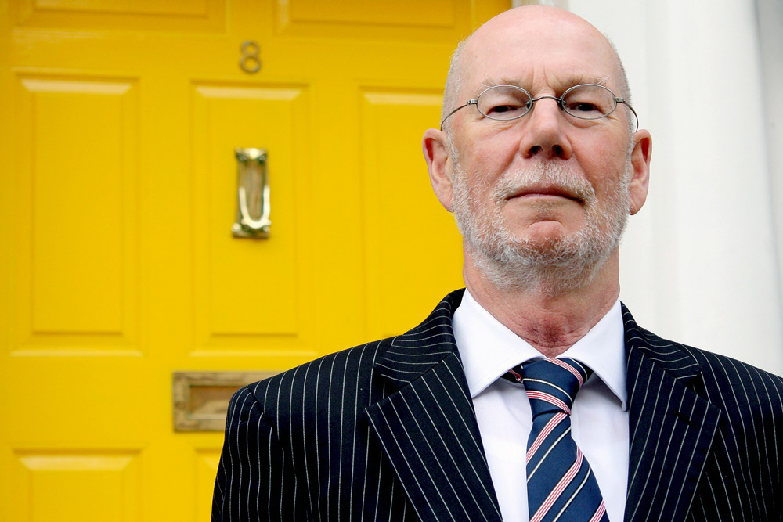
Photo caption: Former Irish Ambassador to the United Kingdom Daithi O’Ceallaigh
Photo credit: Courtesy of Daithi O’Ceallaigh

Who: Former Irish Ambassador to the United Kingdom Daithi O’Ceallaigh
What: “From the Belfast Bunker: Behind the Scenes in the Peace Process,” a lecture presented by Princeton University’s Fund for Irish Studies
When: Friday, October 17 at 4:30 p.m.
Where: James M. Stewart ’32 Theater at Lewis Center for the Arts, 185 Nassau St., Princeton

(Princeton, NJ) Former Irish Ambassador to the United Kingdom Daithi O’Ceallaigh will present a lecture entitled, “From the Belfast Bunker: Behind the Scenes in the Peace Process,” on Friday, October 17 at 4:30 p.m. at the Lewis Center for the Arts’ James M. Stewart ’32 Theater, 185 Nassau Street. Part of the 2014-15 Fund for Irish Studies series at Princeton University, the event is free and open to the public.
Daithi O’Ceallaigh’s distinguished diplomatic career spans more than 35 years. Having graduated from University College Dublin, he and his wife Antoinette spent three years as volunteer teachers in Zambia before joining the Department of Foreign Affairs in 1973. He went on to assume posts in Moscow, London, Belfast, New York, Finland and Estonia before serving as Ambassador to London for six years from 2001. He was subsequently appointed Ambassador to the UN, World Trade Organization, and the Conference on Disarmament in Geneva.
O’Ceallaigh retired from the Foreign Service in 2009. He was appointed to serve as Chairman of the Press Council of Ireland for a three-year term in 2010 and was reconfirmed for a second term in 2013. He is currently Director General (part-time) of the Institute of International and European Affairs in Dublin.
Drawing upon his extensive career in diplomacy, O’Ceallaigh will discuss the complex negotiations that lay behind the Irish peace process, a process in which he played an active role. Mr O’Ceallaigh will discuss the often invisible role played by civil servants in securing a civil society.
The Fund for Irish Studies, chaired by Princeton professor and Pulitzer Prize-winning poet Paul Muldoon, affords all Princeton students, and the community at large, a wider and deeper sense of the languages, literatures, drama, visual arts, history, politics and economics not only of Ireland but of “Ireland in the world.”
Information on upcoming Fund for Irish Studies series events can be found at fis.princeton.edu and includes:
- Charles Fanning on “Banish the Bushwah! Why We Ought to Read James T. Farrell” on November 14
- Historian and broadcaster Tristram Hunt on “The Socialism of The Ragged Trousered Philanthropists: Robert Noonan and the modern Labour Party” on December 5
- Fintan O’Toole delivering the Robert Fagles Memorial Lecture on “Unspeakable Horror: How Ireland Fought the Great War” on February 13
- Glenn Patterson, the Belfast novelist, reads from his work on March 27
- Regina Ui Chollatain on “A ‘New’ Gaelic League Idea: Douglas Hyde 100 Years On” on April 10
- Poulomi Saha on “Easter Risings: The Irish Insurrection in India” on April 17
- Feile Na Bealtaine: The Ghost Trio in a concert of Irish traditional songs, cosponsored with Princeton’s Department of Music, on May 1

To learn more about the over 100 events presented each year by the Lewis Center for the Arts, visit arts.princeton.edu.

###

