For Immediate Release
October 8, 2014

Kevin Young, Acclaimed Poet, Lectures at Lewis Center for the Arts
“How to Write a Hoax Poem” is topic for the
2014-2015 Theodore H. Holmes ’51 and Bernice Holmes Lecture at Princeton

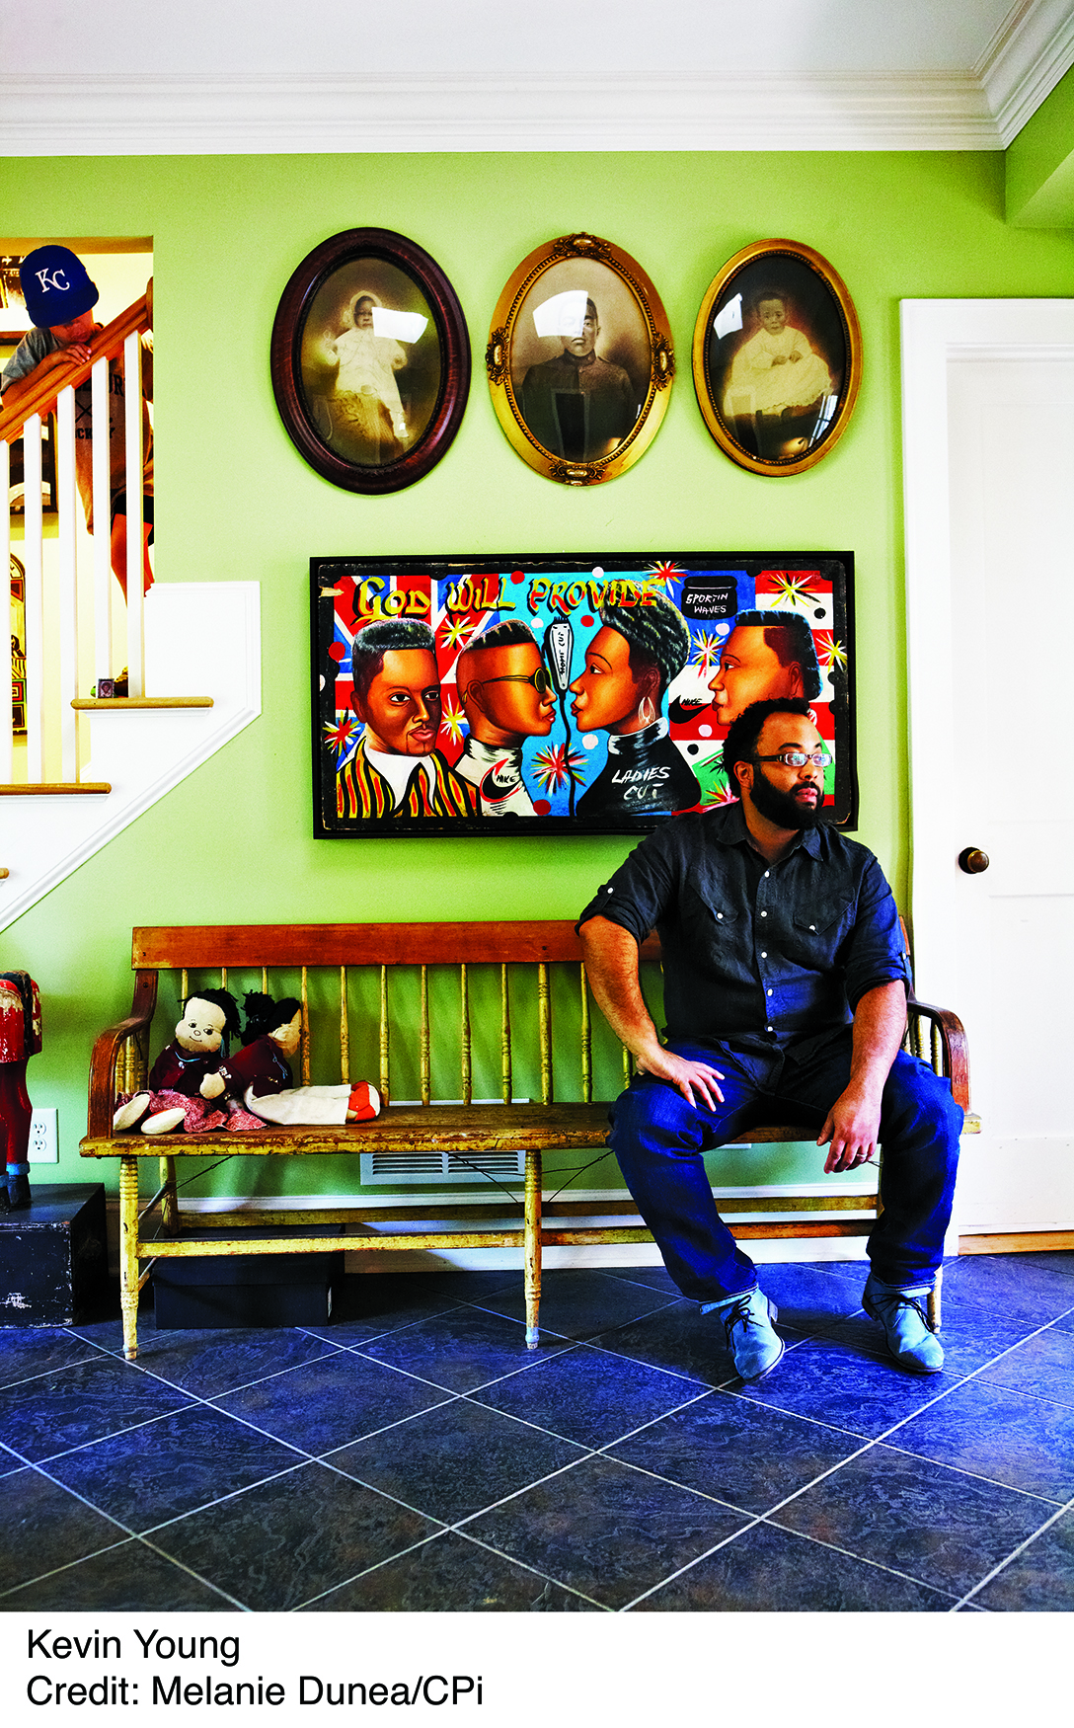
Photo Caption: Acclaimed poet Kevin Young will present a lecture at Princeton University on October 21
Photo Credit: Melanie Dunea

What: A lecture on “How to Write a Hoax Poem,” the 2014 Theodore H. Holmes ’51 and Bernice Holmes Lecture at Princeton
Who: Kevin Young, acclaimed poet, presented by the Lewis Center for the Arts’ Program in Creative Writing
When: Tuesday, October 21, 2014 at 4:30 p.m.
Where: James M. Stewart ’32 Theater at 185 Nassau St., Princeton
Free and open to the public with a reception following

(Princeton, NJ) Acclaimed poet Kevin Young will present a lecture on “How to Write a Hoax Poem” on Tuesday, October 21, at 4:30 p.m. at the Lewis Center for the Arts’ James M. Stewart ’32 Theater at 185 Nassau Street. The event, the 2014-2015 Theodore H. Holmes ’51 and Bernice Holmes Lecture presented by Princeton’s Program in Creative Writing, is free and open to the public.

Kevin Young is the author of eight books of poetry, most recently Book of Hours, which was featured on NPR's "Fresh Air," and editor of eight others. His previous book Ardency: A Chronicle of the Amistad Rebels won a 2012 American Book Award and Jelly Roll: A Blues was a finalist for the National Book Award and the Los Angeles Times Book Prize and winner of the Paterson Poetry Prize. His book The Grey Album: On the Blackness of Blackness won the Graywolf Nonfiction Prize, was a New York Times Notable Book for 2012, a finalist for the National Book Critics Circle Award for criticism, and winner of the PEN Open Award. The Collected Poems of Lucille Clifton (edited with Michael S. Glaser) won a Hurston-Wright Legacy Award in poetry. He is currently Atticus Haygood Professor of Creative Writing and English and Curator of Literary Collections and the Raymond Danowski Poetry Library at Emory University in Atlanta.

Young’s lecture will pose the questions: Is there such a thing as fake poetry? If so, how does one write it? By examining some of the more notable modern poetry hoaxes, Young will offer a glimpse of a secret history of the poem as something conceived to tempt or even trick, going beyond mask or persona to the poem as a forgery of the first order. In understanding the ways the hoax works, he proposes we may better know our assumptions, habits, and hurts, and how to subvert them.

The annual lecture is named for Mr. Holmes, a Class of 1951 biology major and graduate of Princeton who became a poet, and his sister Bernice.

To learn more about the Program in Creative Writing and the more than 100 events offered annually by the Lewis Center visit arts.princeton.edu.

###

