For Immediate Release
October 7, 2014

This is an Elephant, premieres at Lewis Center for the Arts
New play by senior Ava Geyer explores the painful limits of everyday conversation

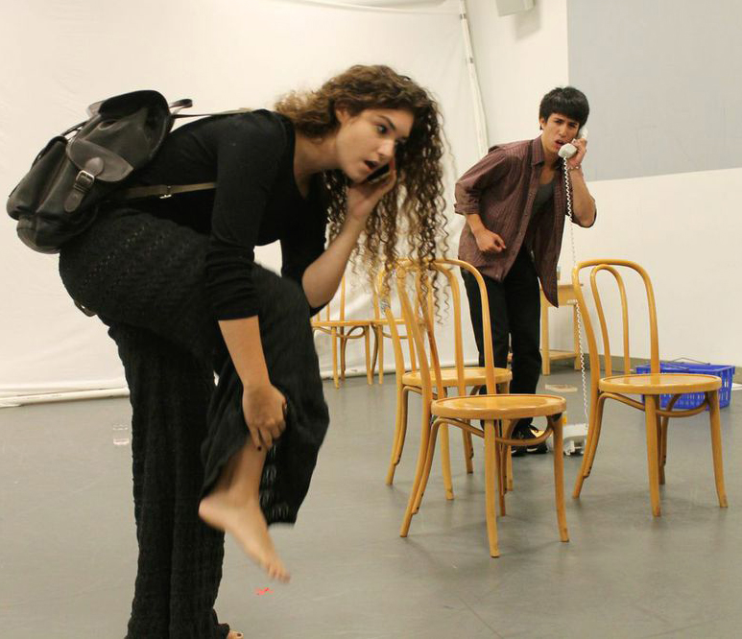
Photo caption: Evelyn Giovine and Kanoa Mulling rehearse a scene from This is an Elephant by Ava Geyer
Photo credits: Photo by Julia Hammer ’15

What: Premiere of a new play, This is an Elephant, that explores the urgent desires and painful limits of everyday conversation via five interwoven narratives.
Who: Written and directed by Princeton senior Ava Geyer and featuring senior Kanoa Mulling and a cast of Princeton undergraduates, presented by the Lewis Center for the Arts’ Program in Theater
When: October 17, 18, 22, 23 and 24 at 8 p.m. Audience talk back follows Oct. 17 and 22 performances.
Where: Marie and Edward Matthews ’53 Acting Studio at 185 Nassau St., Princeton
Tickets: $12 general admission/$10 students available through University Ticketing at 609-258-9220, online at www.princeton.edu/utickets/ and at the door the evening of performances

(Princeton, NJ) The Lewis Center for the Arts’ Program in Theater will premiere, This is an Elephant, written and directed by senior Ava Geyer and featuring senior Kanoa Mulling, on October 17 at the Marie and Edward ’53 Acting Studio at 185 Nassau Street. Distant fathers, fractured marriages, absent mothers, vying siblings all collide in this exploration of the chasm between what we need to express and what we're allowed to say in this new work. Performances continue October 18, 22, 23 and 24 at 8:00 p.m.. Tickets are $12 general admission and $10 for students.

The play is concerned, Geyer explains, with evoking a commonality of emotional experience across disparate settings. Five actors portray seventeen different characters in stories about loneliness: from the isolation of three men marooned by life in an assisted living facility to the simple distance between husband and wife in bed. Through episodic structure and double casting, resonances between the worlds gradually accumulate as the evening progresses and the boundaries break down.

The title chosen has multiple references that relate to the play: the proverbial “elephant in the room” – a topic that is obvious but avoided, the minimal squiggles comprising a doodle universally recognized as an elephant, and the fable of the six blind men feeling different parts of an elephant, demonstrating that while one's subjective experience has validity, it may not be the totality of truth.

Geyer has been working on the script since last spring. The play has evolved with Geyer writing and Mulling and Geyer trying out scenes in collaboration, and will continue to evolve in the weeks leading up to the premiere. “Kanoa and I have established a pattern of workshops inciting material,” explains Geyer, “Which in turn prompts a conversation, which then evolves into a workshop.” Both students note the influence of the avant-garde and ensemble-devised theater of 1960s Europe and particularly the work of Britain’s Joint Stock Company and of Jerzy Grotowski in their conceptualization of this new play. Geyer also attributes inspiration from a course on “Performance and Politics in the 1960s” she took with Professor of Theater Stacy Wolf last fall.

Geyer has been studying playwriting since the age of 13. During her time at Princeton she has written four full-length plays, eight one-act plays and collaborated on a television pilot. She has studied with faculty playwrights R.N. Sandberg, Melissa James Gibson, and Deborah Stein; screenwriter and alumnus David E. Kelley; and Pulitzer Prize-winning playwright Annie Baker. Geyer’s full-length play Everything in Isolation was produced by Princeton’s Theater Intime last May. In 2012 she received summer funding from the Lewis Center through the Alex Adam ’07 Awards to study at the Findhorn Foundation in Scotland and Second City Improv in Chicago.

“I've benefited so much from the unreal generosity and seemingly magic powers of the Lewis Center,” notes Geyer. “To have access to the faculty and resources I have experienced and to have your play professionally produced by a university is almost unheard of in undergraduate theater programs.”

Mulling has appeared in a number of Lewis Center productions over the past four years including, Hamlet, Uncle Vanya, Great Expectations, and the new play Margo in Margoland, and will play the lead in the Program in Theater’s fall production of Red Noses. Later this spring he will direct a production of The Other Shore by Nobel Prize-winning playwright Gao Xingjian. He was also part of a summer 2013 Princeton Global Seminar that traveled to Greece to see and perform classic Greek theater in the very amphitheaters where the ancients performed. Mulling received Peter B. Lewis Summer Funding from the Lewis Center this past year and a Distinguished Achievement Award in Theater.

"This is an Elephant has been such a wonderful undertaking for me,” notes Mulling. “ Ava and I have been rummaging through our whirlwind of theatrical ideas for months now, and it is so gratifying to see it all culminate in something worthwhile. I am so grateful for all the support we’ve received in this process, as well as the opportunity to work with the best up-and-coming playwright I know."

An audience talkback with Professor Stacy Wolf focusing on the show's avant-garde influences will follow the Friday, October 17 performance. A second talkback with director, playwright and professor R.N Sandberg will follow the Wednesday, October 22 performance.

The Lewis Center’s Program in Theater annually presents a major, professionally produced play in the fall, which this year is the Peter Barnes classic Red Noses, as well as a number of student senior thesis productions throughout the year. Coming up this season are the Vietnam era drama The Basic Training of Pavlo Hummel by David Rabe, a new adaptation of Nikolai Gogol’s The Diary of a Madman, the children’s play The Magic Rainforest: An Amazon Journey by José Cruz González, the Tony Award-winning musical Spring Awakening, Paula Vogel’s Pulitzer Prize-winning drama How I Learned to Drive, a new play and an experiential musical, cabaret performances, and a new work incorporating aerial choreography.

Tickets for This is an Elephant are $12 general admission, $10 for students, and are available through Princeton University Ticketing by calling 609.258.9220 or on-line at www.princeton.edu/utickets/, at the Frist Campus Center Ticket Office, or at the Matthews box office on the evenings of performances.

For more information on this event, the Program in Theater and the more than 100 other events offered each year by the Lewis Center for the Arts visit arts.princeton.edu.

###

