December 3, 2014

Lewis Center for the Arts presents Selfie Expression
An end-of-semester showing of digital portraits created in the fall Princeton Atelier course
“Pay Attention: The Art of Here and Now”

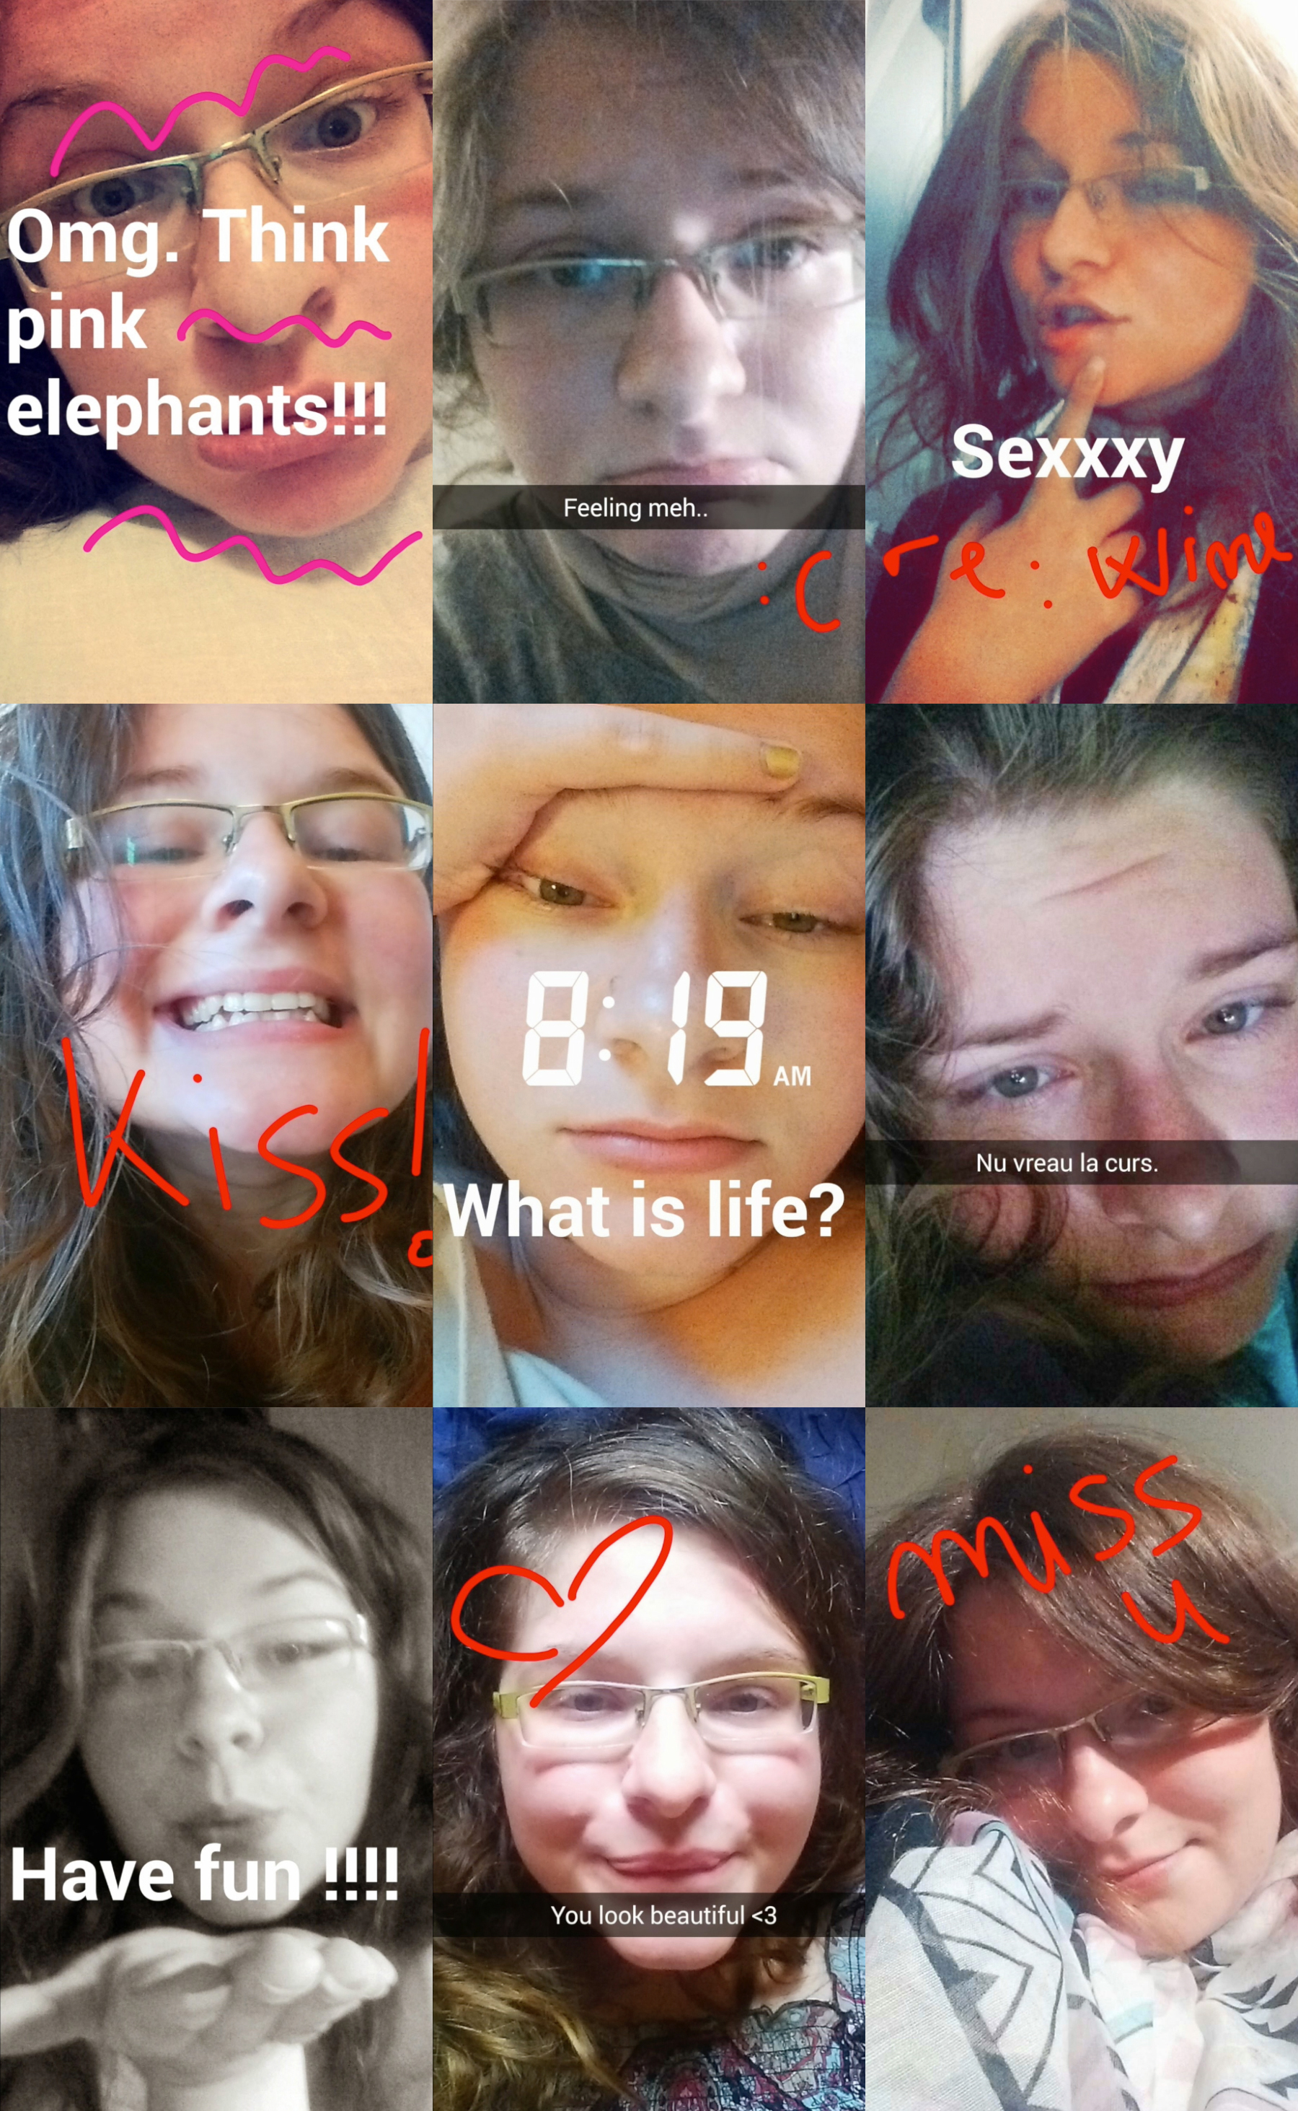
Photo caption: A series of Snapchat posts that are part of one of the digital self portraits to be presented at Selfie Expression
Photo credit: Ioana Ferariu ’15

What: End of semester showing of digital self portraits created in the fall Princeton Atelier course, “Pay Attention: The Art of Here and Now”
Who: Presented by the Lewis Center for the Arts’ Princeton Atelier and the students in the course, taught by theater director Marianne Weems
When: Thursday, December 11 from 4:30 p.m. to 6:00 p.m.
Where: Marie and Edward Matthews ’53 Acting Studio at 185 Nassau Street
Free and open to the public

(Princeton, NJ) The Lewis Center for the Arts will present Selfie Expression, an end-of-semester showing of digital self portraits created by students in the fall Princeton Atelier course, “Pay Attention: The Art of Here and Now,” taught by theater and media director Marianne Weems. The showing will take place on Thursday, December 12 from 4:30 p.m. to 6:00 p.m. in the Marie and Edward Matthews ’53 Acting Studio at 185 Nassau Street. This culminating performance will take the form of a gallery installation, with areas of the Acting Studio devoted to each of the student artists. Visitors are encouraged to come and go throughout the event.

“Pay Attention: The Art of Here and Now” is an Atelier course that asks: in a world where technology shapes the way we think, it appears impossible to free ourselves from the mediatized world. If this is the case, then how are we changing to accommodate the open faucet of information? How has our ability to pay attention transformed in the digital age?

Working in a cross-disciplinary mode students were invited to examine their experience of the “here and now” through readings, discussion, gaming, and a final project. Guest speakers framed the concept of the present in a variety of contexts: from cognitive studies to ADHD coaching to Buddhist philosophy.

Each class begins with a meditation session, in order that the student artists might resist distraction and properly “pay attention.” The course draws upon various perspectives with guest speakers such as technology consultant and innovator Alex Pang and multimedia artist Ed Keller, focusing on spirituality, neuroscience, ontology, psychology, and gaming to investigate these questions of modern consciousness.

Students from a variety of majors enrolled in the course including computer science, cognitive science, neuroscience, and art history, who drew upon their academic expertise in these areas along with other life experiences to create original works of art.

As the culmination of this Atelier’s endeavors, Selfie Expression will consist of a gallery installation of student artists’ “digital selfies,” or self-portraits created out of data that they collected about their daily activities over the course of the semester. In constructing these digital self-portraits, students were asked to contemplate the ways in which they could use technology to elevate their mindfulness of daily life, and the ways in which technology could be employed to raise and focus consciousness, rather than distract consciousness.

One student, for example, is a member of the Princeton rowing crew team, and made it her goal to digitally log data (such as food intake and weight) about herself and her teammates each day. Her installation, as it will be presented at Selfie Expression, will consist of her rowing on a rowing machine against a backdrop of moving projections of her recorded data that will mimic the movement of water. Another student used Snapchat, the ephemeral photo-messaging platform, to document her activities and then compiled these photos into a video that will be displayed at the installation. Selfie Expression will be, in part, a demonstration of the ways in which these students have used technology to comment on their daily use of technology.

Weems, the leader of this course, is the co-founder and artistic director of the Obie Award-winning, New York-based performance company, The Builders Association. This company creates interdisciplinary, multi-dimensional stage performances by incorporating actors with audio and visual elements and has been recognized internationally as a leader of theatrical innovation. In addition to directing theater, Weems' expertise includes dramaturgy, interdisciplinary media, and the intersection of the arts with technology. She recently directed a multimedia workshop with Disney Creative Entertainment and Walt Disney Imagineering. Weems is a faculty member of Carnegie Mellon University’s Integrative Media Program, author of Art Matters: How the Culture Wars Changed America, and co-author of The Builders Association: Performance and Media in Contemporary Theater forthcoming from MIT Press in Fall 2015.

The Princeton Atelier was founded by Princeton Professor Emerita Toni Morrison and is directed by Paul Muldoon, Princeton’s Howard G.B. Clark ’21 Professor in the Humanities and Professor of Creative Writing. This unique academic program brings together professional artists, often from different disciplines, to create new work in the context of a semester-long course. A painter might team with a composer, a choreographer might join with an electrical engineer, a company of theater artists might engage with environmental scientists, or a poet might connect with a videographer. Princeton students have an unrivaled opportunity to be directly involved in these collaborations.

For more information on this event, the Princeton Atelier, and the more than 100 other events offered each year by the Lewis Center for the Arts visit arts.princeton.edu.

###

