March 27, 2015

Eyes Up High in the Redwood Tree, a new play by Annika Bennett, premieres at Lewis Center for the Arts
Promising young playwright’s work is inspired by the 1960s counter-culture icon Ken Kesey, best known for One Flew Over the Cuckoo’s Nest

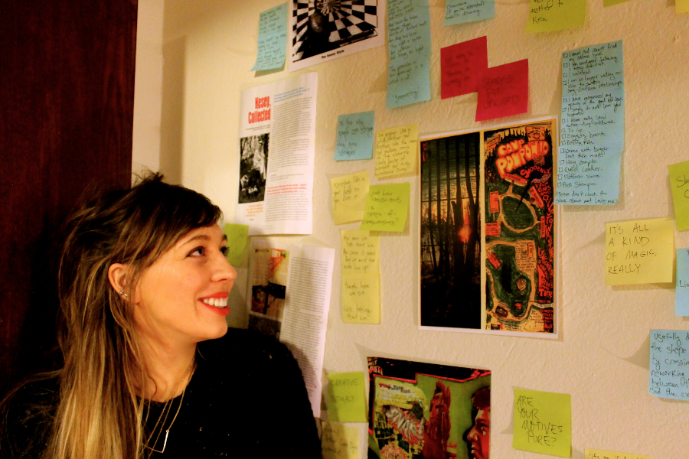
Photo caption: Playwright Annika Bennett with some of the research that informed her new play inspired by the life, letters and writings of 1960s counter-culture icon Ken Kesey, with whom she shares her hometown.
Photo credits: Photo by Justin Goldberg

What: Premiere of a new play, Eyes Up High in the Redwood Tree inspired by the life, letters and writings of 1960s counter-culture icon Ken Kesey
Who: Written by Princeton senior Annika Bennett and directed by faculty member Tim Vasen with a cast of Princeton undergraduates, presented by the Lewis Center for the Arts’ Program in Theater
When: April 3, 4, 8, 9 and 10 at 8 p.m. Audience talk back follows April 3 performance.
Where: Berlind Theatre at McCarter Theatre Center, 91 University Place, Princeton
Tickets: $15 general admission/$10 students available through McCarter box office at 609-258-2787 and at the door the evening of performances

(Princeton, NJ) The Lewis Center for the Arts’ Program in Theater will premiere Eyes Up High in the Redwood Tree, a new play written by senior Annika Bennett and directed by faculty member Tim Vasen, on April 3 at 8:00 p.m. at the Berlind Theatre at McCarter Theatre Center. The new work is inspired by the life, letters and writings of 1960s counter-culture icon Ken Kesey, perhaps best known as the writer of the novel One Flew Over the Cuckoo’s Nest, and credited with ushering in the era of psychedelic drugs. Performances continue April 4, 8, 9 and 10 at 8:00 p.m. with a talkback following the April 3 performance.

Bennett grew up in Eugene, Oregon, near where Kesey was raised and later lived. Kesey as a local, notorious, historical figure – with a statue of him in Eugene -- was ever-present for Bennett growing up. “Kesey is a really fascinating emblem for a place in the country that, culturally, has never quite left the sixties behind,” explains Bennett. “That part of Oregon is so different from the rest of the country, something I only really understood when I left and came to New Jersey for the first time. So the play, for me, has become an exploration of home – and over the last few rehearsals I’ve become really aware of the paradox inherent in that, that the harder I try to write myself home, the further away from home I’m actually getting, and the closer to wherever this next year is going to take me instead. I think the weirdness of that is something that’s definitely present in this play.” The play is Bennett’s senior thesis for both her English major and her certificate in the Program in Theater.

Kesey was born in 1935 and attended the University of Oregon on a wrestling scholarship. After graduating in 1957, he won a scholarship to the graduate program in writing at Stanford University. In 1960, Kesey volunteered as a paid experimental subject in a study conducted by the U.S. Army in which he wrote about the effects of mind-altering drugs. He also worked as an attendant in a hospital's psychiatric ward. These experiences served as the basis for his 1963 novel One Flew Over the Cuckoo's Nest, which was made into an Oscar-winning film starring Jack Nicholson. Kesey reportedly hated the script and refused to watch the film. His next novel, 1964's Sometimes a Great Notion, also focused on questions of individuality and conformity.

Kesey believed the key to individual liberation was psychedelic drugs. Kesey was the leader of a group who called themselves the Merry Pranksters, which supported open drug use. The Pranksters conducted "Acid Tests," at which guests would pay a dollar to receive a cup of "electric," LSD-laced Kool-Aid. Attendees were treated to the music of The Warlocks, who later became known as The Grateful Dead. Tom Wolfe chronicled the Pranksters culture, and in 1968 he published The Electric Kool-Aid Acid Test, which depicted Kesey's adventures throughout the 1960s.

Kesey eventually settled on his father's Oregon dairy farm. He published short stories and essays and taught at the University of Oregon. He died in 2001 at the age of 66 from complications from surgery for liver cancer.

The play is not intended as a biography of Kesey’s life, but Bennett uses the story of his life as a springboard to explore questions about storytelling – who has the right to tell stories, how stories intertwine, and what the aftermath of that is, how lives become stories and stories become myths and what is gained and lost when that happens. Bennett has been working on the play for 11 months drawing on Kesey’s papers housed at the University of Oregon and biographies. She is continuing to write and rewrite the script as she works with a company of seven actors and Vasen on the production.

Bennett has been a playwright since her junior year in high school when she was writing and directing her own material. In her freshman year at Princeton she was a winner of the Young Playwrights, Inc. National Playwriting Competition, founded in 1981 by Stephen Sondheim. Last year she was one of only three students accepted into the National Theater Institute’s Summer Intensive program. On campus she has produced plays for the student theater group Theatre Intime and has staged readings of new plays.

The all-student cast includes Matt Seely ’14, Anna Aronson ’16, Evelyn Giovine ’16, Ryan Gedrich ’16, Maeli Goren ’15, Stanley Mathabane ’17, Adam Hudnut-Beumler ’17, and John Somers Fairchild ’15. Costumes and set are designed by faculty member Anya Klepikov, lighting by Solomon Weisbard, and sound design by Matt Smith ’16, with Cat Andre ’17 as stage manager.

“It’s an incredibly rare opportunity for a playwright of my age to have access to resources like a director as smart and experienced as Tim, professional designers and prop and costume teams like those the Lewis Center has provided, and a space like the Berlind Theatre for a workshop production of a brand new play,” notes Bennett. “I also think it’s pretty rare for a playwright of any age to have access to actors as smart, generous, and inquisitive as those I’ve found in Matt, Anna, Evvy, Ryan, Maeli, Stanley, Adam, and John. Tim’s been reminding me every rehearsal to take this chance to figure out how I can use a rehearsal room to make a play way better, and I’ve learned so much from every single day.”

“I knew Annika as a playwright before I met her, thanks to the funny and provocative script she submitted as part of her Princeton application,” recalls Vasen. “In the past four years we've done a lot of work together, and there is a particular blend of playfulness and seriousness that I associate with her personally and artistically that makes her writing really special, really challenging, and a blast to work on. It's especially exciting to me that we can do this play in the Berlind Theater--most young writers don't get a chance to see their work at this level for years, if ever. My hope is that this production is a significant step in the development of a promising artist, which after all is one of the things the Program in Theater exists for.”

An audience talkback led by Vasen will follow the April 3 performance.

The Lewis Center’s Program in Theater annually presents a major, professionally produced play in the fall, as well as a number of student senior thesis productions throughout the year. Coming up this season are Ding!, a new participatory musical experience conceived by senior Emily Whitaker; a production of The Other Shore by Nobel Prize-winning playwright Gao Xingjian; a cabaret performance of songs from Stephen Sondheim musicals; Hero, a new musical work by senior Eamon Foley based on interviews with Vietnam veterans and incorporating aerial choreography; and a workshop reading of a new play based on the experiences of people struggling with depression.

Tickets for Eyes Up High in the Redwood Tree are $15 general admission, $10 for students and seniors, and are available through the McCarter box office at 609.258.2787 or online at www.mccarter.org/TicketOffice/buytickets.aspx?page_id=22, through Princeton University Ticketing by calling 609.258.9220 or online at www.princeton.edu/utickets/, at the Frist Campus Center Ticket Office, or at the Berlind box office on the evenings of performances.

For more information on this event, the Program in Theater and the more than 100 other events offered each year by the Lewis Center for the Arts visit arts.princeton.edu.

###

