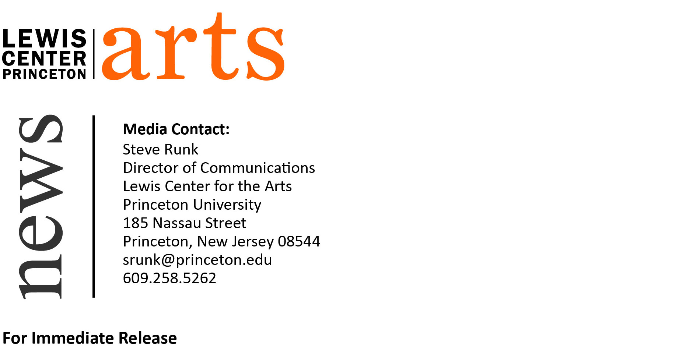

February 27, 2015

Lewis Center for the Arts presents biennial Princeton Poetry Festival
International roster of poets to present readings and panels March 13 & 14
Festival opens with New Jersey State Finals of Poetry Out Loud high school competition

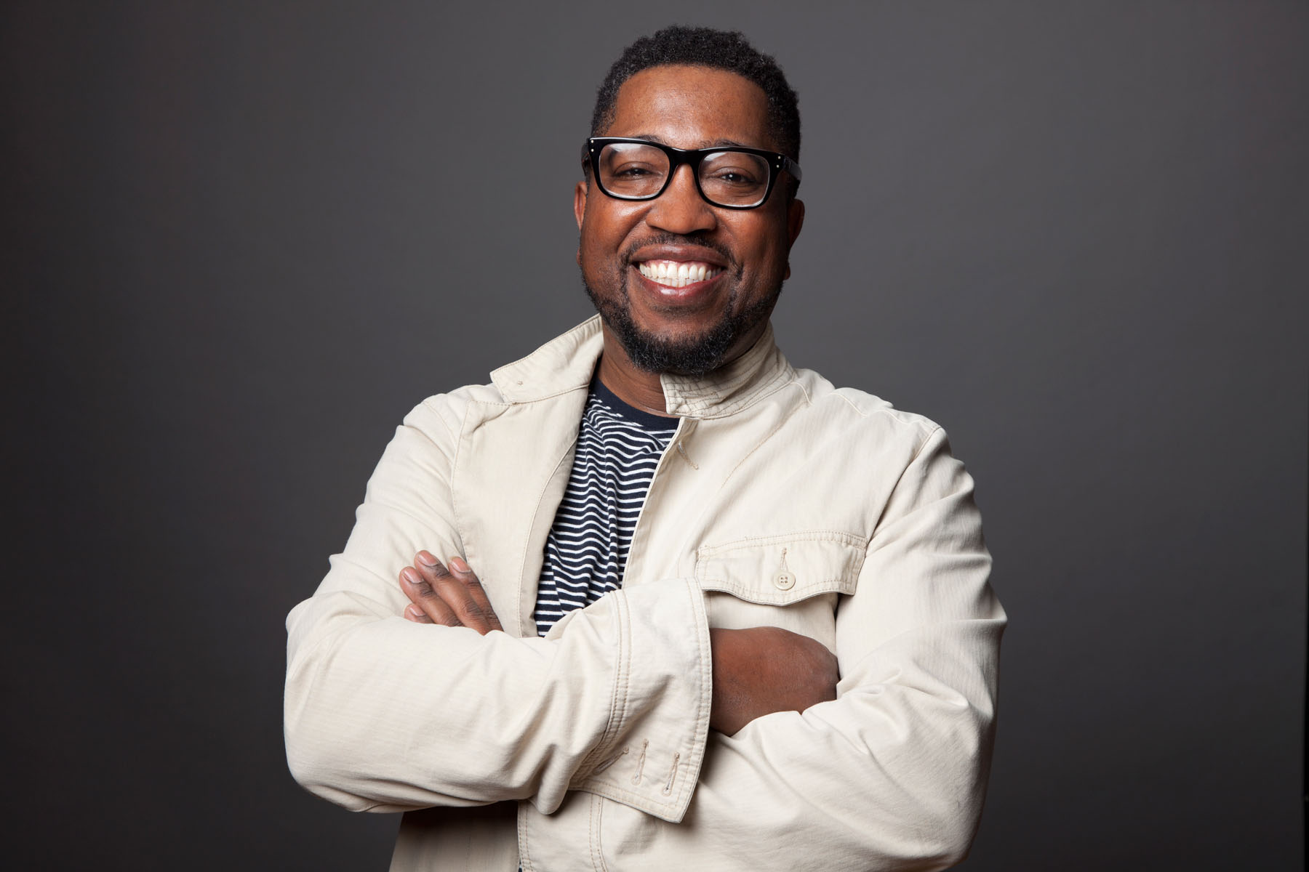
Photo caption: Major Jackson, one of the poets to be featured at the Princeton Poetry Festival March 13 & 14
Photo credit: Erin Patrice O’Brien
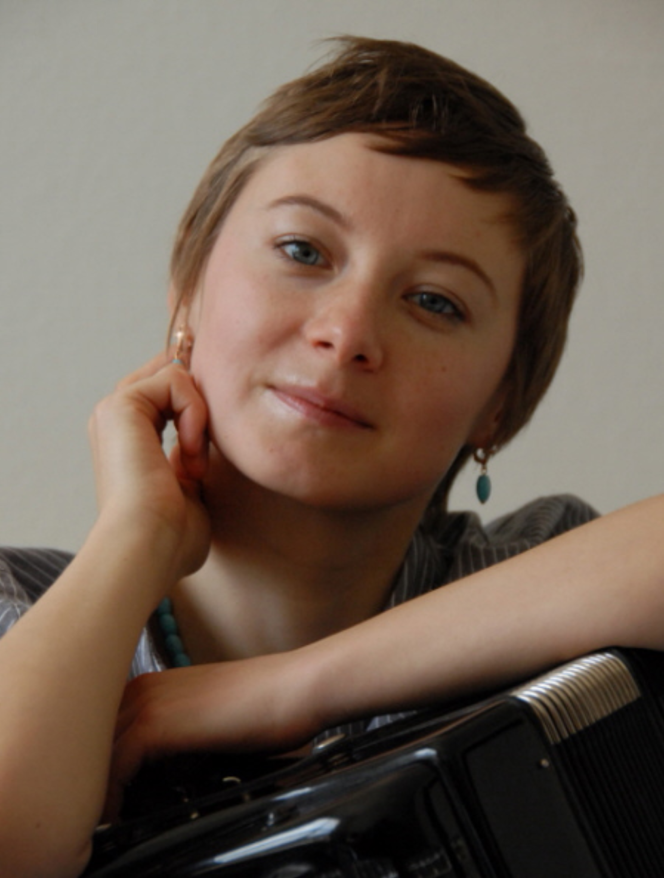
Photo caption: Valzhyna Mort, one of the poets to be featured at the Princeton Poetry Festival March 13 & 14
Photo credit: Doug Barber

What: Biennial Princeton Poetry Festival presented by Lewis Center for the Arts’ Performance Central Series opening with the New Jersey State Finals of Poetry Out Loud, a national poetry recitation competition for high school students
Who: International poets featured in readings and panel discussions organized by Princeton professor and poet Paul Muldoon including Ellen Bryant Voigt (U.S.), Kwame Dawes (Ghana), Paul Farley (U.K.), Major Jackson (U.S.), Kathleen Jamie (Scotland), Ada Limón, (U.S.), Maureen N. McLane (U.S.), Valzhyna Mort (Belarus), Michael Robbins (U.S.), Tomasz Różycki (Poland) with translator Mira Rosenthall (U.S.), Ocean Vuong (Vietnam), Ray Young Bear (Meskwaki Nation)
When: Friday and Saturday, March 13 & 14, 2015
Where: Richardson Auditorium in Alexander Hall on the campus of Princeton University
Tickets: $15 per day, $25 two-day Festival Pass, free for students; NJ State Finals of Poetry Out Loud is free
For more information: http://arts.princeton.edu/events/princeton-poetry-festival-2015/2015-03-13/

(Princeton, NJ) Princeton University’s Lewis Center for the Arts Performance Central will present the 2015 Princeton Poetry Festival, a two-day biennial event. Poets from around the world will read from their work and hold panel discussions. The Festival will take place March 13 and 14 in Richardson Auditorium in Alexander Hall on the Princeton campus. Organized by Pulitzer Prize-winning poet and Princeton professor Paul Muldoon, the Festival will open with the New Jersey State Finals of Poetry Out Loud, a national poetry performance competition for high school students.

Princeton University has a longstanding tradition of nurturing poets. From Revolutionary War poet Philip Morin Freneau, class of 1771, to major post-war poets William Ralph Meredith ’40, Galway Kinnell ’48, and W. S. Merwin ’48, to acclaimed contemporary poet Emily Moore ’99, hundreds of renowned graduates have studied poetry and creative writing at Princeton. Today, poetry continues to thrive at Princeton under the direction of such renowned poets and professors as Michael Dickman, Paul Muldoon, James Richardson, Tracy K. Smith, Susan Wheeler, and Monica Youn.

This year’s twelve poets represent four continents. Seven poets from the United States include Ellen Bryant Voigt, finalist for both the National Book Award and the National Book Critics Circle Award; Major Jackson, winner of a Whiting Writers’ Award and finalist for the National Book Critics Circle Award; Maureen N. McLane, winner of the National Critics Circle Award in autobiography; as well as Ada Limón, Michael Robbins, and Ray Young Bear, a member of the native American Meskwaki Nation.

International poets include Ghanaian-born Jamaican poet Kwame Dawes, British poet Paul Farley, Scottish poet Kathleen James, Belarusian poet Valzhyna Mort, Polish poet Tomasz Różycki with translator Mira Rosenthal, and Vietnamese poet Ocean Vuong.

“We are pleased to bring some of the best poets in the world to Princeton,” notes Muldoon, the Howard G.B. Clark ’21 University Professor in the Humanities, “and to provide this venue for sharing their diverse work with our students and the wider community including middle and high school students.”

The Festival will open on the morning of March 13 with the New Jersey State Finals of Poetry Out Loud, when 12 high school students will compete for the state title and the opportunity to represent New Jersey at the national finals in Washington, DC. The state finals are the culmination of a statewide poetry performance program that started in the fall and included more than 38,000 students from 162 New Jersey high schools. Poetry Out Loud is a nationwide program sponsored by the National Endowment for the Arts and the Poetry Foundation. In New Jersey, this program is supported by the New Jersey State Council on the Arts/Department of State, and administered in partnership with Playwrights Theatre of New Jersey, ArtPride New Jersey Foundation, and the Lewis Center for the Arts, among others.

A gala opening reading will follow in the afternoon when the New Jersey winner and runner-up will perform, followed by a reading by each of the Festival poets, introduced by Muldoon. A panel discussion and lecture will complete the afternoon with a reading by four of the poets in the evening. On Saturday the Festival will continue with an afternoon reading and panel discussion and conclude with an evening reading.

While featured poets come from around the world and write in numerous languages, the readings, discussions and panels will be in English.
Richardson Auditorium is an accessible venue, however patrons are encouraged to contact the Lewis Center or University Ticketing with any questions or specific needs. Assistive listening devices will be available upon request and large print programs may be requested in advance. Patrons in need of other access accommodations are invited to contact the Lewis Center at 609.258.5262 or LewisCtr-Comm@princeton.edu for assistance at least two weeks prior to the Festival.

Tickets for the Princeton Poetry Festival are $15 for each day, free for students, and $25 for a two-day Festival Pass and are available through Princeton University Ticketing by calling 609.258.9220, on-line at www.princeton.edu/utickets/, or at the Frist Campus Center Ticket Office. The New Jersey State Finals of Poetry Out Loud is free, however advance tickets are required and can be reserved through University Ticketing.

To learn more about the Festival, including a detailed schedule of events and information on the poets, and the more than 100 other events presented each year by the Lewis Center for the Arts visit: arts.princeton.edu.

###

