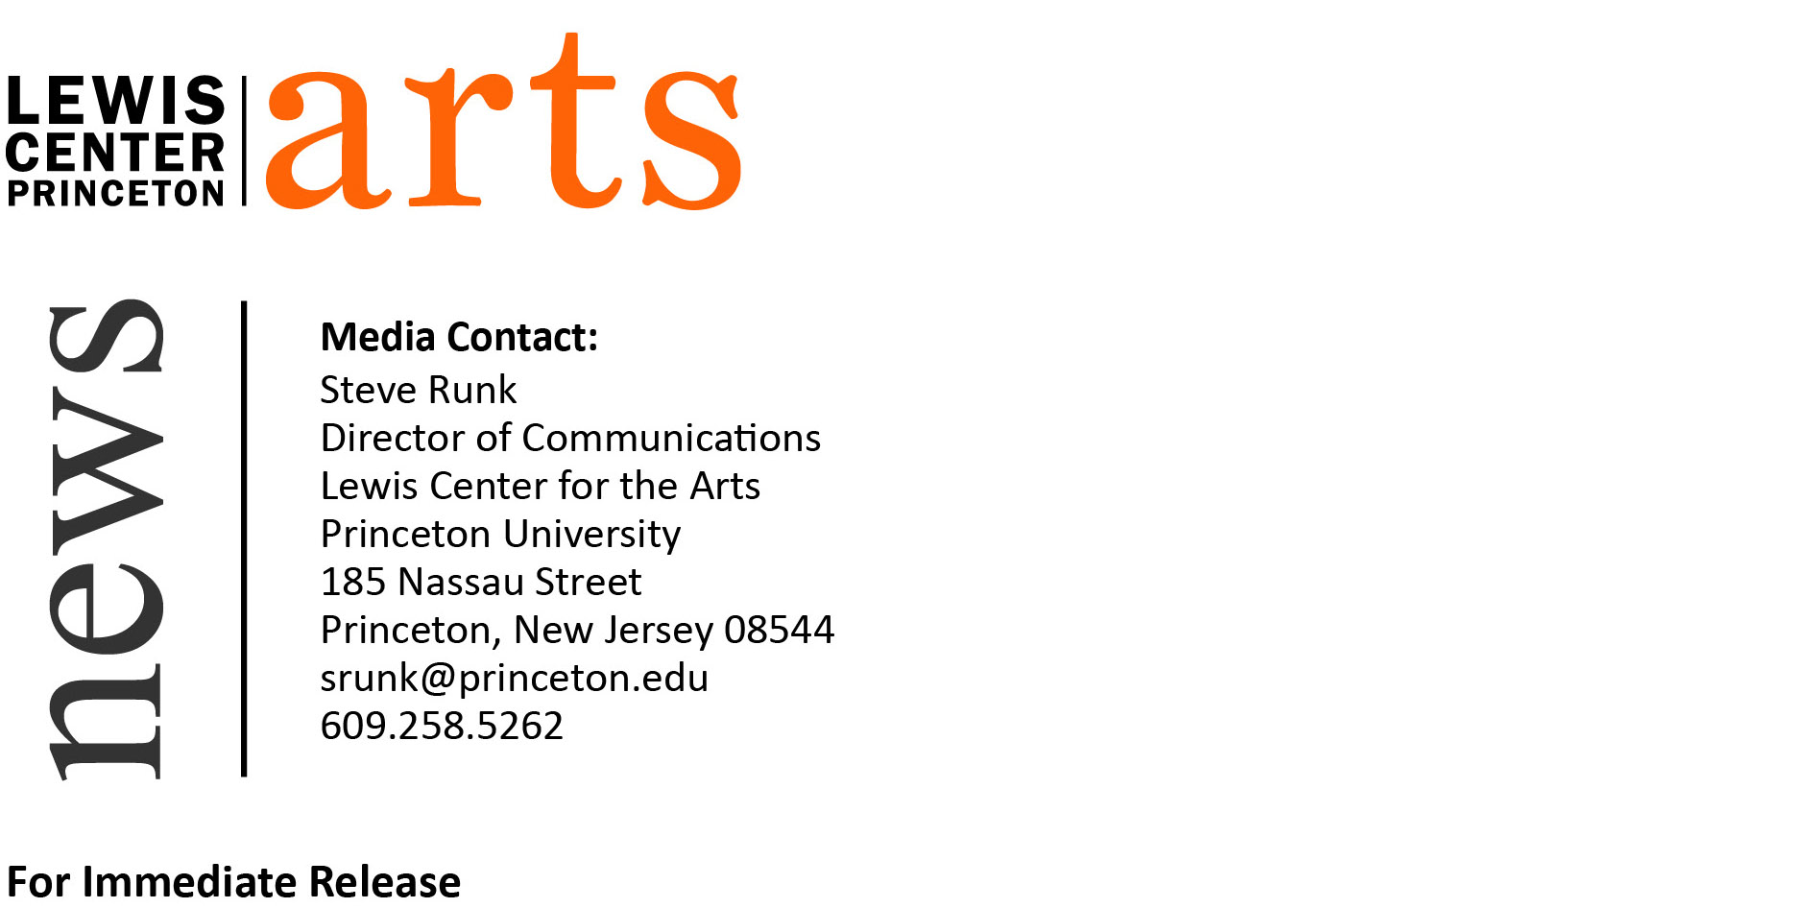

March 2, 2015

Akhil Sharma and A.E. Stallings Read at Lewis Center for the Arts
Award-winning writers next in Althea Ward Clark W’21 Reading Series

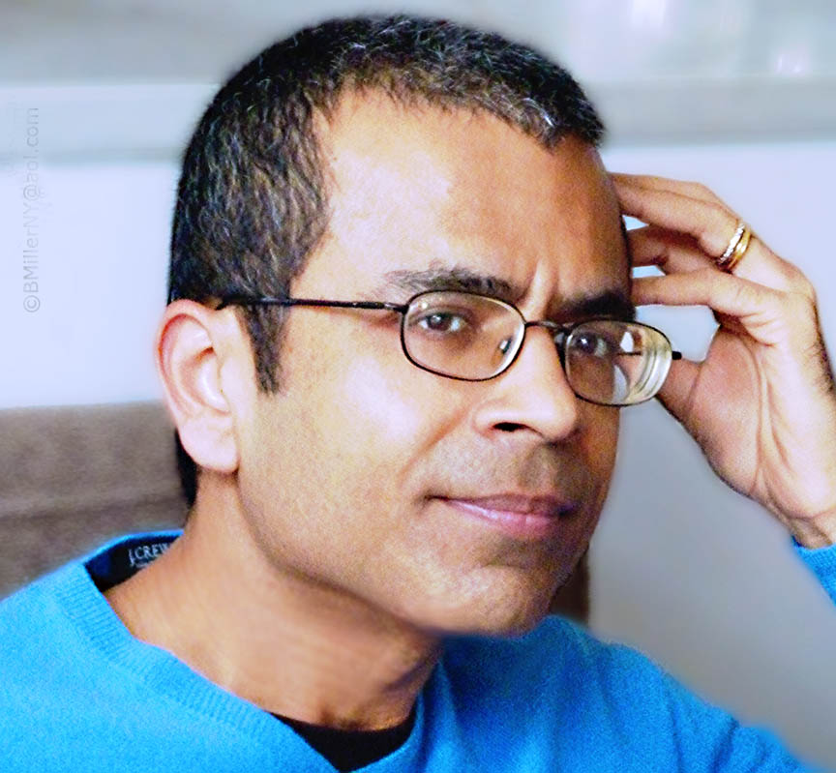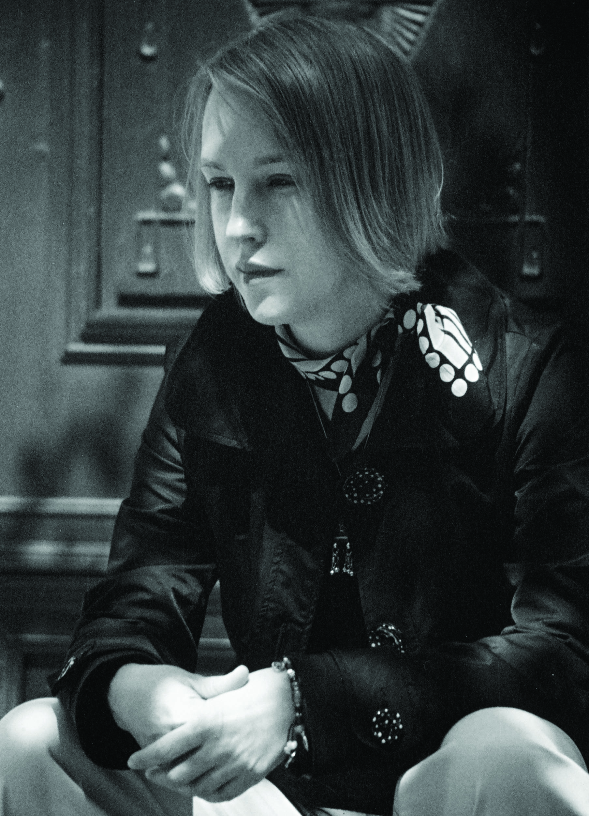
Photo Caption 1: Writer Akhil Sharma
Photo Credit 1: Bill Miller
Photo Caption 2: Poet and translator A.E. Stallings
Photo Credit 2: John Psaropoulos

What: Reading - Althea Ward Clark W’21 Reading Series
Who: Fiction writer Akhil Sharma and poet and translator A.E. Stallings
When: Wednesday, March 11 at 4:30 p.m.
Where: Berlind Theatre at McCarter Theatre Center
Free and open to the public

(Princeton, NJ) On Wednesday, March 11, fiction writer Akhil Sharma and poet and translator A.E. Stallings will read from their works as part of the Althea Ward Clark W’21 Reading Series of the Program in Creative Writing at the Lewis Center for the Arts. The reading, beginning at 4:30 p.m. at the Berlind Theatre at the McCarter Theatre Center, is free and open to the public.

Akhil Sharma is the author of Family Life (2014), named one of the Ten Best Books of 2014 by the New York Times Book Review and New York Magazine. The New York Times describes the book as “deeply unnerving and gorgeously tender at its core.” He is also the author of the Pen/Hemingway Prize winning novel Obedient Father (2000), which has been published in numerous languages and was a New York Times Notable Book of the Year. His award-winning short stories have appeared in The New Yorker, The Atlantic, Best American Short Stories, and O. Henry Award Stories. In 2007, he was included on Granta’s list of Best Young American novelists. Currently an assistant professor of English at Rutgers University-Newark, Sharma is a Princeton alumnus, Class of 1992.

Sharma will be introduced by award-winning poet, translator and critic Rowan Ricardo Phillips, a Visiting Associate Professor of Creative Writing at the Lewis Center.

A.E. Stallings’ collections of poetry include Archaic Smile (1999), which won the Richard Wilbur Award; Hapax (2006); and Olives (2012). Her poems and essays have been published in Poetry, The Atlantic, The Hudson Review, The Yale Review, and Best American Poetry. In her translation of The Nature of Things (2007), Stallings rendered Lucretius’s epic-length treatise on the nature of reality into rhyming fourteeners. Her honors include fellowships from the Guggenheim Foundation and the MacArthur Foundation, which noted, “Through her technical dexterity and graceful fusion of content and form, Stallings is revealing the timelessness of poetic expression and antiquity’s relevance for today.” Currently, she serves as director of the poetry program at The Athens Centre in Athens, Greece.

Stallings will be introduced by James Richardson, an award-winning poet, Professor of Creative Writing at the Lewis Center, and a Princeton alumnus, Class of 1971.

The Lewis Center’s Program in Creative Writing is sponsoring this event as part of the Althea Ward Clark W’21 Reading Series, which provides opportunities for students, as well as all in the greater Princeton region, to hear and meet the best writers of contemporary poetry and fiction. All readings are free and open to the public. Readings take place on select Wednesdays at 4:30 p.m. at the Berlind Theatre at McCarter Theatre Center.

Other upcoming readings in the series include Rachel Kushner and John Yau on April 15. Students in creative writing courses during the spring semester will read from their recent work on April 29. Seniors will read from the novels, screenplays, translations, and collections of poems and short fiction created as part of their senior thesis projects on May 4 and 6.

To learn more about the Program in Creative Writing, the Reading Series, and the more than 100 events offered annually by the Lewis Center, visit arts.princeton.edu.

###

