March 2, 2015

The Lewis Center for the Arts’ Program in Theater presents
Spring Awakening
Tony Award-winning rock musical will be directed by Julia Hammer and features
John Somers Fairchild, both seniors in the program

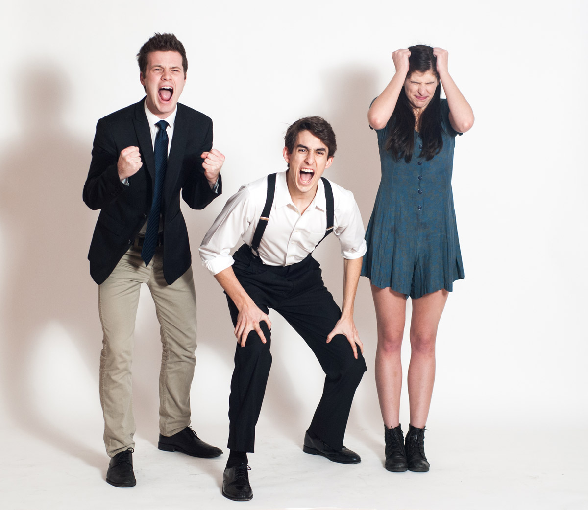
Photo caption: Appearing in Spring Awakening are from left to right John Somers Fairchild ’15 as Moritz, Billy Cohen ’16 as Melchior, and Maddie Meyers ’17 as Wendla.
Photo credit: Marcos Cisneros

What: Spring Awakening, the Tony Award-winning rock musical celebrating youth and rebellion follows the tumultuous journey from childhood to adulthood among a group of young people growing up in the repressive world of late 19th Century Germany. Book and lyrics by Steven Sater and music by Duncan Sheik.
Who: Presented by Lewis Center for the Arts’ Program in Theater at Princeton University, directed by Julia Hammer ’15 and featuring John Somers Fairchild ’15
When: March 6, 7, 12, and 13 at 8:00 p.m.; March 8 at 2:00 p.m.
Where: Berlind Theatre at McCarter Theatre Center
Tickets: $15 general admission, $10 for students and seniors

(Princeton, NJ) The Lewis Center for the Arts’ Program in Theater presents Spring Awakening, the Tony Award-winning rock musical celebrating youth and rebellion directed by Princeton senior Julia Hammer and featuring senior John Somers Fairchild as Moritz. The musical follows the universal journey from childhood to adulthood through a group of young people growing up in the repressive world of late 19th-century Germany as they face the inner and outer tumult of sexuality. Performances will be held on March 6, 7, 12 and 13 at 8:00 p.m. and March 8 at 2:00 p.m. at the Berlind Theatre at McCarter Theatre Center.

With music by Duncan Sheik and book and lyrics by Steven Sater, a Princeton alumnus, the show is based on the controversial 1891 play of the same title by Frank Wedekind. The original play was banned in Germany due to its portrayal of masturbation, abortion, rape and suicide. The musical’s rock score and postmodern lyrics were heralded as groundbreaking and ironic counterpoints to the suffocating conventions of the play’s setting.

In Spring Awakening, the headstrong Melchior and naive Wendla stumble into each other’s arms, passionate and curious, while the anxious Moritz struggles to live up to the stringent expectations of society. They and their friends are oppressed by the authority figures in their lives who mislead them, dole out punishment and physical and sexual abuse, and exert academic pressure. The repression and narrow-mindedness of the society around them and their struggle to find who they are leads to both exhilarating and tragic consequences.

The original Broadway production opened in 2006, featuring a cast including Lea Michele, Jonathan Groff, and John Gallagher, Jr. The production received eight Tony Awards including Best Musical, Best Direction, Best Book, Best Score, and Best Featured Actor. Spring Awakening also claimed four Drama Desk Awards, while its original cast album received a Grammy Award. The production was directed by Michael Mayer and choreographed by dance legend Bill T. Jones, who has been a frequent visitor to the Lewis Center’s dance program.

Hammer, who will direct this production, has worked extensively on campus as a director, stage manager, and production manager. She directed Venus in Fur for Theatre Intime last year and Bloody, Bloody Andrew Jackson for Princeton University Players. The native New Yorker is pursuing a degree in East Asian studies and a certificate in theater.

“These teenagers live in a world that’s full of rules,” says Hammer, speaking about the production. “Their lives are totally governed by the rules that their parents, teachers, and other figures of authority have laid out for them. What we’re interested in exploring is how everything starts to break down once you realize that the rules are flawed. Once you find a crack in the system, it expands at a staggering pace.”

Fairchild, who takes on the role of Moritz, is pursuing a degree in Economics with certificates in theater and South Asian studies. He too has an extensive theater career on campus including roles in the Lewis Center’s productions of The Tempest and Great Expectations, as well as Theatre Intime productions of Red and Circle Mirror Transformation. He is from Newark, Delaware.

“I was drawn to the character of Moritz,” notes Fairchild, “and his struggle to live in a society that hides from him all these things he doesn’t understand. He is incredibly repressed by that environment, but the music allows us to get into his inner world.”

Both students were interested in the musical for their senior thesis project. “The show was running on Broadway when we were the age of these characters,” notes Fairchild. “The issues the characters are facing are very relevant to our fellow students at Princeton,” adds Hammer. “This is definitely a time in our lives of exploration, rebellion, questioning and challenge.”

The all-student cast also includes Ross Barron ’17, Katie Birenboim ’16, Maeve Brady ’15, Billy Cohen ’16, Sam Gravitte ’17, Jared Hopper ’18, Maddie Meyers ’17, Michaela Milgrom ’16, Chris Murphy ’15, Maddie Reese ’16, and Bits Sola ’15. Adin Walker ‘16 is serving as choreographer, and Jake Schade ‘17 is stage manager. Sets are being designed by Wesley Cornwell ’16. Lewis Center Resident Musical Director and Composer Vince di Mura serves as music director for this production.

Duncan Sheik is an American singer-songwriter and composer who has written music for film and the Broadway stage. He is currently working on a musical adaptation of the novel American Psycho, which recently debuted in London. Steven Sater is an American poet, playwright, lyricist, television writer, and screenwriter. He studied English literature in the graduate program at Princeton.

Because Spring Awakening includes adult language and mature themes including sexual content the show may not be appropriate for all ages.

The Berlind Theatre is an accessible venue. Assistive listening devices are available upon request when attending a performance. Patrons in need of other access accommodations are invited to contact the Lewis Center at 609.258.5262 or LewisCtr-Comm@princeton.edu for assistance at least two weeks prior to the selected performance.

Tickets for Spring Awakening are $15 general admission, $10 for students and seniors, and are available through the McCarter box office at 609.258.2787 or online at www.mccarter.org/TicketOffice/buytickets.aspx?page_id=22, through Princeton University Ticketing by calling 609.258.9220 or online at www.princeton.edu/utickets/, at the Frist Campus Center Ticket Office, or at the Berlind box office on the evenings of performances.

The Lewis Center’s Program in Theater annually presents a major, professionally produced play, as well as a number of student senior thesis productions throughout the year. Other productions this season will include the drama How I Learned to Drive by Paula Vogel; Hero, a new play based on interviews with Vietnam veterans and featuring aerial choreography; a new play based on 1960s counter-culture icon Ken Kesey; The Other Shore by Nobel Prize-winning playwright Gao Zingjian; Groove!, a new “experiential” musical; a one-woman cabaret performance of Stephen Sondheim songs; and a new play based on interviews with people impacted by depression.

To learn more about this event, the Program in Theater, and the over 100 other activities presented at the Lewis Center visit arts.princeton.edu.

###

