April 15, 2015

Poets C.A. Conrad and Dorothea Lasky Read with Seniors in
Princeton’s Creative Writing Program
Poets read in series organized by Princeton students in collaboration with Labyrinth Books

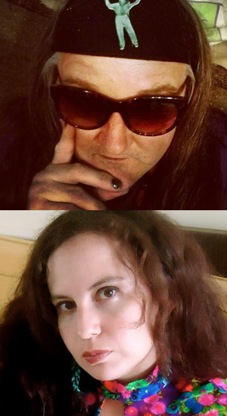
Photo caption 1: Award-winning poet C.A. Conrad
Photo credit 1: Ambrose Bye
Photo caption 2: Dorothea Lasky, Professor of Poetry at Columbia University
Photo credit 2: Courtesy of Dorothea Lasky

What/Who: Reading by poets C.A. Conrad and Dorothea Lasky and four seniors in Princeton’s Program in Creative Writing, part of a new Emerging Writers Reading Series
When: April 24 at 6:00 p.m.
Where: Labyrinth Books, 122 Nassau St., Princeton
Free and open to the public

(Princeton, NJ) Poets C.A. Conrad and Dorothea Lasky and four seniors in the Lewis Center for the Arts’ Program in Creative Writing at Princeton University will read from their work on Friday, April 24 at Labyrinth Books. The reading is part of the Emerging Writers Reading Series, which showcases senior thesis students of the Program in Creative Writing with established writers as special guests. Featuring student writers Amanda Devine, Emily McDonald, Vivian Ludford, and Susannah Sharpless the reading begins at 6:00 p.m. at the bookstore at 122 Nassau Street and is free and open to the public.

C.A. Conrad is the author of numerous collections of poetry, including ECODEVIANCE: (Soma)tics for the Future Wilderness (2014); Philip Seymour Hoffman (were you high when you said this?) (2014); A Beautiful Marsupial Afternoon: New (Soma)tics (2012); The City Real & Imagined (2010), with the poet Frank Sherlock; and The Book of Frank (2009), recipient of the Gil Ott Book Award. He has also authored a book of nonfiction essays, Advanced Elvis Course (2009). Conrad’s honors include fellowships from the Banff Art Center, Lannan Foundation, MacDowell Colony, Pew Center for Arts & Heritage, and Ucross Foundation. Conrad conducts lectures and workshops across the country on Soma(tics) and Ecopoetics. He currently lives in Philadelphia.

Dorothea Lasky has published three collections of poetry, AWE (2007), Black Life (2010), and Thunderbird (2012), as well as several chapbooks, including the polemical Poetry Is Not a Project (2010). Her poems have appeared in The New Yorker, Paris Review, The Atlantic, Boston Review, and American Poetry Review. She was awarded a Bagley Wright Fellowship in 2013 and has taught at New York University, Wesleyan University, Bennington College, among other places. She is currently an assistant professor of poetry at Columbia University and is co-Director of the Ashbery Home School.

The four seniors, who are pursuing a certificate in Creative Writing in addition to their major areas of study, will read from their senior thesis projects. Each is currently working on a novel, screenplay, translations, or a collection of poems or short stories as part of a creative thesis for their certificate with a member of the Creative Writing faculty including Jeffrey Eugenides, Chang-rae Lee, Paul Muldoon, Joyce Carol Oates, James Richardson, Tracy K. Smith, Susan Wheeler, and Edmund White.

The series, hosted by the seniors in the Program, is intended to present a public showcase for the work of their peers and to invite professional writers by whom the students have been inspired.

To learn more about the reading, the Program in Creative Writing, and the more than 100 public events presented each year by Lewis Center for the Arts, visit arts.princeton.edu.

###

