April 21, 2015

Hero, a new music theater work by Eamon Foley,
premieres at Lewis Center for the Arts
Princeton senior and Broadway veteran’s new work tells the story of a young man transformed by the Vietnam War, told through indie rock music, dance and aerial choreography

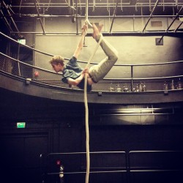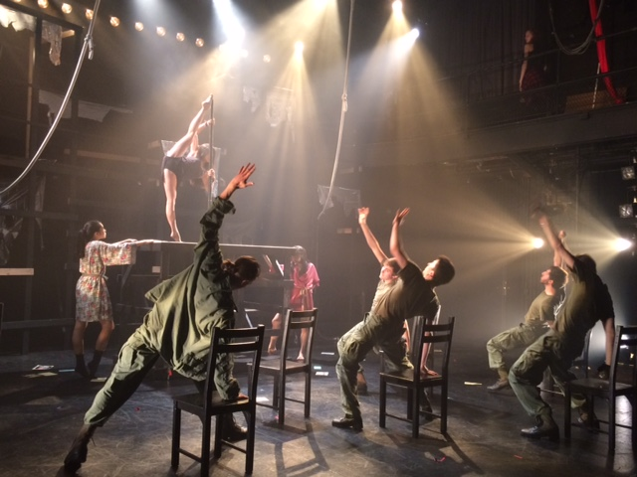
Photo caption 1: Princeton senior Eamon Foley creating the aerial choreography for his new music theater work Hero
Photo credit: Photo courtesy of Eamon Foley
Photo caption 2: The cast of Hero in rehearsal
Photo credit: Rob del Colle

What: Premiere of a new music theater work, Hero, which tells the story of a young man transformed by his experiences during the Vietnam War, told through indie rock music, dance and aerial choreography and based on interviews with Vietnam veterans.
Who: Written, directed and choreographed by Princeton senior Eamon Foley, already a veteran Broadway performer, with a cast of Princeton undergraduates, presented by the Lewis Center for the Arts’ Program in Theater
When: April 25, 26, 29 and 30 at 8 p.m. and May 1 at 6:00 p.m. Audience talk back follows April 26 performance.
Where: Marie and Edward Matthews ’53 Acting Studio, 185 Nassau St., Princeton
Free, however advance reservations are strongly recommended at http://arts.princeton.edu/events/hero-a-new-performance-piece/2015-04-25/

(Princeton, NJ) The Lewis Center for the Arts’ Program in Theater will premiere Hero, a new music theater work written, directed and choreographed by Princeton University senior Eamon Foley on April 25 at 8:00 p.m. at the Marie and Edward Matthews ’53 Acting Studio at 185 Nassau Street. Hero tells the story of a young man transformed by his experiences in the Vietnam War, told through indie rock music, dance, and aerial choreography and based on interviews with Vietnam veterans and other research conducted by the playwright. Foley is already a Broadway veteran at 21, having appeared in six productions. Performances of Hero continue April 26, 29 and 30 at 8:00 p.m. and May 1 at 6:00 p.m. with a talkback following the April 26 performance.

Foley came to Princeton knowing that he wanted to create theater. Inspired as a child after seeing a production of The Nutcracker, he started taking dance classes at the age of six. He was quickly cast as the prince in a Nutcracker production and was winning dance competitions. He also sang with his church choir and did local community theater in his hometown of New Canaan, Connecticut. At age nine, Foley auditioned for the 2003 Broadway revival of Gypsy, and after several call backs was cast in the show. He went on to perform in Broadway productions of Assassins, Dr. Seuss’ How the Grinch Stole Christmas (2005 and 2006), 13, and Everyday Rapture. “I got to watch some of the greats like Bernadette Peters, Sam Mendes, and Michael Mayer from backstage,” recalls Foley. “I learned early that performing is hard, rewarding work.” After appearing in Everyday Rapture with Sherie Rene Scott, who wrote the book for the musical, he realized he wanted to make theater and not just perform.

Foley’s idea for this work goes back to his teens as he commuted by train from Connecticut to rehearsals in New York City. He listened to indie rock music, some of which made him think about how a young person might grapple with the experience of war. He knew he wanted to explore this idea in a theatrical work.

At Princeton Foley enrolled as an anthropology major and pursued a certificate in theater. He explains, “I chose Princeton because to make great theater one needs to know more than just theater. I realized I could get that broader world view to help me create provocative theater in Princeton’s program” Foley also cites the level of skill of his peers as another aspect he values at the University.

Foley’s research for Hero draws on his background in anthropology including the study of ethnographic tools. These methods formed the basis for interviews he conducted with veterans of the Vietnam War and their families. These stories, and a visit to Vietnam last summer, led to the development of the fictional narrative of Sam, the main character in Hero. He cites The Laramie Project – a play about the reaction to the 1998 murder of University of Wyoming gay student Matthew Shepard in Laramie, Wyoming, based on interviews with hundreds of community members – as one of the inspirations for Hero. “The Laramie Project is a perfect example of where anthropology meets theater,” he notes.

Professor Isabelle Clark-Decès is Foley’s senior thesis advisor in the Department of Anthropology. Suzanne Agins, Lecturer in the Program in Theater, is his senior thesis advisor for this theater production.

Other influences Foley cites are the Billy Joel musical Moving Out, which uses dance to present the narrative of the story, The Who’s rock musical Tommy, and the Tony and Drama Desk Award-winning Broadway director Michael Mayer, who created the rock musical American Idiot and received a Tony Award for Best Direction of a Musical in 2007 for directing Spring Awakening. Mayer, who directed Foley in Everyday Rapture, wrote a letter of recommendation for him when he was applying to Princeton.

Foley started training in aerial arts at French Woods Festival for the Performing Arts at the age of eleven. “I was always interested in how the intense, super-human movement used in circus arts could translate into a narrative,” he recalls. In his application to Princeton, he wrote an essay on how he hopes to revolutionize musical theater choreography with the use of narrative based aerial dance. “I am thrilled to have come full circle with this project,” he adds.

Interest in creating theater that pushes boundaries and takes risks was Foley’s impetus for launching a new student theater group on campus, Grind Arts Company, in 2014 with an inaugural production of the musical Sweeney Todd performed on the loading dock of one of the University’s buildings. He has also directed, choreographed, and performed with the student theater and dance groups Princeton University Players, Bodyhype and Princeton Shakespeare Company, as well as the Lewis Center’s productions of Fuente Ovejuna, Woyzeck, The Producers, and the 2014 Spring Dance Festival. He workshopped choreography for Hero through Bodyhype.

The all-student cast includes Alex Quetell ’17, Colby Hyland ’16, Kamber Hart ’16, Carson Hughes ’16, Connor Scott Werth ’17, Luke Pfleger ’17, Clark Griffin ’18, Trent Kowalik ’17, Adin Walker ’16, Natalie Lu ’18, Stephanie Liu ’18, Anna Pearson ’18, Victoria Gu ’18, Maria Yu ’16, and Ayla Allen ’18. Live music will be performed by Vince di Mura, Lewis Center Resident Musical Director and Composer, on keyboards and who is providing musical direction for the show; Tyler Nellesen ’17 and Guillermo Martinez Cabalga ’17 on guitar, Aqeel Philips ’17 on bass, Michael Bruschi ’15 on drums, and Sam Harris ’17 on keyboards with singers Jared Hopper ’18, Greg Kraft ’15, Lachlan Kermode ’17, Alex Morton ’15, Emily Libresco ’17, Katie Raber ’16, and Pam Soffer ’15.

Sets are designed by Carolyn Mraz, costumes by Julia Peiperl ’17, lighting by Thom Weaver, sound design by Florian Staab, and projection design by Daniel Foley with Jillian Marie Walker as sound engineer, Regina Zeng ’18 as stage manager, and Katie Birenboim ’16 as assistant stage manager.

An audience talkback led by Princeton faculty member, playwright and theater director R.N. Sandberg will follow the April 26 performance.

The Lewis Center’s Program in Theater annually presents a major, professionally produced play in the fall, as well as a number of student senior thesis productions throughout the year. The current season winds down with a production of The Other Shore, an experimental work by Nobel Prize-winning playwright Gao Xingjian; a cabaret performance of songs from Stephen Sondheim musicals; and a workshop reading of a new play based on the stories of people experiencing depression.

Tickets for Hero are free, however reservations are strongly recommended as the limited seating is filling up quickly - http://arts.princeton.edu/events/hero-a-new-performance-piece/2015-04-25/.

For more information on this event, the Program in Theater and the more than 100 other events offered each year by the Lewis Center for the Arts visit arts.princeton.edu.

###

