May 7, 2015

The Lewis Center for the Arts’ Program in Theater presents workshop reading of
I’m Fine, I’m Better, Don’t Worry About Me
New investigative theater piece by senior Joseph Labatt explores issues of student mental health at Princeton based on interviews with students and faculty

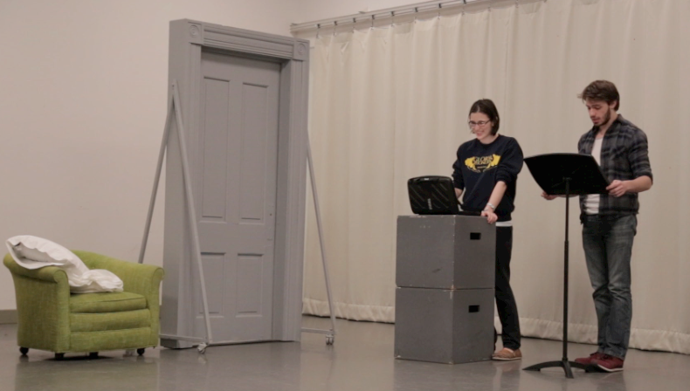
Photo caption: Student actors in rehearsal for the developmental reading of theater senior Joseph Labatt’s new investigative theater piece I’m Fine, I’m Better, Don’t Worry About Me.
Photo credit: Cameron Johanning

What: Developmental reading of a new investigative theater piece, I’m Fine, I’m Better, Don’t Worry About Me, exploring issues of student mental health at Princeton based on interviews with students and faculty
Who: Written and directed by Program in Theater senior Joseph Labatt
When: May 8 at 8 p.m., May 9 at 8:00 and 10:30 p.m. and May 10 at 3 p.m., with a talkback led by Dr. Calvin Chin, Director of Princeton Counseling and Psychological Services, following the May 10 performance
Where: Marie and Edward Matthews ’53 Acting Studio at 185 Nassau Street
Free and open to the public

(Princeton, NJ) The Lewis Center for the Arts’ Program in Theater at Princeton University will present a developmental workshop reading of a new play, I’m Fine, I’m Better, Don’t Worry About Me, exploring issues of student mental health at Princeton by theater senior Joseph Labatt. This new work is based on interviews conducted by Labatt with students and faculty at Princeton; he will also direct student actors in the reading. Performances will take place on Friday, May 8 at 8:00 p.m., Saturday, May 9 at 8:00 p.m. and 10:30 p.m., and Sunday, May 10 at 3:00 p.m. in the Marie and Edward Matthews ’53 Acting Studio at 185 Nassau Street. A talkback led by Dr. Calvin Chin, Director of Princeton Counseling and Psychological Services will follow the performance on May 10. The show is free and open to the public, however advance reservations are recommended and can be made at im-fine.eventbrite.com.

Labatt’s project is a deeply personal one. He took a year off from Princeton to cope with a host of physical and mental health challenges. “You probably hear it every day: ‘How are you?’ ‘I'm fine.’” notes Labatt. “Everyone at Princeton is always ‘fine’. Except, I wasn't.”

When he came back to visit campus, he recalls being obsessed with proving that he had fully recovered and was “ready to pop back into the Orange Bubble like nothing ever happened.” He adds, “Just a few days of relentlessly trying to maintain the façade that I was once again ‘fine’ caused incredible stress. I realized I couldn't bury my problems and have any hope of living in a healthy way–so I started telling people. ‘I left because I was depressed, and had a severe sleep disorder. I'm doing better, but still have a ways to go.’”

He found that sharing his story and situation with others helped tremendously, relieving a huge part of the burden he was carrying and giving him the support of informed friends. “That's why I decided to focus my thesis project on giving other students an opportunity to share as well,” he explains. “This is a piece of investigative theater, drawing on sources such as newspaper articles and therapy techniques, but also–and most importantly — the actual words of Princeton students I've interviewed who are dealing with mental health struggles.”

Labatt, an English major from San Antonio, Texas, pursuing a certificate in theater, drew upon skills and knowledge developed through his Princeton courses. A visit by the artistic director of the New York-based investigative theater company The Civilians as part of an American Studies course opened up the idea of ethnographic techniques to develop a theater piece on these issues. He also took a playwriting course with Program in Theater faculty member and playwright R.N. Sandberg, and continued his study of ethnographic playwriting in a course with 2014-16 Princeton Arts Fellow Aaron Landsman. The play he developed fulfills his senior thesis projects in both English and theater.

The stories told in the piece cover a range of issues related to past trauma in high school, assault, personality disorder, depression and suicide. These issues have been making headlines at college campuses around the country including at Princeton, as students struggle with stress and anxiety and academic and social pressures of all kinds.

Labatt hopes the piece will touch and help others who are struggling and sees the development and presentation of the play as a service to others, utilizing the storytelling power of theater to address critical issues. The playbill for the reading includes a list of campus and national mental health resources.

Labatt has been an active member of Princeton’s theater community appearing in or stage managing Lewis Center productions of The Wakefield Mystery Plays, Eugene Onegin and another senior’s new play reading, Silsie. He has been a board member and past president of the Princeton Shakespeare Company and done work with both Theatre Intime and Princeton University Players.

After graduation in June Labatt plans to pursue a career in arts administration. He completed an internship in the summer after his sophomore year in the marketing department of The Public Theater and last summer interned in the development office of New York Musical Theatre Festival.

The ensemble cast of Princeton undergraduate actors includes Mary Gilstad ’15, Lena Henke ’16, Sam Kessler ’15, Nathan Leach ’18, and Stephanie Webb ’17. The production team includes Anna Aronson ’16 as stage manager, Ava Geyer ’15 as assistant stage manager, and
Madeleine Planeix-Crocker ’15.

The Lewis Center’s Program in Theater annually presents a major, professionally produced play, as well as a number of student senior thesis productions throughout the year. Running concurrently with this production to close out the season is a one-woman cabaret performance by senior Katie Welsh exploring several female characters in the musicals of Stephen Sondheim.

To learn more about this event, the Program in Theater, and the over 100 other activities presented at the Lewis Center visit arts.princeton.edu.

###

