Media Contact:
Steve Runk
Director of Communications
Lewis Center for the Arts
Princeton University
185 Nassau Street
Princeton, New Jersey 08544
srunk@princeton.edu
609.258.5262

June 25, 2015

Lewis Center for the Arts’ Program in Visual Arts Announces
New Photography Faculty Members
Artists Deana Lawson and Jeff Whetstone Join Princeton Faculty

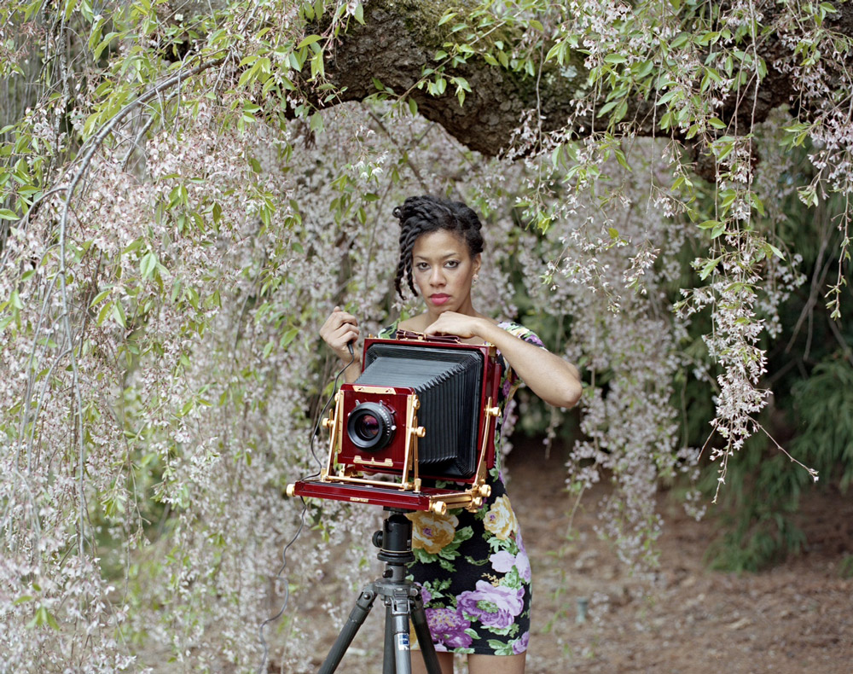
Photo caption: Assistant Professor Deana Lawson
Photo credit: Dru Donovan

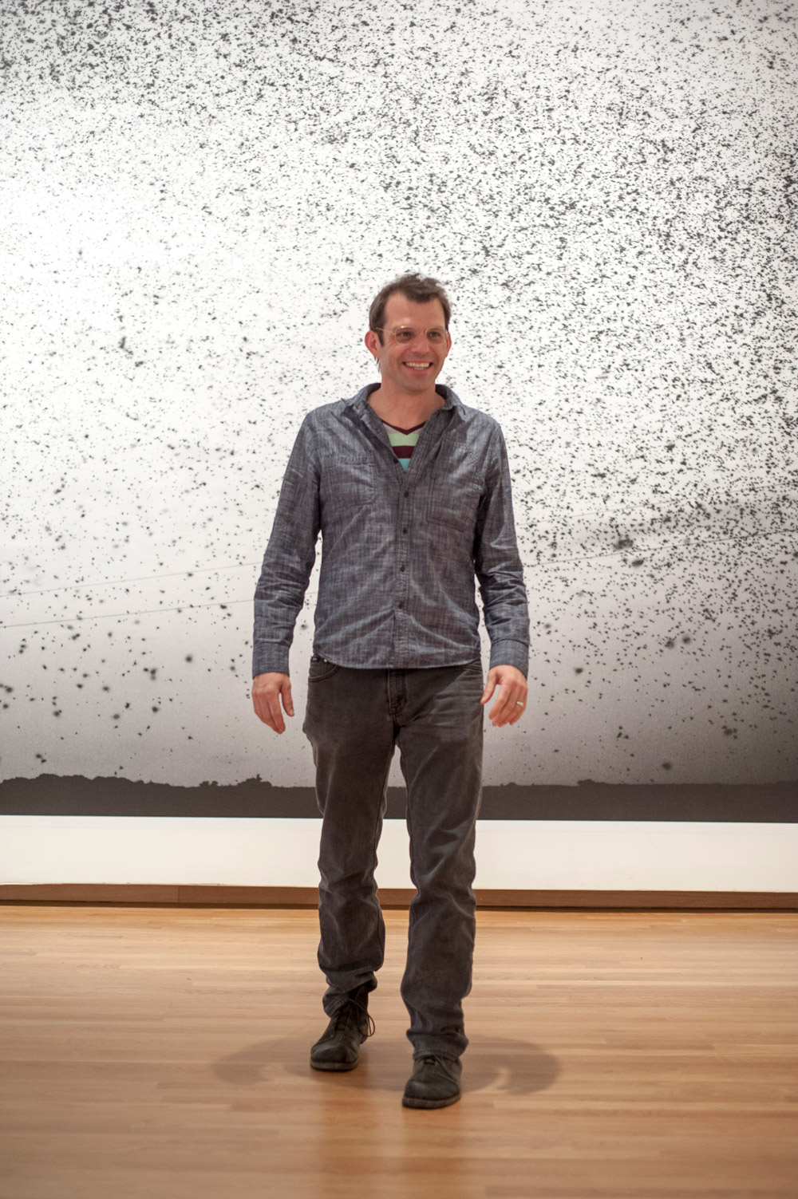
Photo caption: Professor Jeff Whetstone
Photo credit: Photo of Jeffrey Whetstone by J Caldwell for the Nasher Museum of Art at Duke University

(Princeton, NJ) The Program in Visual Arts in the Lewis Center for the Arts at Princeton University is pleased to announce that Deana Lawson and Jeff Whetstone will join the photography faculty. Both appointments will commence September 1, 2015.

Lawson, who is currently a lecturer at Princeton, has been appointed an Assistant Professor. Whetstone, a professor at The University of North Carolina at Chapel Hill, where he has been teaching full-time since 2001, has been appointed a full Professor.

Michael Cadden, Chair of the Lewis Center, observes, “With these two appointments, we solidify what has also been one of the jewels in the crown of our Visual Arts Program – the teaching and study of photography.”

Deana Lawson describes her work as negotiating knowledge of selfhood through a corporeal dimension. Her photographs speak to the ways that sexuality, violence, family, and social status may be written, sometimes literally, on the body. She utilizes a wide spectrum of photographic languages: staging, subjective documentary, and found or appropriated images.

Lawson’s work was included in New Photography 2011 at the Museum of Modern Art, New York. She has an upcoming solo exhibition at The Art Institute of Chicago Museum in September. Lawson has participated in group exhibitions at The Studio Museum, Harlem; MoMA P.S.1 and Artists Space, New York; and the Spelman College Museum of Fine Art, Atlanta. Gallery shows include Rhona Hoffman Gallery, Chicago; Yancey Richardson Gallery, New York; and Helene Bailly Gallery, Paris.

Lawson earned a B.F.A. from Penn State University (2001) and an M.F.A. from the Rhode Island School of Design (2004). She was born in Rochester, New York, and currently lives and works in the Bedford-Stuyvesant neighborhood of Brooklyn.

As Joe Scanlan, Director of the Program in Visual Arts notes, “Deana’s work begins with her approach to the camera as a mediating device between herself and others. For Deana, taking a photograph means putting herself into a certain power relation to the world. What is really impressive is how she shares that power to create striking and profound moments of beauty.”

Jeff Whetstone’s work examines the human place in the landscape. He was born in Chattanooga, Tennessee. He began photographing and writing about the relationship between humans and the natural world while a student at Duke University, where he received a degree in Zoology in 1990. As an Artist-in-Residence at Appalshop, a media arts center in Whitesburg, Kentucky, Whetstone directed the Before the Flood exhibition, which premiered at the National Folk Festival. Whetstone earned an M.F.A. from the Yale School of Photography in 2001 and was the recipient of the George Sakier Prize for Photography at Yale that year.

Over the course of his academic career Whetstone has been the recipient of numerous prizes, including a Guggenheim Fellowship (2007), the University of North Carolina Hettleman Prize (2009), a Factor Prize (2008), and two North Carolina Arts Council Fellowships (2006, 2012).

His work has been exhibited internationally and has received reviews in The Village Voice, The New York Times, The New Yorker, and the Los Angeles Times. He is represented by Julie Saul Gallery in New York and Karyn Lovegrove Gallery in Los Angeles.

Whetstone’s New Wilderness project explores the life and landscape of Appalachia, through the lenses of anthropology and mythology. His Post-Pleistocene images illuminate interiors of wild caves, documenting layers of human markings, which reveal millennia of cultural evolution. His work particularly interrogates stereotypes of ignorance, poverty, and self-destruction and, as he notes, “reveals the unique reverence and complicated bond people in the American South have with the landscape.” Whetstone’s work focuses on the role gender, geography, and heritage play in defining humans’ position in the natural world.

As Scanlan notes, “Jeff’s artistic approach is clearly informed by his training as a scientist. The relationship between scientific and creative methods, and how the history and philosophy of each influences the kinds of knowledge it produces, is a fundamental question in his work.”

“I’m delighted to have Deana and Jeff become part of the arts faculty in the Lewis Center and at Princeton,” says Scanlan. “Despite having worked with profoundly different subjects in different parts of the world, in many ways Deana and Jeff are two sides of the same coin. Politics play a strong role in the people and places they photograph, both have a collaborative rather than authoritative approach, and bother are consummate technicians. With growing interest in gender and sexuality studies, ethnographic study, and African American studies on campus, their creative thinking has much to offer the Princeton community.”

To learn more about the Program in Visual Arts and all the programs of the Lewis Center for the Arts visit arts.princeton.edu.

###

