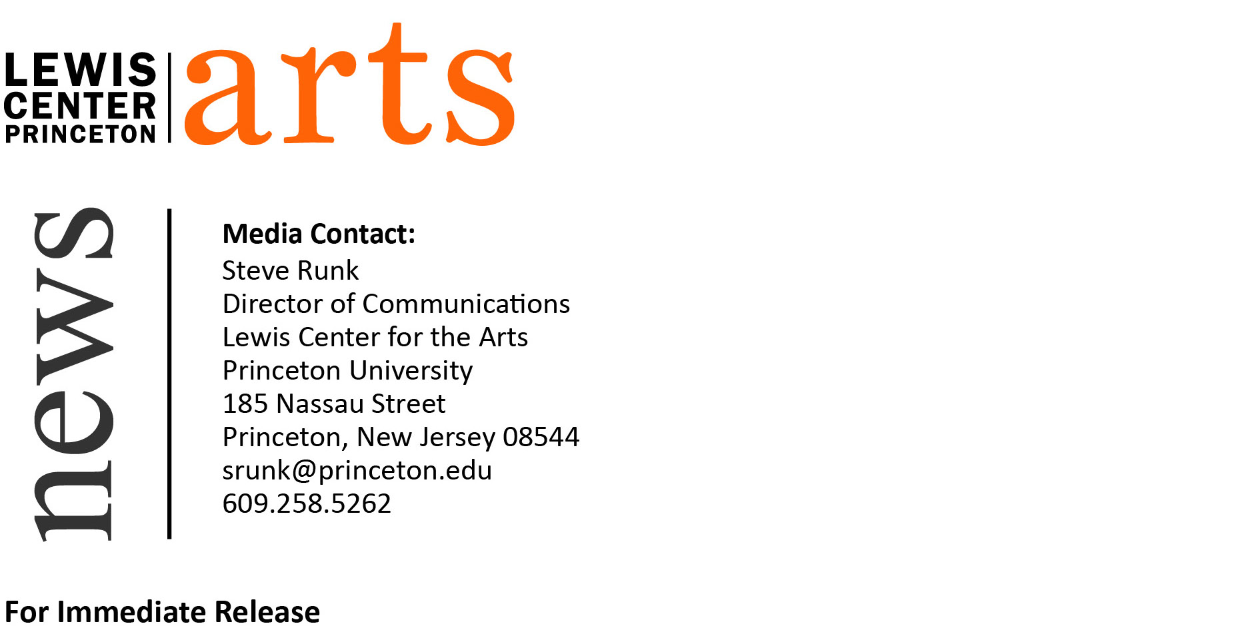

October 5, 2015

Jhumpa Lahiri and Mary Szybist Read at Lewis Center for the Arts
Award-winning writers next in Althea Ward Clark W’21 Reading Series

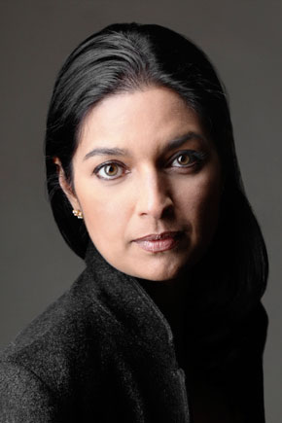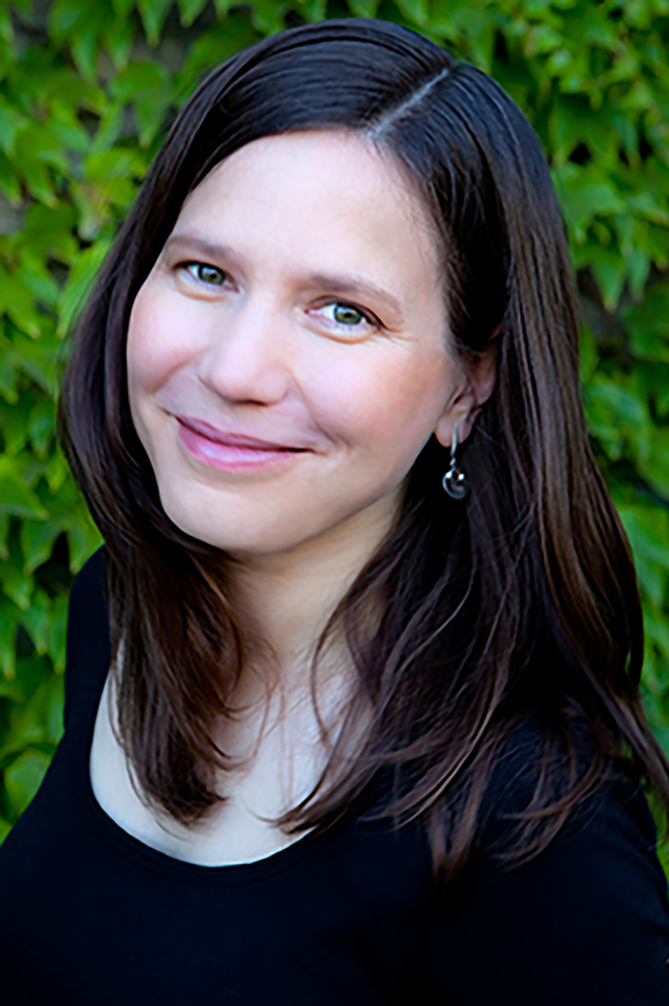
Photos caption: Fiction writer Jhumpa Lahiri (left) and poet Mary Szybist read at the Althea Ward Clark W’21 Reading Series on October 14
Photo credits: Jhumpa Lahiri by Marco Delogu; Mary Szybist by Joni Kabana

Who: National Humanities Medal recipient and Pulitzer Prize-winning fiction writer Jhumpa Lahiri and National Book Award-winning poet Mary Szybist
What: A reading, part of the 2015-16 Althea Ward Clark W’21 Reading Series
When: Wednesday, October 14 at 4:30 p.m.
Where: Berlind Theatre at McCarter Theatre Center, 91 University Place, Princeton
Free and open to the public

(Princeton, NJ) On Wednesday, October 14, National Humanities Medal recipient and Pulitzer Prize-winning fiction writer Jhumpa Lahiri and National Book Award-winning poet Mary Szybist will read from their works as part of the Althea Ward Clark W’21 Reading Series of the Program in Creative Writing at the Lewis Center for the Arts. The reading, beginning at 4:30 p.m. at the Berlind Theatre at the McCarter Theatre Center, is free and open to the public.

Jhumpa Lahiri received the National Humanities Medal from President Obama on September 10, 2015 at the White House. Her most recent book, The Lowland (2013), won the DSC Prize for South Asian Literature and was a finalist for both the Man Booker Prize and the National Book Award for fiction. Her debut short story collection, Interpreter of Maladies, received the Pulitzer Prize for Fiction and the PEN/Hemingway Foundation Award. Her other works include the novel The Namesake (2003), which was adapted into a film directed by Mira Nair, and the short story collection Unaccustomed Earth (2008), which won the Frank O’Connor International Short Story Award. Lahiri is also the recipient of an O. Henry Award, the Addison Metcalf Award from the American Academy of Arts and Letters, and the Asian American Literary Award, as well as fellowships from the Guggenheim Foundation and the National Endowment for the Arts. Her nonfiction debut, In Other Words, is forthcoming in 2016. Lahiri joined the Program in Creative Writing faculty at Princeton in September.

Mary Szybist is the author of Incarnadine, winner of the 2013 National Book Award for Poetry. She is the recipient of fellowships from the Guggenheim Foundation, the National Endowment for the Arts, the Rockefeller Foundation's Bellagio Center, and the Witter Bynner Foundation in conjunction with the Library of Congress. Her first collection of poetry, Granted (2003), was a finalist for the National Book Critics Circle Award. She lives in Portland, Oregon, where she teaches at Lewis & Clark College.

The Lewis Center’s Program in Creative Writing annually presents the Althea Ward Clark W’21 Reading Series, which provides an opportunity for students, as well as all in the greater Princeton region, to hear and meet the best writers of contemporary poetry and fiction. All readings are free and open to the public and take place on select Wednesdays at 4:30 p.m. at the Berlind Theatre at McCarter Theatre Center. Other readings scheduled in the 2015-2016 series include:
- Adam Johnson and Dorianne Laux on November 18
- Marlon James and Claudia Rankine on February 10
- Edwidge Danticat and Robert Hass on March 9
- Ciaran Berry & Nell Zink on April 6

In addition poet Marie Howe will deliver the annual Theodore H. Holmes ’51 and Bernice Holmes Lecture on October 27 at 4:30 p.m. at the James M. Stewart ’32 Theater at 185 Nassau Street.

For more information on the Program in Creative Writing and the many other events offered by the Lewis Center for the Arts, visit arts.princeton.edu.

###

