

November 2, 2015

Lewis Center for the Arts presents Zoyka’s Apartment
Guest director Alexandru Mihail brings Mikhail Bulgakov’s once-buried, subversive farce to
Princeton as the Program in Theater’s Fall Show

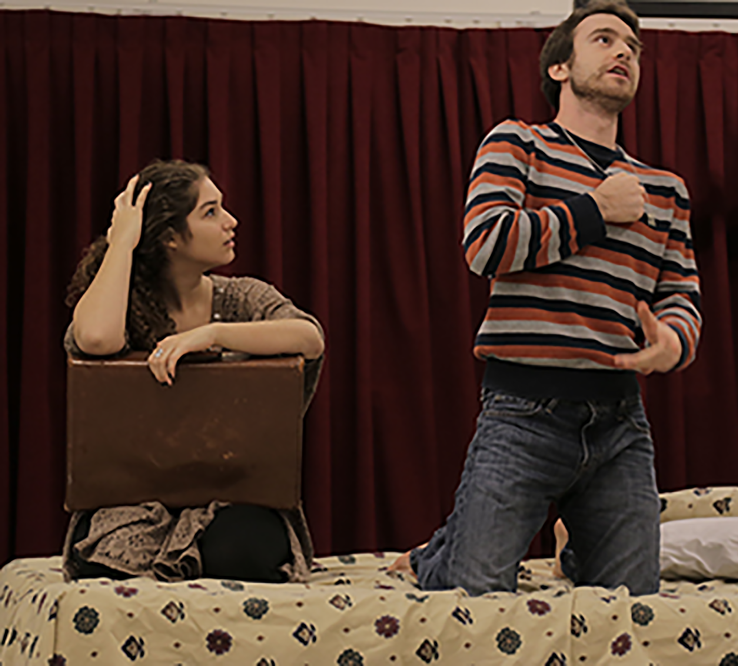
Photo caption: Evelyn Giovine in the title role and Sam Gelman as Ametistov in a rehearsal for Zoyka’s Apartment by the great Russian novelist and playwright Mikhail Bulgakov, opening November 13 at Lewis Center for the Arts
Photo credit: Justin Goldberg

What: Zoyka’s Apartment, a tuneful, subversive farce set in 1920s post-revolutionary Russia by Mikhail Bulgakov, the author of Master and Margarita, in an English translation by Nicholas Saunders and Frank Dwyer, was censored by the Soviet government.
Who: Presented by Lewis Center for the Arts’ Program in Theater, directed by guest artist Alexandru Mihail and performed by a cast of Princeton students
When: November 13, 14, 19, 20, and 21 at 8:00 p.m.
Where: Berlind Theatre at McCarter Theatre Center, 91 University Place in Princeton
Tickets: In advance of show date -$12 general admission/$11 students and seniors; box office on days performances -$17 general admission/$15 students and seniors

(Princeton, NJ) The Lewis Center for the Arts’ Program in Theater at Princeton University will present Zoyka’s Apartment, a tragicomic farce by Mikhail Bulgakov, in an English translation by Nicholas Saunders and Frank Dwyer. The show is directed by guest artist Alexandru Mihail with a cast of Princeton students and will be presented on November 13, 14, 19, 20, and 21 at 8:00 p.m. Performances will take place in the Berlind Theatre at McCarter Theatre Center, located at 91 University Place. A discussion with director and cast will follow the November 14 performance. A conference on Bulgakov, a Russian novelist and playwright, will be presented by Princeton’s Department of Slavic Languages and Literatures on November 13 and 14.

Zoyka’s Apartment combines elements of vaudeville and tragicomic farce to tell the story of Zoyka, a widow, who opens an undercover brothel in her apartment to make ends meet in 1920s Moscow during a severe housing shortage. As Zoyka and other former bourgeoisie struggle under the new regime, mixing with a cast of drug pushers, black market dealers, and corrupt officials, the audience comes to understand the dark, at times humorous, existence of citizens in post-revolutionary Russia.

The play was performed just three times before it was censored by the Soviet government, and remained a somewhat lost work through the 1960s.

“Soviet Russia in the 1920s was a time of great experimentation,” notes Mihail, the Romanian director invited to lead the production. “The characters we meet in Zoyka’s Moscow apartment are all seeking freedom, which for them means leaving the country, and they are willing to make significant sacrifices and moral compromises -- willing to lose everything -- to secure a passport.” Mihail finds this theme of striving for freedom, and the price individuals are willing to pay to achieve it, continues to have great resonance today in both the U.S. and Russia.

Mihail also notes the play demonstrates the use of imagination as a weapon to escape the harsh realities faced by the characters. “In some ways,” he notes, “Zoyka’s apartment becomes the heavenly haven of Paris, and the play a celebration of imagination.”

Bulgakov gained international appreciation only after the posthumous publication of his most famous work, the novel Master and Margarita. However, he gained popularity in Russia during the 1920s for his satirical plays and novels, even while they were often censored by the government for ridiculing the Soviet regime. Bulgakov wrote Zoyka’s Apartment sometime between 1922 and 1926, though he was not allowed to produce it until 1928 when it premiered in Moscow, to public enthusiasm.

Guest director Mihail is a theater director now based in New York City, working in both the U.S. and Europe, and notes a commitment to changing the world through live performance. He graduated from the Yale School of Drama’s M.F.A. directing program in 2012. His most recent work includes a concert version of The Threepenny Opera by Bertolt Brecht and Kurt Weill, part of Polyphone Festival at UARTS in Philadelphia, and the European premiere of Aliens with Extraordinary Skills by Savanna Stanescu at The Odeon Theatre, Bucharest. In Romania, among other awards, he won the prestigious UNITER Prize for his direction of Peter Shaffer's Black Comedy. He is a 2013 Drama League Directing Fellow.

Music is integral to the play and in Mihail’s production an important element. The actors also serve as the musicians, performing an eclectic score for the production that includes opera, jazz and Latino music, all genre that were popular at that time in Russia.

While set in the 1920s and realistically portraying the circumstances that Russia’s citizens lived through at that time, the production borrows a variety of visual and sound elements from a range of time periods, and embraces a rhythm and pace intended to resonate with 21st century audiences.

The production is itself a credited course, taught by Mihail, in which students experience the rigorous and challenging work of creating a piece of theater in collaboration with a professional director, design team, and stage manager.

“The purpose of the fall show is to allow our students to engage deeply with professional theater artists on a significant work of dramatic literature,” notes Tim Vasen, Director of the Program in Theater. “Bulgakov is one of my artistic heroes, largely unknown in the U.S., and I am thrilled to bring his work to Princeton audiences. Alex Mihail is a young director of remarkable inventiveness who glories in the kind of artistic chaos Bulgakov creates with his work. I think this will be a great, only-at-Princeton experience for audiences and performers alike.”

The professional design team includes sets by Kristen Robinson, costume design by Montana Levi Blanco, lighting by Masha Tsimiring, and music composition and sound design by Chad Raines.

The cast of 16 undergraduate and graduate students, many of whom are pursuing or intend to pursue certificates in the Program in Theater at the Lewis Center, includes senior Evelyn Giovine in the title role, along with Carey Camel ’17, Matt Chang ’19, Blaine Crabtree ’19, graduate student Tom Dowling, Sam Gelman ’16, Kasia Kalinowska ’19, Hope Kean ’18, Changshuo Liu ’19, Ugonna Nwabueze ’18, T.J. Smith ’16, Justin Sansone ’19, Feyisola Soetan ’19, Luke Soucy ’19, Avanthika Srinivasan ’16, and Katherine Zhao ’17. Adin Walker ’16 is choreographing the show and Arianna Lanz ’17 and Alice Terrett ’16 are assistant director and assistant stage manager, respectively.

In addition to the annual fall show, the Lewis Center’s Program in Theater annually presents a season of student senior thesis productions throughout the year, which will include Cloud Nine by Caryl Churchill, Sophocles’ Elektra, Disco Pigs by Enda Walsh, a new take on the musical classic Singin’ in the Rain, a new dance-theater work exploring the racial concept of dual consciousness, a new musical based on The Picture of Dorian Gray, and a concert performance of two Golden Age musicals that explores issues of womanhood.

The Berlind Theatre is an accessible venue with access details available at www.mccarter.org <http://www.mccarter.org/VisitorInfo/VisitorDefault.aspx?page_id=32>. Assistive listening devices are available upon request when attending a performance. Patrons in need of other access accommodations are invited to contact the Lewis Center at 609.258.5262 or LewisCtr-Comm@princeton.edu for assistance at least two weeks prior to the selected performance.

Reserved seating tickets for Zoyka’s Apartment are $12/$11 for students and seniors when purchased in advance, or $17/$15 for students and seniors on the day of performances. Tickets are available online through arts.princeton.edu/zoyka, by calling the McCarter box office at 609.258.2787, at the Frist Campus Center Ticket Office, and at the door on the night of performances.

To learn more about this event, the Program in Theater, and the over 100 other activities presented at the Lewis Center visit princeton.edu/arts.

###

