January 26, 2016

Lewis Center for the Arts presents Elektra
Guest Director Alexandru Mihail and theater senior Evelyn Giovine
bring new life to Sophocles’ classic Greek tragedy

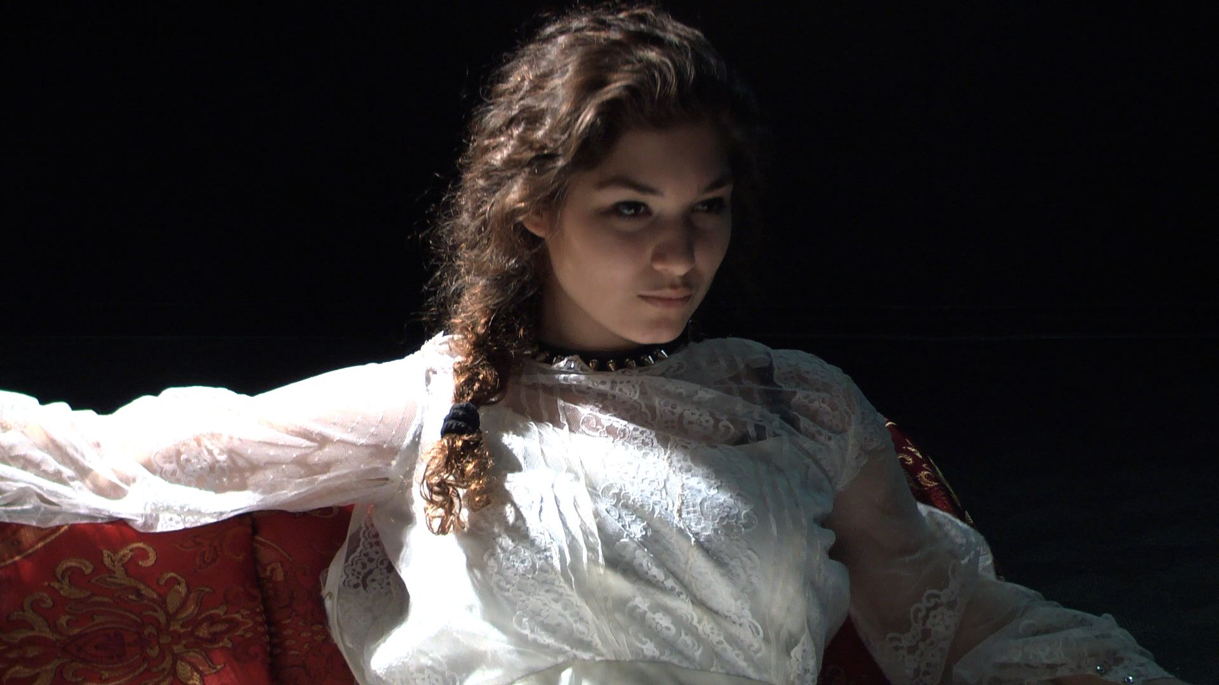

Photo caption: Evelyn Giovine, a senior in Princeton’s Program in Theater, who will be featured in the title role of Sophocles’ Elektra, opening February 5 at the Lewis Center for the Arts
Photo credit: Hawa Sako

What: Sophocles’ tragedy, Elektra, a new take on this dark, bloody tale of familial vengeance from ancient Greece
Who: Presented by Lewis Center for the Arts’ Program in Theater, directed by Alexandru Mihail and featuring senior Evelyn Giovine in the title role
When: February 5, 6, 11, 12, and 13 at 8:00 p.m.
Where: Marie & Edward Matthews '53 Acting Studio at 185 Nassau
Tickets: $12 general admission, $11 students and seniors in advance; $17 general admission, $15 students and seniors on the day of performances

(Princeton, NJ) The Lewis Center for the Arts’ Program in Theater at Princeton University will present Elektra by Sophocles, the classic, dark, bloody tale of familial vengeance from ancient Greece, explored anew by guest director Alexandru Mihail and senior Evelyn Giovine in the title role. Performances will take place on February 5, 6, 11, 12, and 13 at 8:00 p.m. in the Marie and Edward Matthews ’53 Acting Studio located at 185 Nassau Street.

Elektra is one of Sophocles’ best known tragedies, lauded for its deep and complex characterization of the titular figure as she experiences grief and contemplates revenge. In the play, Elektra, daughter of King Agamemnon, mourns her father’s murder, blaming her mother Clytemnestra and her mother’s new husband Aegisthus. Elektra, her sister Chrysothemis, and her brother Orestes, who has returned from abroad, band together to seek familial retribution through the murder of their mother and Aegisthus.

The production is Giovine’s senior thesis project in pursuit of a certificate in theater. The English major from Colts Neck, New Jersey, explains that her decision to explore a work from the ancient Greek canon was inspired partly by a course taken in her sophomore year, “Re:Staging the Greeks,” taught by the late Director of the Program in Theater Tim Vasen. Vasen passed away suddenly on December 28 following an accident; he was scheduled to direct this production of Elektra. This popular course, a collaboration between the Theater Program and the Program in Hellenic Studies, is an acting/directing workshop investigating how to stage ancient Greek plays on the contemporary stage and includes a spring break trip to Greece and the ancient amphitheaters on which these plays were first performed.

“I knew I wanted to perform a role from a classic Greek play,” said Giovine, “but it was Tim who pushed me to challenge myself as an actor with a character so full of life while on the brink of death, who is both extreme and totally unpredictable, which means that the number of possibilities for any given action of hers is limitless. I cannot think of anything more exciting.”

Giovine’s performance of the role of Elektra is part of her senior thesis in English as well, through both an academic reading of Elektra and its perspectives on femininity and maintenance of an actor’s journal.

Mihail and Giovine are drawing from a number of versions of the play for this production and have set the plot in a contemporary but non-specific time and place. A student design team is creating sets, costumes and lighting that project both the deterioration and tragedy rooted in the play but with a pulse of hope.

Mihail, a theater director now based in New York City, works in both the U.S. and Europe and espouses a commitment to changing the world through live performance. He graduated from the Yale School of Drama’s M.F.A. directing program in 2012. His most recent work includes a concert version of The Threepenny Opera by Bertolt Brecht and Kurt Weill, part of Polyphone Festival at UARTS in Philadelphia, and the European premiere of Aliens with Extraordinary Skills by Savanna Stanescu at The Odeon Theatre, Bucharest. In Romania, among other awards, he won the prestigious UNITER Prize for his direction of Peter Shaffer's Black Comedy. He is a 2013 Drama League Directing Fellow and a current recipient of the New York Theatre Workshop 2050 Fellowship. In November he directed the Program in Theater’s production of Zoyka’s Apartment, which featured Giovine in the title role.

In addition to the role of Zoyka, Giovine has been featured in more than ten Lewis Center productions, often in leading roles. She has also starred in student theater company productions on campus including Antigone, Othello, King Lear (Princeton Shakespeare Company), Venus in Fur, No Exit, and Frankenstein (Theatre Intime).

The cast also features undergraduates Matt Barouch, Dylan Blau Edelstein, Kasia Kalinowska, Robert Keown, Changshuo Liu, and Alex Vogelsang. Sets are being designed by Casey Ivanovitch, costumes by Julia Peiperl, lighting by Doug Ashley, and sound by Matt Smith with Edwin Rosales as stage manager and Cat Andre as assistant director, all of whom are also undergraduates in the theater program.

Tickets for Elektra are $12 general admission and $11 for students and seniors when purchased in advance, and $17 general admission and $15 for students and seniors purchased the day of performances at the box office. Tickets are available through the University’s new ticketing system, which offers greater flexibility for online ordering and print-at-home tickets. To purchase tickets online visit arts.princeton.edu or call Princeton University Ticketing at 609-258-9229, or stop by the Frist Campus Center Ticket Office. Tickets will also be available at the door prior to performances.

The Lewis Center’s Program in Theater annually presents a major, professionally produced play in the fall, as well as a number of senior thesis productions throughout the year. Coming up this spring are a production of Disco Pigs by Enda Walsh, a new take on the musical classic Singin’ in the Rain, a new dance-theater work exploring the racial concept of dual consciousness, a new musical based on The Picture of Dorian Gray, and a new ethnographic play drawn from interviews with people who clown.

To learn more about this event, the Program in Theater, and the more than 100 other public events presented each year at the Lewis Center visit arts.princeton.edu.

###

