jss
February 24, 2014

Lewis Center for the Arts presents a
Symposium on Contemporary Irish Theater
Symposium, organized by senior Erin Valentine, features panel discussions with Princeton students and faculty working on Irish theater projects

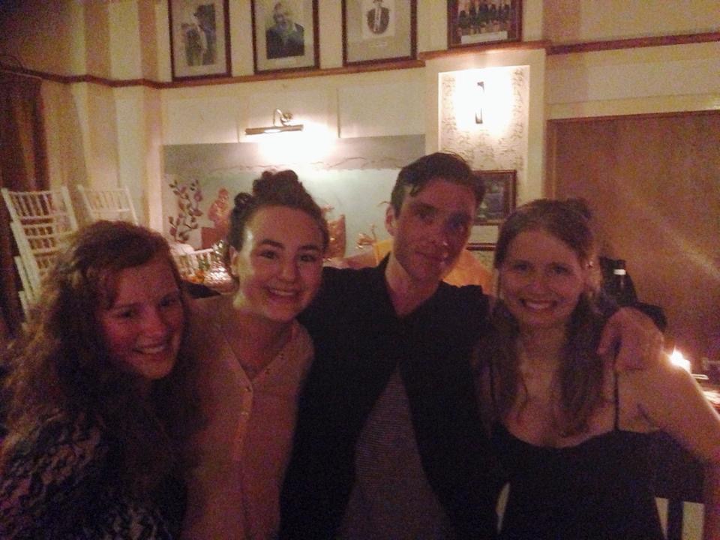
Photo caption: In a photo taken at the 2014 Galway International Arts Festival during the Princeton Global Seminar, to Ireland are (from left) Katie Reid, a student from National University of Ireland Galway, who participated in the Global Seminar; Princeton junior Nadia Diamond; actor Cillian Murphy, who originated roles in Enda Walsh’s Disco Pigs and Ballyturk; and Erin Valentine, the Princeton senior organizing the Contemporary Irish Theater Symposium.
Photo credit: Courtesy of Erin Valentine

What: Symposium on Contemporary Irish Theatre
Who: Organized by Princeton senior Erin Valentine, featuring panel discussions with Princeton students and faculty working on Irish theater projects
When: Saturday, February 27 from 1:00-5:00 p.m.
Where: Whitman College Theater on the Princeton campus

(Princeton, NJ) The Lewis Center for the Arts’ Program in Theater at Princeton University will present a symposium on contemporary Irish theater, organized by senior Erin Valentine, featuring panel discussions with students and faculty in the Program in Theater working on Irish theater projects on Saturday, February 27 from 1:00-5:00 p.m. in the Whitman College Theater on the Princeton campus. Panel discussions at the symposium will explore Ireland’s rich history of producing some of the most innovative theater of the past 100 years as context for what is happening in Irish theater today with a special focus on the work of Tony Award-winning Irish playwright Enda Walsh. The symposium is free and open to the public; no registration is required.

The symposium will include three panels. From 1:00 to 2:00 p.m., Valentine will discuss Irish theater history and how it differs from that of the U.S., the current state of contemporary Irish theater and why it is so well-regarded around the world. From 2:00 to 3:00 p.m., a panel discussion will be held with the student design team for the concurrently running Lewis Center production of Disco Pigs by Walsh (February 26-March 5) and Tony Award-nominated lighting designer, Princeton faculty member, and Dublin native Jane Cox. They will discuss the very insular, strange worlds of Walsh’s plays and how they employed design to both assemble and destroy the surroundings of the characters. From 3:15 to 4:15 p.m. a panel of students and faculty will discuss their exploration of Irish plays as American theater artists, also with a focus on Walsh’s work. A reception will follow.

Valentine is a senior from Houston, Texas majoring in sociology and pursuing a certificate in the Program in Theater. She has long had a passion for Ireland and the theater the country produces and organized this symposium as part of her senior thesis project in theater.

The summer before arriving at Princeton she spent a month traveling through Ireland with her mother. “I fell in love with Ireland the moment we stepped off the ferry, and it has continued to inspire me ever since,” says Valentine. She took four courses with Fintan O’Toole, a leading Irish theater critic and Princeton faculty member, ranging from a course on Modern Irish Theater to a criticism workshop to a course on the poetry of Seamus Heaney. In the summer after her sophomore year at Princeton she spent six weeks enrolled in a Global Seminar in Ireland with professors Stacy Wolf and Jill Dolan during which students studied a range of Irish theater and performance. The class attended a production of one of Walsh’s earliest plays, Disco Pigs, and the premiere of one of his most recent plays, Ballyturk. Global Seminars are six-week summer courses offered through Princeton’s Institute for International and Regional Studies.

“Theater is completely interwoven into the history and life of Ireland,” Valentine adds “ and you can feel that when you spend time in the country. The shows being done in Ireland have a fantastic energy to them—they are bitingly political without losing the heart and humanity of theatrical storytelling. Theater and Ireland are the two great passions of my life, so to be able to have my senior thesis combine these two things I love is absolutely amazing. It's the perfect culmination of the past four years of my Princeton theater experience.”

Valentine’s interests after graduating from Princeton in June include issues of social justice, particularly as advanced through theater, and political nation-building.

In conjunction with the symposium, the Lewis Center for the Arts will present a production of Walsh’s Disco Pigs, a play about two Irish teenagers whose intense, lifelong friendship is tried by growing older and growing different, on February 26-27 and March 4-5 at 8 p.m. and February 28 at 2 p.m., also in Whitman College Theater. The play is directed by Morgan Young, a senior thesis student in the Program in Theater, who also participated in the 2014 Global Seminar to Ireland.

For more information on this event, the Program in Theater, or the more than 100 public events offered each year at the Lewis Center for the Arts visit: arts.princeton.edu.

###

