February 25, 2016

Lewis Center for the Arts presents Ireland and Shakespeare Symposium
Centered on Irish versions and adaptations of Shakespeare’s plays, featuring leading Irish directors, actors, and critics

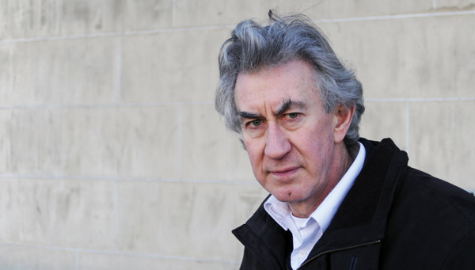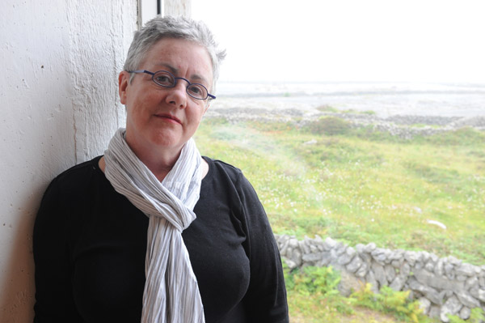
Photo caption: Actor Barry McGovern (left) and theater director Garry Hynes (right), two of several scholars, theater artists and critics who will present at the Ireland and Shakespeare Symposium on March 5 at Princeton
Photo credit 1: Courtesy of Barry McGovern
Photo credit 2: Robert Day

What: Ireland and Shakespeare, a symposium of debate and performance centered on Irish versions and adaptations of Shakespeare’s plays, featuring leading Irish directors, actors, and critics
Who: Scholars Mark Burnett, Bradin Cormack, Katherine Hennessey, and Patrick Lonergan; theater directors Garry Hynes, Conall Morrison, Lynne Parker and Robert Sandberg; actors Barry McGovern and Owen Roe; theater critic and Princeton professor Fintan O’Toole, and scholar and Princeton professor Clair Wills, co-organizer of the symposium with Hennessey.
When: March 5 from 9:15 a.m. to 5:30 p.m., with a pre-symposium lecture by James Shapiro, author of The Year of Lear: Shakespeare in 1606 on March 4 at 4:30 p.m.
Where: James M. Stewart ’32 Theater, Lewis Center for the Arts, 185 Nassau St., Princeton, NJ
Free and open to the public

(Princeton, NJ) The Lewis Center for the Arts and the Fund for Irish Studies at Princeton University will present Ireland and Shakespeare, a symposium of debate and performance centered on Irish versions and adaptations of Shakespeare’s plays and featuring leading Irish directors, actors, and critics, on Saturday, March 5 from 9:15 a.m. to 5:30 p.m. in the James M. Stewart ’32 Theater at 185 Nassau Street.

The day-long symposium will be preceded by a keynote lecture on Ireland and Shakespeare by James Shapiro, author of several books on Shakespeare, including the recent The Year of Lear: Shakespeare in 1606, on Friday, March 4 at 4:30 p.m. also at the James M. Stewart ’32 Theater. Shapiro will be introduced by Princeton’s Charles Barnwell Straut Class of 1923 Professor of English and Comparative Literature, Emeritus, Michael Wood.

All events are free and open to the public; no pre-registration is required.

Symposium participants include scholars Mark Burnett, Katherine Hennessey, and Patrick Lonergan; theater directors Garry Hynes, Conall Morrison, and Lynne Parker; actors Barry McGovern and Owen Roe; theater critic and Princeton lecturer Fintan O’Toole; Princeton professor of English Bradin Cormack; Robert Sandberg, acting director of the Program in Theater and professor of English and Theater at Princeton; and scholar and Princeton professor of English Clair Wills, co-organizer of the symposium with Hennessey and chair of Princeton’s Fund for Irish Studies.

Symposium sessions will include a practitioners roundtable titled “Staging Shakespeare in Ireland” moderated by O’Toole, followed by a screening of Mickey B, an adaptation of Shakespeare’s Macbeth set in an Irish maximum security prison, introduced by Burnett. Next, a critics panel titled “Debating Shakespeare in Ireland” moderated by Cormack will include three talks: “Shakespeare, Film, and Northern Ireland” by Burnett; “‘We don’t produce foreign playwrights’- Shakespeare on (and off) the contemporary Irish stage” by Lonegran; and “‘What’s Hecuba to him, or he to Hecuba?’ Irish and Global Shakespeares” by Hennessey. The symposium will conclude with “Performing Shakespeare in Ireland,” featuring recitations of Shakespearean monologues and reflections on Shakespearean passages by acclaimed Irish actors and directors, moderated by Sandberg.

The symposium is supported in part by Princeton’s David A. Gardner '69 Magic Fund.
To learn more about this event and the more than 100 other public events presented each year at the Lewis Center visit arts.princeton.edu.

###

Brief Symposium Participant Bios:

Mark Burnett is Professor of Renaissance Studies at Queen's University, Belfast and author of more than ten books on Shakespeare, Renaissance literature, and modern productions of Shakespeare’s plays.

Bradin Cormack is a professor in the English Department at Princeton University who studies early modern and Renaissance literature, with a focus on poetry and drama as they relate to law, the bookish disciplines, and intellectual culture more generally.

Katherine Hennessey is a Research Fellow with the Global Shakespeare program at the University of Warwick and Queen Mary University of London,. She researches Middle Eastern as well as Irish drama, and is the author of Shakespeare on the Arabian Peninsula (2016).

Garry Hynes is founding artistic director of Druid Theatre Company and served as artistic director of the Abbey Theatre in Dublin. She has worked with The Royal Shakespeare Company and The Royal Court (UK), and with Second Stage and Manhattan Theater Club in New York; with The Kennedy Center in Washington D.C; for Center Theater in Los Angeles and with the Spoleto Festival (USA). She was the first woman to win a Tony Award for direction in 1998 for The Beauty Queen of Leenane.

Patrick Lonergan is a Professor of Drama and Theatre Studies at National University of Ireland Galway. His research is on contemporary Irish drama, Shakespeare and Ireland, theatre and social media, and globalization and performance.

Barry McGovern is an actor who has appeared in eight productions of Shakespeare's plays. A former member of the RTE Players and the Abbey Theatre Company, in recent years he has mainly been associated with the Gate Theatre, especially their various Beckett productions. He has taught at the University of California at Davis and has spent the recent fall semester teaching at Notre Dame University.

Conall Morrison is a Dublin-based director and writer. Most recently, he directed La Traviata for the English National Opera and The Taming of The Shrew for the Royal Shakespeare Company.

Fintan O’Toole is a visiting lecturer in the Program in Theater at Princeton and one of Ireland’s leading public intellectuals. He has served as a drama critic for The Irish Times, New York Daily News, Sunday Tribune (Dublin), and In Dublin Magazine. His books on theater span a wide range of topics, from his biography of Richard Brinsley Sheridan to whatever is now appearing on Irish stages.

Lynne Parker is artistic director and co-founder of Rough Magic Theatre Company and an associate artist of Charabanc Theatre Company. Recent directorial projects include the world premiere of Hilary Fannin’s Famished Castle and The Train, a new musical by Arthur Riordan and Bill Whelan, both for Rough Magic, and Seamus Heaney’s Beowulf (Tron Theatre, Glasgow), Stewart Parker’s Northern Star and The Provok’d Wife by John Vanbrugh (The Lir Academy).

Owen Roe is an Irish actor last seen on stage as an aging Romeo in a re-imagining of Romeo & Juliet by Ben Power at The Project Theatre in Dublin. In addition to his stage work, he is currently appearing as Count Odo in the hit series, Vikings, and has been featured in an array of television and film productions.

Robert Sandberg is acting director of Princeton’s Program in Theater and a professor of English and Theater. He has been teaching playwriting, acting, and dramatic literature at Princeton since 1995 and received the President's Distinguished Teaching Award in 2014. His plays have been seen in Australia, Canada, England, Japan, Panama, and South Korea as well at theaters throughout the U.S.

James Shapiro is a professor of English and Comparative Literature at Columbia University, where he has taught since 1985. He is the author of several books on Shakespeare, most recently, The Year of Lear: Shakespeare in 1606 (2015). He is currently the Shakespeare Scholar in Residence at the Public Theater in New York City.

Clair Wills is the Leonard L. Milberg '53 Chair of Irish Letters, Chair of the Fund for Irish Studies and a Professor of English at Princeton. Her most recent book is The Best Are Leaving: Emigration and Post-War Irish Culture.

Michael Wood is a Professor of English and Comparative Literature at Princeton University. He is on the Advisory Committee for Princeton’s Fund for Irish Studies. His most recent book is Literature and the Taste of Knowledge.

###

