March 9, 2016

Lewis Center for the Arts’ Program in Creative Writing presents
A Reading by Salgado Maranhão
Award-winning Brazilian poet and his translator Alexis Levitin present poetry reading

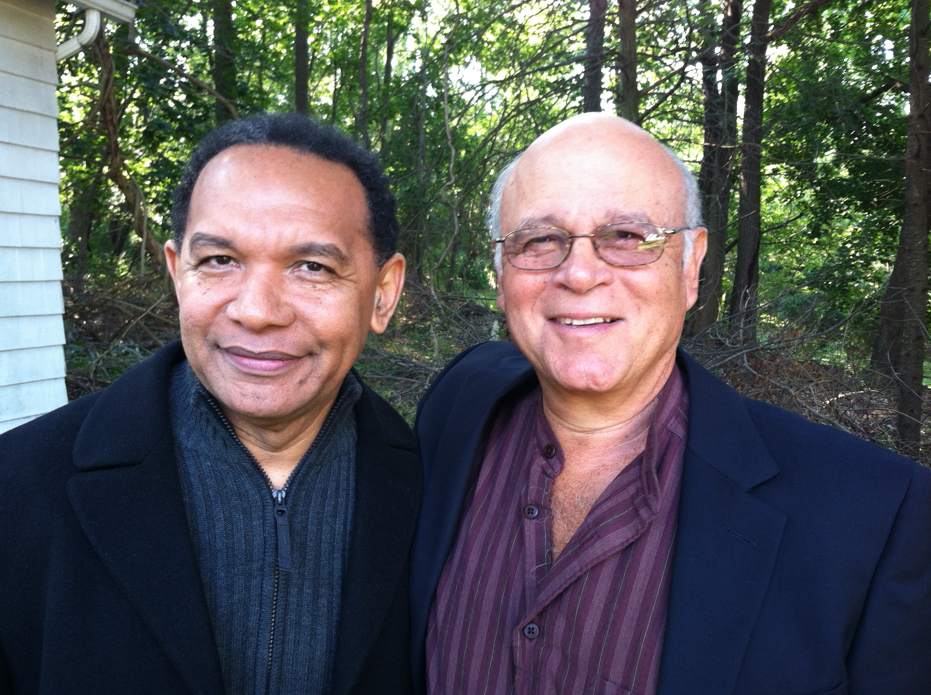
Photo caption: Salgado Maranhão (left) and his translator, Alexis Levitin, will read from Maranhão’s work on March 24 at Princeton University.
Photo credits: Photo by Nick Levitin

Who/What: Reading by poet Salgado Maranhão and his translator Alexis Levitin of Maranhão’s work in both Portuguese and English
When: Thursday, March 24 at 4:30 p.m.
Where: McCosh Hall, Room 28, on the Princeton University campus
Free and open to the public

(Princeton, NJ) On Thursday, March 24, Brazilian poet Salgado Maranhão will give a poetry reading together with his translator, Alexis Levitin. Maranhão’s poems will be read both in Portuguese and in English. The reading, beginning at 4:30 p.m. in Room 28 of McCosh Hall on the Princeton University campus, is free and open to the public. The reading is being presented by the Lewis Center for the Arts’ Program in Creative Writing, and cosponsored by the Department of Spanish and Portuguese and the Program in Translation and Intercultural Communication.

Salgado Maranhão, the author of ten books or poetry, rose from rural poverty to become one of the best-known poets of his generation in Brazil. Last August, the Union of Brazilian Writers honored him with its poetry award for his retrospective collection A cor da palavra. He has won every major literary award available in Brazil, including the Brazilian PEN Club prize (2014), the Brazilian Academy of Letters’ poetry prize (2011), and the Jabuti Award (1999), Brazil’s highest literary award. In the United States, his bilingual collection Blood of the Sun (Milkweed Editions, 2012) led to a 90-day reading tour that brought Maranhão to fifty-two universities; his second book for American audiences, Tiger Fur, was published last fall by White Pine Press.

Alexis Levitin has translated thirty-eight books, including Clarice Lispector’s Soulstorm and Eugenio de Andrade’s Forbidden Words (both from New Directions). Books published in 2015 include: 28 Portuguese Poets, translated with Richard Zenith, (Dedalus Press, Dublin, Ireland), Destruction in the Afternoon by Santiago Vizcaino (Dialogos Books, New Orleans), Exemplary Tales by Sophia de Mello Breyner Andresen (Tagus Press), and Maranhão’s Tiger Fur. He has been awarded three Fulbright Scholarships and two National Endowment for the Arts Translation Fellowships. He has held translation residencies at the Banff International Translation Center, The European Translators Collegium in Straelen, Germany, and the Rockefeller Foundation Study Center at Bellagio.

For more information on this event, the Program in Creative Writing, and the more than 100 other events annually offered by the Lewis Center for the Arts, most of them free, visit arts.princeton.edu.

###

