March 9, 2016
The Lewis Center for the Arts presents
Under Pressure
A Collaborative Senior Dance Thesis Concert
New works created by four seniors, a new work by Rebecca Lazier and repertory works by Martha Graham, Gustavo Ramírez Sansano and Karole Armitage

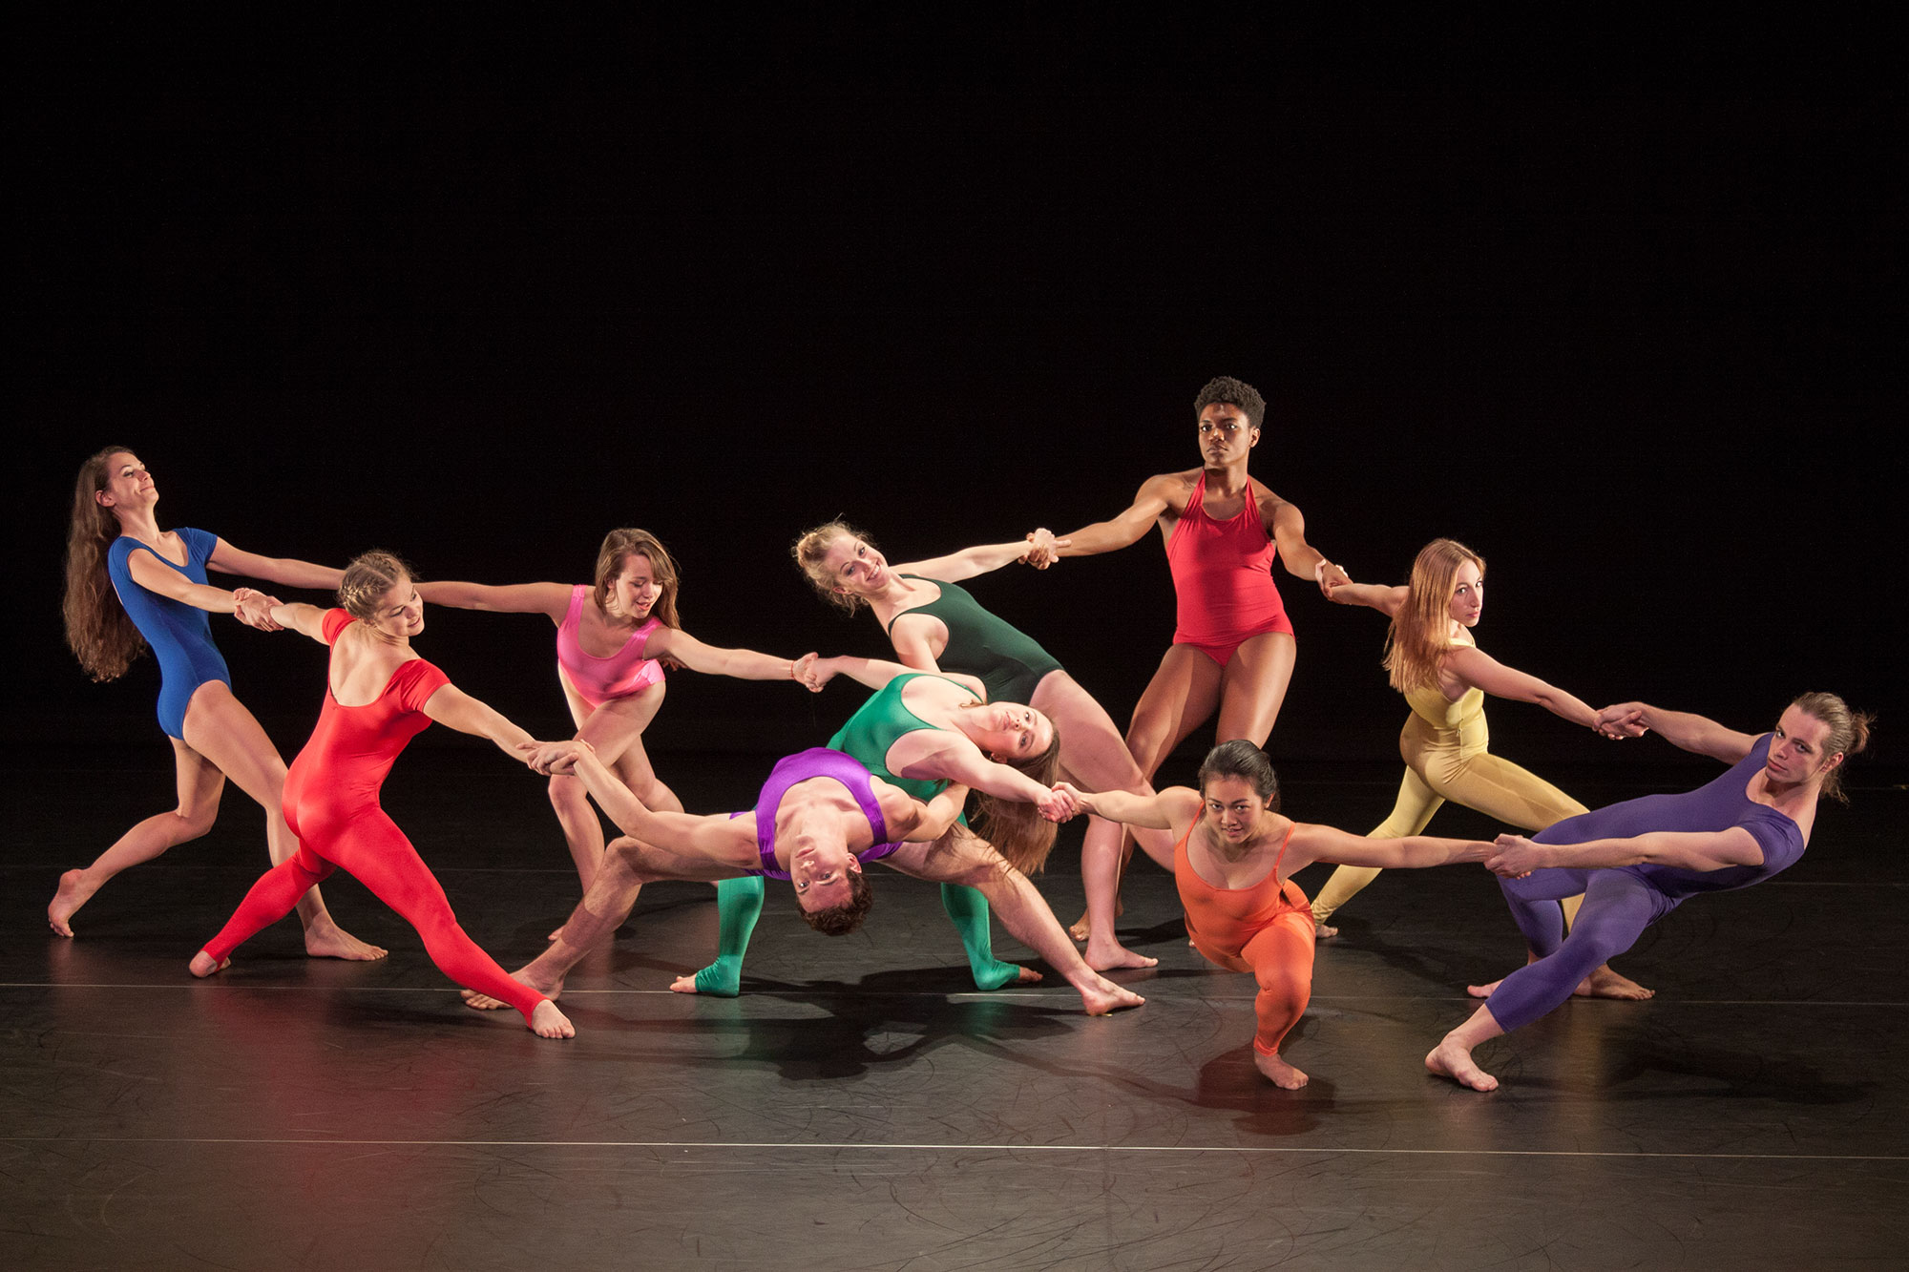
Photo caption: Seniors in Princeton’s Program in Dance, whose work and performances will be featured in the dance concert Under Pressure March 25 and 26.
Photo credit: Crystal Liu

What/Who: Under Pressure, a performance by Princeton Program in Dance students of four new works by seniors in the program, a new work by Rebecca Lazier, and repertory works by Martha Graham, Gustavo Ramírez Sansano and Karole Armitage.
When: March 25 at 8:00 p.m. and March 26 at 2:00 and 8:00 p.m.
Where: Berlind Theatre at McCarter Theatre Center
Tickets: In advance of show date — $12 general admission/$11 students and seniors; box office on days performances — $17 general admission/$15 students and seniors

(Princeton, NJ) The Lewis Center for the Arts’ Program in Dance at Princeton University will present Under Pressure, a collaborative senior dance thesis concert, on Friday, March 25 at 8:00 p.m. and Saturday, March 26 at 2:00 p.m. and 8:00 p.m. in the Berlind Theatre at McCarter Theatre Center. Students will perform works by acclaimed choreographers Martha Graham, Gustavo Ramírez Sansano, and Karole Armitage, a new work by faculty member Rebecca Lazier, and new works by seniors Sophie Andreassi, Kamber Hart, Bree White, and Glenna Yu.

The dance certificate program at Princeton requires students to undertake a rigorous course of study that can include courses in modern, contemporary, ballet, experimental, urban and African dance techniques, choreography, and dance theory and history, along with performance opportunities that include the annual Princeton Dance Festival. The dance certificate is in addition to a student’s major area of study. Under Pressure is an opportunity for seniors to collaborate on producing their own choreography and to work with professional choreographers and professional lighting and costume designers to bring their vision to life.

Kamber Hart, a senior psychology major, will perform a solo, “Lamentation,” by Martha Graham, staged by Denise Vale, senior artistic associate at Martha Graham Dance Company. “Lamentation” is a "dance of sorrow," as described by the legendary choreographer. “It is not the sorrow of a specific person, time or place, but the personification of grief itself.” The performance will feature live music, with Vince di Mura on piano.

"Toda Una Vida" (“A Full Life”), choreographed by Gustavo Ramírez Sansano, is a duet set to Maurice Ravel's composition Boléro. Praised as a "masterpiece" by the Chicago Sun Times, "Toda Una Vida" abstractly explores all the stages of an intimate relationship. Known for his intricate partnering, lightening speed and deep musicality, Sansano weaves an exciting story told through the execution of intense physicality. An exceprt from the piece, set by Nigel Campbell, will be performed by seniors Colby Hyland and Emily Wohl.

A solo from Ligeti Essays, choreographed by Karole Armitage, will be performed by senior Marisa Remez. The ballet is set to three song cycles by György Ligeti, on the poetry of fellow Hungarian, Sandor Weöres. In the songs that make up Ligeti Essays, Ligeti uses haiku-like compression to reveal different states of mind — from the sarcastic and humorous to the trivial or languorous. The solo presented in Under Pressure is titled “Kuli” (“Coolie”) and is scored for xylophone and three marimbas.

Work created by the seniors in the Dance Program includes “Disambiguation,” a duet choreographed by Kamber Hart. The piece was conceived as an exploration of movement specificity and difficulty without the grand and expansive athleticism that is traditionally valued. Working from hands as a common communicative tool and the primary mechanism for interaction with the world, this piece attempts to explore and conceptualize the multiple facets of control.

“coded.scripted.go,” a group piece choreographed by senior Glenna Yu began with conversations about ethics and empathy and later moved into conversations that asked the questions: What compels us to take the actions we do? Is it me, her, or this pinball machine I'm trapped in? When I talk to you, am I actually talking to you or am I just talking to myself?

Yu will also perform in a co-choreographed duet with senior Bree White entitled “Dunewalker.” This work began as an experiment to see what would emerge from the two students’ friendship in an artistic collaboration. As the work developed from their improvisations, they found that the piece became imbued with their experiences navigating their own and each other's beings.

“come to the park they say is dead” is a piece choreographed by senior Sophie Andreassi that considers the allure of ruins by way of the simultaneous historicity and timelessness of folk music. She cites a quote from Henri Lefebvre’s Introduction to Modernity as her inspiration: "With or without dignity, sumptuous or slovenly, in plush or in tatters, more and more brutal, more rapid, more noisy, the modern world marches on." The dancers will be joined by country-folk-rock singer Caroline Reese, Princeton Class of 2014, from Caroline Reese and the Drifting Fifth.

Each year the Program in Dance presents a work performed by all the seniors together. This year, the students will perform a unique, condensed version of a new work by faculty member Rebecca Lazier, There Might Be Others. The work is inspired by Terry Riley’s In C and builds on the tradition of open scores, where performers compose in real-time based on a predetermined array of content to stage negotiation. Lazier developed the score during residencies in Poland, Turkey, Canada, and New York. The music was composed by Princeton Department of Music faculty member Dan Trueman in collaboration with Sō Percussion, the Edward T. Cone Ensemble-in-Residence at Princeton, and Mobius Percussion. A company of professional dancers will premiere the full work at New York Live Arts March 16 through 19. Throughout the rehearsal process Princeton students have had the opportunity to rehearse with the professional dancers on campus and in New York City.

The Berlind Theatre is an accessible venue with access details available at www.mccarter.org [embed link:http://www.mccarter.org/VisitorInfo/VisitorDefault.aspx?page_id=32]. Assistive listening devices are available upon request when attending a performance. Patrons in need of other access accommodations are invited to contact the Lewis Center at 609.258.5262 or LewisCtr-Comm@princeton.edu for assistance at least two weeks prior to the selected performance.

Reserved seating tickets for Under Pressure are $12 ($11 for students and seniors) when purchased in advance, or $17 ($15 for students and seniors) on the day of performances. Tickets are available online through arts.princeton.edu, by calling the McCarter box office at 609-258-2787, at the Frist Campus Center Ticket Office, and at the door on the night of performances.

For more information on this event, the Program in Dance, or any of the more than 100 events presented annually by the Lewis Center for the Arts, visit arts.princeton.edu.

###

