April 28, 2016

Lewis Center for the Arts premieres I.M. LOST!, a show about clowns
A new, one-person, interactive play written and performed by senior Nathalie Ellis-Einhorn directed by senior Ogemdi Ude

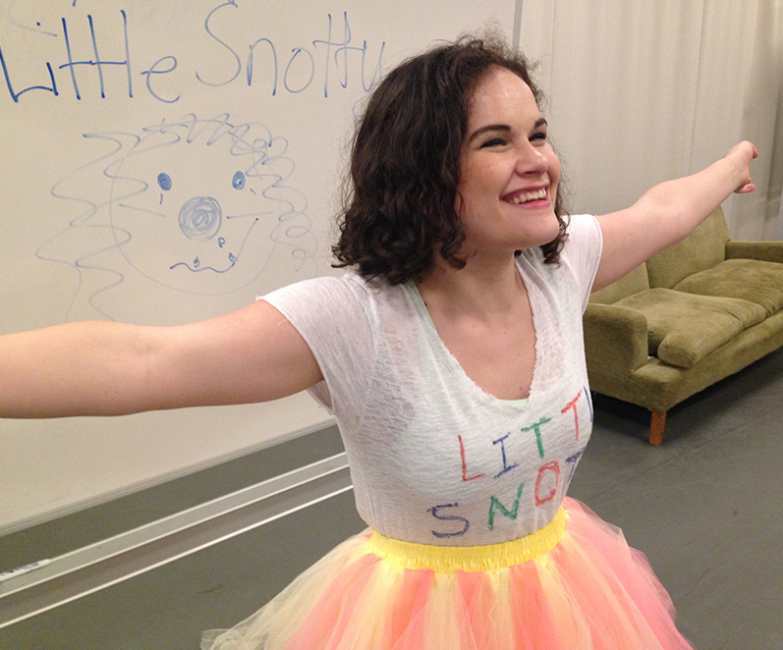
Photo caption: Senior Nathalie Ellis-Einhorn in rehearsal for I.M. LOST! the one-person, interactive play she wrote and will perform.
Photo credit: Photo by Nadia Diamond

What: I.M. LOST!, a show about clowns, a new interactive, one-person ethnographic play based on interviews with different types of clowns
Who: Presented by Lewis Center for the Arts’ Program in Theater, a senior thesis production written and performed by senior Nathalie Ellis-Einhorn and directed by senior Ogemdi Ude
When: May 5 and 6 at 8:00 p.m. and May 7 at 2:00 and 8:00 p.m. A talkback discussion led by Princeton Arts Fellow and playwright/theater artist Aaron Landsman follows the May 7, 2:00 p.m. performance
Where: Marie and Edward Matthews ’53 Acting Studio at 185 Nassau St., Princeton
Tickets: $12 general admission, $11 students and seniors in advance/$17 general admission, $15 students and seniors on the day of performances

(Princeton, NJ) The Lewis Center for the Arts’ Program in Theater at Princeton University will premiere I.M. LOST!, a show about clowns, an interactive, one-person, ethnographic play written and performed by senior Nathalie Ellis-Einhorn and directed by senior Ogemdi Ude. Performances will be held May 5 and 6 at 8:00 p.m. and May 7 at 2:00 and 8:00 p.m. at the Marie and Edward Matthews ’53 Acting Studio at 185 Nassau Street. A talkback discussion led by Princeton Arts Fellow and playwright/theater artist Aaron Landsman will follow the May 7 matinee performance.

I.M. LOST! is an interactive solo show based on interviews with different types of people who clown: birthday clowns, hospital clowns, actor clowns, clown teachers, even an astrophysics professor who enjoys going to clown classes. “Clowning is a performance form based on repeated failure,” notes Ellis-Einhorn. “We love the clown because they fail again and again but come back the next time with hope anyway.” The show will chart how each clown character, and Ellis-Einhorn herself, grapples with that inevitable failure. Audiences will be encouraged to actively participate in the performance through a variety of games. “And there will be balloons!,” adds Ellis-Einhorn.
Ellis-Einhorn is a senior from Hong Kong, majoring in English and pursuing certificates in theater and gender and sexuality studies. She began this project the fall of her junior year in Landsman’s “Ethnographic Playwriting” course, after spending a part of her previous summer at a clown class in London. The clowns she met in that class became her first interview subjects. She then received funding from the Lewis Center to spend the summer before her senior year training in clown and interviewing as many clowns from as many different backgrounds and traditions as possible.

In addition to Landsman’s influence and advice, Ellis-Einhorn took inspiration and guidance for this project from Lewis Center faculty member Stacy Wolf, who is her English Department adviser, and from a number of courses including “Body and Thought” co-taught by Tracy Bersley from the theater faculty and Susan Marshall from the dance faculty, and a course taught by Fintan O’Toole on Samuel Beckett, another clown enthusiast. Ellis-Einhorn has acted in many Lewis Center and undergraduate theater productions at Princeton, including Disco Pigs, Macbeth, The Other Shore, and Red Noses. She is also the outgoing vice president of the Princeton University Players, a student theater company on campus.

Ellis-Einhorn plans to pursue acting in New York City after graduating from Princeton with plans to later pursue a theater M.F.A.

Ude, who is directing the new work, is a senior from Stone Mountain, Georgia, majoring in English and pursuing certificates in theater and dance with a special interest in African American performance theory. She recently directed the premiere of a dance-theater work she created as her senior thesis in both programs, there.remaining., which explored W.E.B. Du Bois's theory of double consciousness as a racial and mental phenomenon. As a junior, Ude was awarded a grant from the Lewis Center’s Mallach Senior Thesis Fund to spend the summer researching representations of “double consciousness” in contemporary Black performance art, attending a summer intensive with the dance-theater company Witness Relocation, where she studied the creation of original work through devising methods. She also worked with and interviewed African American artists in Chicago, St. Louis, and New York to advance her understanding of their processes of creation in various disciplines, focusing most on theater, dance, and mixed media art.

As a recipient of the prestigious Daniel M. Sachs Class of 1960 Graduating Scholarship, Ude will spend next year as a Sachs Global Scholar studying indigenous Australian physical theater in Melbourne, Australia. Ude’s interest in indigenous Australian performance was sparked by her research on the Black performance tradition, noting how both Black Americans and Indigenous Australians in the 1960s and 1970s used theater to express their political struggles. "Ultimately,” says Ude, “my goal is to advance theater's role in challenging sociopolitical oppression."

Ude accepted Ellis-Einhorn’s invitation to direct I.M. LOST! noting the opportunity to direct both comedy and a one-person show, two experiences she has not yet had.

The production is being designed by junior Sydney Becker with sound design by freshman Zara Jayant and stage management by junior Nadia Diamond, assisted by junior David Cruikshank.

Tickets for I.M. LOST! are $12 general admission and $11 for students and seniors when purchased in advance, and $17 general admission and $15 for students and seniors purchased the day of performances at the box office. Tickets are available through the University Ticketing, which offers flexibility for online ordering and print-at-home tickets. To purchase tickets online visit arts.princeton.edu/imlost, call Princeton University Ticketing at 609-258-9229, or stop by the Frist Campus Center Ticket Office. Tickets will also be available at the door prior to performances.

The Lewis Center’s Program in Theater annually presents a major, professionally produced play, as well as a number of senior thesis productions throughout the year. The 2016-17 season will be announced shortly and will include an eclectic mix of classics, contemporary work, original plays, solo performances, and musicals.

To learn more about this event, the Program in Theater, and the over 100 other activities presented at the Lewis Center visit arts.princeton.edu.

###

