April 22, 2016
“Princeton Arts Fellows Present…”

A sharing of recent work by current Princeton Arts Fellows Aaron Landsman, Hanna Pylväinen, Pacho Velez and Pavel Zuštiak

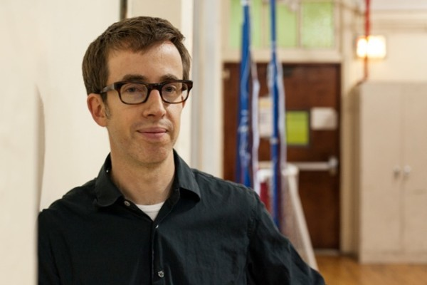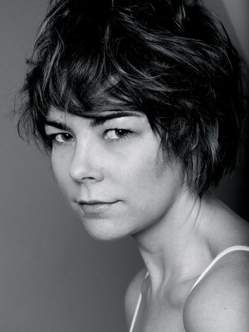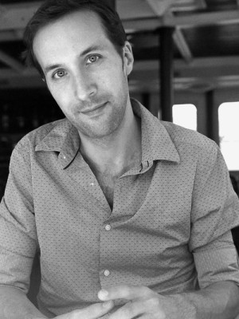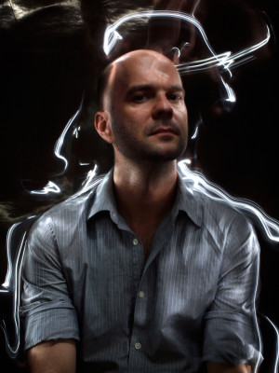
Photo caption/credits: Princeton Arts Fellows (left to right) Aaron Landsman (photo by David A. Brown), Hanna Pylväinen (courtesy Hanna Pylväinen), Pacho Velez, (courtesy Pacho Velez), and Pavel Zuštiak (photo by Robert Flynt)

Who: Princeton Arts Fellows – playwright and theater artist Aaron Landsman, fiction writer Hanna Pylväinen, filmmaker Pacho Velez, and choreographer Pavel Zuštiak
What: Presenting recent work and works-in-progress
When: April 25 at 7:00 p.m. with artists’ reception following
Where: Marie and Edward Matthews ’53 Acting Studio and James M. Stewart ’32 Theater at 185 Nassau Street
Free and open to the public

(Princeton, NJ) Princeton University’s current Arts Fellows will gather together for “Princeton Arts Fellows Present…,” a joint showing of new and developing work by these four innovative and diverse artists, in the Marie and Edward Matthews ’53 Acting Studio and James M. Stewart ’32 Theater at 185 Nassau Street on April 25 at 7:00 p.m. This event, which will feature performances, a reading, screening and presentations by playwright and theater artist Aaron Landsman, fiction writer Hanna Pylväinen, filmmaker Pacho Velez and choreographer Pavel Zuštiak, is free and open to the public.

Funded in part by the Mellon Foundation, Fellows are selected for a two-year residency to teach one course each semester or, in lieu of a course, to undertake an artistic assignment that deeply engages undergraduate students, such as directing a play, conducting a music ensemble, or choreographing a dance piece. Fellows are expected to be active members of the University's intellectual and artistic community while in residence; in return, they are provided the resources and spaces necessary to do their work.

Landsman will share excerpts from his upcoming work Perfect City, a multivalent artwork about cities, access, and complicity. Pylväinen will read an excerpt from her current novel-in-process. Velez will screen a segment of his current film project, The Reagan Years, and Zuštiak will perform a brief excerpt from recent work.

Landsman, concluding his final year as a Fellow, makes performances that are staged in homes, offices, theaters, buses and other locations. Two projects he developed during his fellowship and workshopped at Princeton are currently receiving their New York City premiere. Empathy School and Love Story, both monologues with video and original music, written and directed by Landsman, are being performed at Abrons Arts Center in New York through April 30. His recent work City Council Meeting, created in collaboration with director Mallory Catlett and designer Jim Findlay, has been presented in New York, Tempe and Houston, San Francisco and Keene, New Hampshire. His previous work has been commissioned and produced by The Foundry Theatre and PS122 in New York, DiverseWorks in Houston, and KulturaNova in Novi Sad, Serbia. Landsman has also worked as an actor with Elevator Repair Service Theater, Julia Jarcho, Richard Maxwell, Tory Vazquez and Deke Weaver, among other artists. Over the past two years at Princeton, he has also taught courses in ethnographic playwriting, artist entrepreneurship, and creating collaborative theater.
Pylväinen, also completing her final year as a Fellow, graduated from Mount Holyoke College and received her M.F.A. from the University of Michigan, where she was also a postgraduate Zell Fellow. She is the recipient of residencies at Djerassi, The MacDowell Colony and Yaddo, and a fellowship at the Fine Arts Work Center in Provincetown, Massachusetts. Her first novel, We Sinners, was published by Henry Holt in 2012. She is the recipient of the 2012 Whiting Writers' Award and the 2013 Balcones Fiction Prize. Her work has appeared in Harper's Magazine, The New York Times, The New York Times Magazine, The Wall Street Journal, and Chicago Tribune. Currently, she lives in Brooklyn, where she is completing her second novel, The End of Drum Time. At Princeton, Pylväinen has been teaching fiction writing workshops.
Zuštiak is a director, choreographer, performer, and founder/artistic director of the New York City-based performance group Palissimo Company. Born in Czechoslovakia, he trained at the School for New Dance Development in Amsterdam. His work merges the abstract aspects of dance with nonlinear qualities of “theater of images” and cinematic mise-en-scène. Themes explored in Zuštiak’s work include sensory deprivation (Blind Spot, 2003), gluttony and obsession (Itch in the Stitch, 2007), death and sex (Le Petit Mort, 2007), and joy and terror (Weddings and Beheadings, 2009). One of the recurring motives in many of his projects is the interplay between performers and audiences. His five-hour trilogy The Painted Bird, inspired by Jerzy Kosiński’s novel, received a 2013 Bessie Award nomination for Outstanding Production. Zuštiak’s work has been presented in the U.S. at Wexner Center for the Arts, Performance Space 122, Baryshnikov Arts Center, Abrons Arts Center, Legion Arts, Performance Art Dance Lab (PADL) West, and internationally at Archa Theatre (Czech Republic), Bratislava in Movement dance festival, Slovak National Theatre, Bytom International Dance Festival (Poland), and KioSK Festival and State Theatre Kosice (both in Slovakia). His most recent work was co-commissioned by New York Live Arts, Walker Arts Center, and Legion Arts. Zuštiak has been an artist in residence at the Grotowski Institute in Poland, Stanica in Slovakia, Lower Manhattan Cultural Council, Abrons Art Center, Vermont Performance Lab, and Maggie Allesee National Choreographic Center. He is the winner of three Princess Grace Awards and is a recipient of 2013 Lower Manhattan Cultural Council President's Award for Excellence in Artistic Practice, a 2012 New England Foundation for the Arts/National Dance Project Award, and a 2010 Guggenheim Fellowship. He is currently teaching “Dance Appreciation: Seeing Dance in New York City/Articulating the Elusive,” and last fall taught “Special Topics in Contemporary Practice — Idea, Concept, Context: Making Performance Fast.”
Velez is a filmmaker who works at the intersection of ethnography, contemporary art, and political documentary. His current project, The Reagan Years, explores a prolific actor’s defining role: Leader of the Free World. Velez’s previous film, Manakamana, was screened at Princeton last October and won a Golden Leopard Award at the Locarno Film Festival. It played around the world, including at the Whitney Biennial and the Toronto International Film Festival. His earlier film and theater work has been presented at venues such as the Edinburgh Fringe Festival, the Museum of Ethnography in Stockholm, and on Japanese National Television. Last fall he taught a course on documentary filmmaking and this current semester is teaching a course, “World on a Wire: 12 Films, 12 Filmmakers,” in which he has invited 12 contemporary filmmakers to screen and discuss their recent films, screenings that were opened to the public.

As Landsman and Pylväinen conclude their tenure as Fellows in June, Velez and Zuštiak will begin their second year joined by recently announced 2016-18 Arts Fellows, composer Shawn Jaeger, filmmaker Afia Serena Nathaniel, and writer Rebekah Rutkoff.

The application cycle for the 2017-19 round of Fellows will begin in July with a submission deadline in mid-September.

To learn more about the Arts Fellows and the Lewis Center for the Arts, including the more than 100 public events offered each year, visit arts.princeton.edu.

###

