October 3, 2016

Lewis Center for the Arts presents
“Curtain Up: Celebrating Music Theater at Princeton”
Day-long symposium marks the launch of Princeton’s new Program in Music Theater

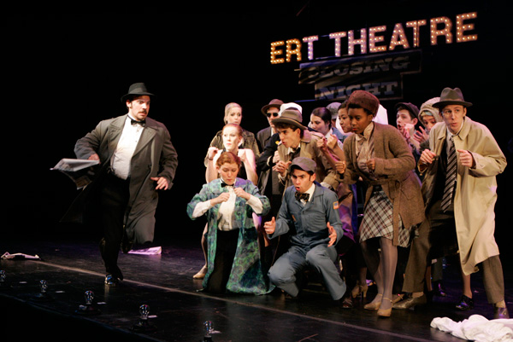
Photo caption: Photo from a 2015 Lewis Center for the Arts production of “The Producers”
Photo credit: Frank Wojciechowski

What: Princeton University’s Lewis Center for the Arts and the Department of Music celebrate the launch of a new Program in Music Theater with a day-long symposium, "Curtain Up: Celebrating Music Theater at Princeton.”
Who: Princeton alumni, faculty, and students who are singers, actors, directors, writers, composers, producers, musicians, choreographers, designers, dramaturgs, and theater historians with a keynote conversation with Broadway producer and president of Jujamcyn Theaters Jordan Roth '97. The symposium is organized by a committee of faculty, alumni, students, and staff, led by Professor of Theater Stacy Wolf, Director of the new Program in Music Theater.
When: October 8, 2016, 10 a.m.-5 p.m.
Where: James M. Stewart ’32 Theater, Lewis Center for the Arts, 185 Nassau St.
Free and open to the public but reservations are encouraged arts.princeton.edu/curtainup

(Princeton, NJ) Princeton University’s Lewis Center for the Arts and the Department of Music will mark the launch of a new Program in Music Theater with a day-long symposium on Princeton’s music theater past, present and future on Saturday, October 8 from 10 a.m. to 5 p.m. in the James M. Stewart ’32 Theater at 185 Nassau Street. The event is free and open to the public, however advance reservations are encouraged at arts.princeton.edu/curtainup.

Princeton alumni, faculty and students—singers, actors, dancers, scholars, and composers who are making their creative marks on the opera world and on and off Broadway—will come together to participate in a series of panels on the art form and its importance at Princeton and beyond. The symposium is organized by a committee of Princeton faculty, alumni, students, and staff, led by Princeton Professor of Theater Stacy Wolf, who directs the new Program in Music Theater.

The symposium will kick off at 10 a.m. with a brief welcome by Lewis Center Chair Michael Cadden, Director of Choral Activities and Senior Lecturer in Music Gabriel Crouch, and Deputy Dean of the College Elizabeth Colagiuri, followed by a panel on the rich history of music theater at Princeton. Current and past music theater student moderators will be in conversation with notable arts alumni, including Broadway actor Paul Anthony Stewart ’89, theater manager Kelvin Dinkins, Jr. ’09, actor/writer Catherine Cohen ’13, arts administrator Izzy Kasdin ’14, and Program in Theater faculty member and professional director Ethan Heard, whose credits as an opera director include the Princeton University Opera Theater’s performance of Claudio Monteverdi’s L’incoronazione di Poppea.

At 11 a.m., a panel entitled “Why Music Theater” will address the experiences, inspirations and motivations of those who are pursuing a career in music theater writing or composing, as well as the larger question of why it matters that we write music theater. The panel will feature composer and lyricist Pete Mills ’95, director and writer Cara Reichel ’96, who are the founding members of the Prospect Theatre Company; visiting Lecturer in Theater Robert Lee ’92; and recent alumna and composer Sam Kaseta ’15. The panel will begin with a short performance of an original piece by Kaseta.

At noon, the symposium will feature an interview with Jordan Roth ’97 by Wolf followed by questions from the audience. Roth, who graduated summa cum laude and Phi Beta Kappa from Princeton University with a degree in philosophy and a certificate in theatre, is one of the most influential figures in today’s theater world. As the president and majority owner of Jujamcyn Theaters in New York City, Roth is in charge of the Broadway venues that have been home to Tony Award-winning and box-office-busting productions such as Book of Mormon, Kinky Boots, Something Rotten!, Jersey Boys and, most recently, The Crucible. Roth also produced the Pulitzer Prize and Tony Award-winning Best Play Clybourne Park. He recently appeared in a recurring role on the hit television show Smash and is featured regularly on national news channels such as the “Broadway Correspondent.”
The symposium will continue in the afternoon with a master class on “Vocal Styles in Music Theater” from 2 to 3 p.m. Soprano Martha Elliot, a member of the Program in Musical Performance’s faculty in the Department of Music who has sung in numerous opera performances at Princeton, will lead students in a demonstration and discussion on the nuances of singing in a wide range of music theater genres.

At 3 p.m., the symposium will feature a panel on collaboration and design in music theater. Addressing the creative challenges and rewards of designing the technical elements of music theater productions, the panel will feature award-winning lighting designer and Director of the Program in Theater Jane Cox, who recently designed the lighting for the Broadway revival of The Color Purple; faculty member and set/costume designer Anya Klepikov; and recent technical artist alums Alex Mannix ’12 and Wesley Cornwell ’16.

The final panel, which will begin at 4 p.m., will be a discussion about choreography, directing, and collaboration in music theater both on Princeton’s stages and beyond. The panel will feature both professional and student choreographers and performers, including Marlo Hunter ’99, Whitney Mosery ’08, Adam Hyndman ’12, Adin Walker ’16, and a presentation about the history of Broadway choreography by Emily Libresco ’17.

A reception at 5 p.m. will cap off the day.

Princeton has a long history of academic pursuit of music theater through the Program in Theater and the Department of Music and through student groups such as the legendary Triangle Club and the more recent Princeton University Players. Student interest in the field and a growing roster of Princeton alumni who are working in the industry led to the creation of the separate new certificate program in music theater, which is a collaboration among the Lewis Center’s Programs in Theater and Dance and the Department of Music. The new program brings together students, faculty, and guest artists in the creation, study, and performance of music theater, including Broadway musicals, musical comedy, cabaret, music hall, experimental music theater, ballet, and all kinds of opera — essentially any theatrical form that combines singing, acting, and movement — as both an artistic practice and a field of scholarly study.

Wolf teaches courses in American musical theatre history, dramaturgy and dramatic literature, histories of U.S. performance, performance theory, and performance studies. She is the author of Changed for Good: A Feminist History of the Broadway Musical (recently named one of the “top ten books every theater lover should read” by Marissa Friedman); A Problem Like Maria: Gender and Sexuality in the American Musical; and the co-editor of The Oxford Handbook of the American Musical. Wolf is also director of the Princeton Arts Fellows program in the Lewis Center.

For additional information on the symposium and to register visit arts.princeton.edu/curtainup.

For more information on the new Program in Music Theater and the more than 100 public events offered each year at the Lewis Center for the Arts visit arts.princeton.edu. Department of Music events can be viewed at music.princeton.edu.

###

