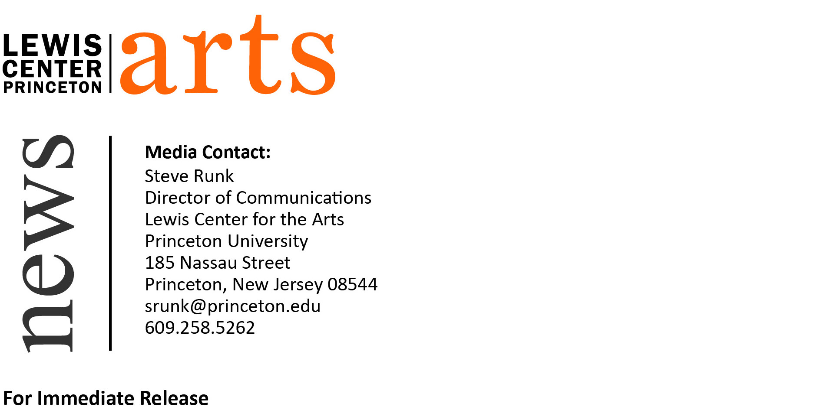

December 9, 2016

Lewis Center for the Arts presents Reading of New Work by
Students in the Creative Writing Program

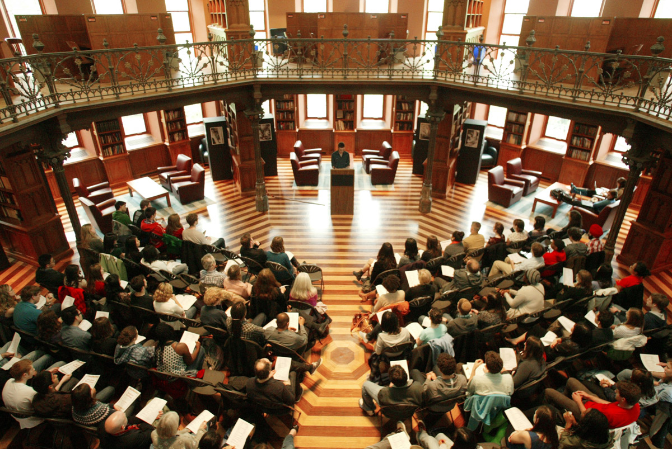
Photo caption: A recent student reading presented by the Program in Creative Writing
Photo credit: Frank Wojciechowski

What: Student Readings - Althea Ward Clark W’21 Reading Series
Who: Students in the Lewis Center for the Arts’ Program in Creative Writing read from new work in fiction, poetry, screenwriting and literary translation written during the fall semester
When: Wednesday, December 14 at 5:00 p.m.
Where: Chancellor Green Rotunda on the Princeton University campus
Free and open to the public

(Princeton, NJ) Students in the Lewis Center for the Arts’ renowned Program in Creative Writing will read from their recent work as part of the Program’s Althea Ward Clark W’21 Reading Series. The reading will take place on Wednesday, December 14 at 5:00 p.m. in the Chancellor Green Rotunda on the Princeton University campus. The event is free and open to the public.

Students will read from new works of fiction, poetry, screenwriting, and literary translation written during the past semester as part of the fall creative writing workshops.

“The student reading is always one of the highlights of the semester,” notes Tracy K. Smith, Director of the Program in Creative Writing. “It’s a rare opportunity to observe what’s been happening in the workshops, and to celebrate the broad range of student voices.”

Through the Program, students can earn a certificate in creative writing in addition to their degree in a major. They have the opportunity to pursue original work in fiction, poetry, screenwriting and translation under the guidance of practicing, award-winning authors, including faculty members Jeffrey Eugenides, Jhumpa Lahiri, Paul Muldoon, Kirstin Valdez Quade, James Richardson, Tracy K. Smith, Susan Wheeler, Edmund White, and a number of distinguished lecturers.

The small workshop courses offered by the Program are limited in enrollment to ten students to ensure the benefits of working closely with faculty. Workshops meet for up to three hours weekly and are devoted primarily to discussion of student work. Each year, 15 to 20 seniors also work individually with a member of the faculty on a creative thesis, such as a novel, a screenplay, or a collection of short stories, poems, or translations.

Alumni of the Program include such well-known writers as Jonathan Ames ’87, Jonathan Safran Foer ’99, Jane Hirshfield ’73 and Monica Youn ’93, who is currently teaching in the program.

The Althea Ward Clark W’21 Reading Series annually brings a number of distinguished writers to campus to read and discuss their work. Writers reading in the coming months include Paul Beatty and Marilyn Chin on February 8, Douglas Kearney and Kirstin Valdez Quade on March 15, and John Ashbery and Jim Jarmusch on April 19. All readings are free and open to the public.

To learn more about the Program in Creative Writing, the reading series, and the more than 100 public events offered annually by the Lewis Center for the Arts visit arts.princeton.edu.

###

