December 22, 2016

The Lewis Center for the Arts’ Program in Theater presents
Mad Forest by Caryl Churchill
A senior thesis show designed by Sydney Becker and directed by junior Nico Krell at Princeton University

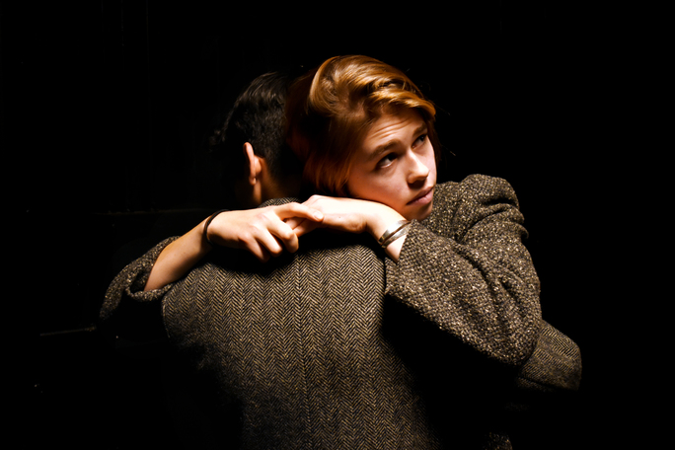
Photo caption: Junior Emma Watkins and sophomore Marcelo Jaimes-Lukes in rehearsal for Mad Forest, with set and lighting design by senior Sydney Becker, directed by junior Nico Krell
Photo credit: Sydney Becker

What: Mad Forest by Caryl Churchill, a drama in which two families witness the collapse of their entire way of life. When rebellion brings down a dictator, what is left in the void? How will you use your freedom? Based on ethnographic research, Mad Forest provides a personal look into the exceptionally brief events of the Romanian Revolution.
Who: Presented by Lewis Center for the Arts’ Program in Theater, designed by senior Sydney Becker and directed by junior Nico Krell
When: January 12, 13 and 15 at 8 p.m. and January 14 at 2 p.m. and 8 p.m. Talkback following the January 12 performance.
Where: Marie and Edward Matthews ’53 Acting Studio at 185 Nassau St. in Princeton
Tickets: In advance of show date — $12 general admission/$11 students and seniors; box office on days of performances — $17 general admission/$15 students and seniors

(Princeton, NJ) The Lewis Center for the Arts’ Program in Theater at Princeton University will present Mad Forest by Caryl Churchill, with set and lighting design by senior Sydney Becker and directed by junior Nico Krell, on January 12, 13 and 15 at 8 p.m. and January 14 at 2 p.m. and 8 p.m. Performances will take place in the Marie and Edward Matthews ’53 Acting Studio located at 185 Nassau Street. A talkback discussion with Associate Professor of English Tamsen Wolff will follow the January 12 performance.

Mad Forest offers a personal look into the events of the 1989 Romanian Revolution as two families witness the radical collapse of their entire way of life. The play’s three acts occur shortly before, during, and shortly after the Revolution. Through these personal stories the play paints an incisive portrait of a society in turmoil to reveal what life is like under a totalitarian regime and what results when that regime is gone. When rebellion brings down a dictator, the characters are left to grapple with what is left in the void and how they will use their newfound freedom.

Churchill, an already well-established playwright at the time, was commissioned in March 1990 by London’s Central School of Speech and Drama to travel to Bucharest with director Mark Wing-Davey and 10 students to conducted ethnographic research for a play about the Revolution, just three months after the fall of the Communist leader Nicolae Ceauşescu. The team stayed with Romanian drama students and their families, and worked with them to develop the new work. Within two months of their return to England the play premiered to critical acclaim. Mad Forest received its New York City premiere in November 1991 at the Perry Street Theatre. The play’s title alludes to a passage in A Concise History of Romania by Andrei Oţetea and Andrew MacKenzie that explains that Bucharest stands on land that was once a forest "impenetrable by the foreigner who did not know the paths," known to "the horsemen of the steppe" as “Teleorman - Mad Forest."

Becker, an anthropology major from Margate, New Jersey, pursuing a certificate in theater with a focus on theatrical design, chose Mad Forest as her senior thesis based on the challenges it poses to a designer. “The play takes place in a wide range of locations and explores an often blurred line between the real and the supernatural,” explains Becker. “The challenge to transport the audience along with the characters through time and to these different places while keeping the story clear was thrilling to me. Mad Forest is such a visually rich piece of theater, and I wanted to explore that.” The plays origins in ethnography – the study of people and cultures from the point of view of the subjects of study – also drew Becker, as it relates to her studies in anthropology. She serves as dramaturg on Mad Forest as well as designer, exploring the show within the rehearsal room as well as through design.

Becker had an interest in theatrical design when she arrived at Princeton and designed last year’s Lewis Center productions of Cloud 9 (another play by Churchhill) and The Seagull, and The Basic Training of Pavlo Hummel and How I Learned to Drive the year prior. In addition to her work in the Program in Theater, she has also designed over 40 productions for various student theater groups on campus. She has taken Lewis Center courses in lighting design, sound design, and the advanced course, “Theatrical Design Studio,” as well as its predecessor, “Advanced Theatrical Design.” She plans to pursue a career in theatrical design after graduation.

As Becker was considering a Churchill play for her thesis, Krell suggested Mad Forest. The play had been recommended to Krell as a good challenge for a director by the late Tim Vasen, previous director of the Program in Theater. “Ultimately, I see Mad Forest as a play about freedom,” notes Krell.

Krell is an independent concentrator from California creating a major in performance studies. He directed shows in high school and has directed and performed with a number of Princeton student theater groups, including an original immersive theater piece with Theatre Intime last year, which he credits for solidifying his interest in directing for the audience perspective. Krell also notes the influence of a directing workshop with Vasen, a Princeton Atelier course last year with a graphic novelist and dance theater artist to collaborate on creating an immersive theater work, and a number of courses with Broadway director John Doyle including “The Nature of Theatrical Reinvention” and an Atelier course taught by Doyle based on the director’s new adaptation of Ibsen’s Peer Gynt. He will propose his senior thesis project for next year this spring.

The cast of Princeton undergraduates includes Evan Gedrich ’18, Chase Hommeyer ’19, Marcelo Jaimes-Lukes ’19, Abby Melick ’17, Michelle Navis ’17, Luke Soucy ’19, Alex Vogelsang ’18, Emma Watkins ’18, Eric Yang ’17, and Anna Zabel ’19. Other students involved with the production include Megan Berry ’19 assisting with lighting design and Jake Schade ’17 serving as stage manager. Professional designers Sarita Fellows and Pornchanok Kanchanabanca are costume designer and sound designer, respectively. Faculty member and theater director Elena Araoz is serving as directing advisor and Jane Cox, lighting designer and director of the Program in Theater, and set/costume designer and faculty member Anya Klepikov are serving as design advisors for the production.

Tickets for Mad Forest are $12 general admission and $11 for students and seniors when purchased in advance, and $17 general admission and $15 for students and seniors when purchased the day of performances at the box office. Tickets are available through University Ticketing, which offers online ordering and print-at-home tickets. To purchase tickets online visit arts.princeton.edu/madforest or call Princeton University Ticketing at 609.258.9220, or stop by the Frist Campus Center Ticket Office. Tickets will also be available at the door prior to performances.

To learn more about this event, the Program in Theater, and the more than 100 other activities presented at the Lewis Center, visit arts.princeton.edu.

###

