December 21, 2017

The Lewis Center for the Arts’ Program in Theater presents
Letters and Dreams, a new play by senior Fiona Bell
A senior thesis exploration of two female Russian poets

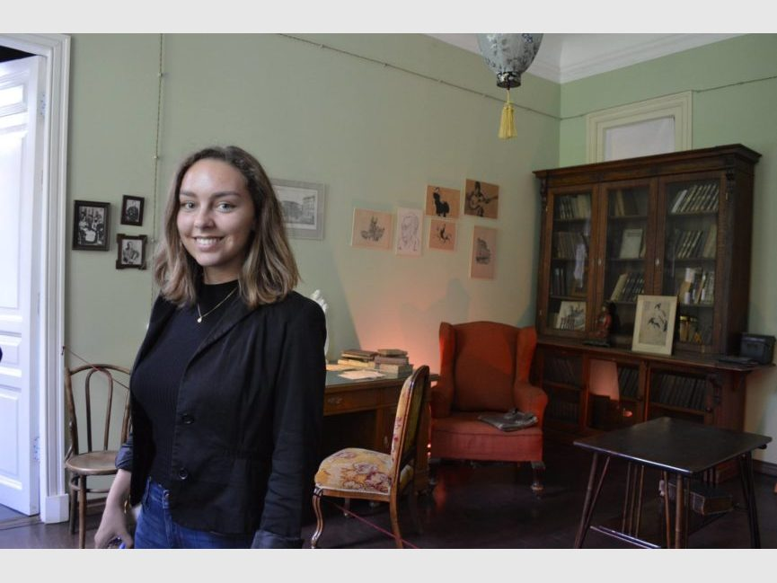

Photo caption 1: Junior Julia Mosby and senior Fiona Bell, who also wrote the new play Letters and Dreams, are featured as two Russian poets whose friendship evolves through a series of poems, letters and dreams
Photo credit: Justin Goldberg
Photo caption 2: Senior Fiona Bell at the Apartment Museum of Russian poet Anna Akhmatova in St. Petersburg, where she conducted some of the research for her new play
Photo credit 2: Courtesy of Fiona Bell

What: Letters and Dreams, a new play that explores the friendship between Russian poets Anna Akhmatova and Marina Tsvetaeva, told through a series of poems, letters and dreams.
Who: Presented by Lewis Center for the Arts’ Program in Theater, written by and featuring senior Fiona Bell and directed by junior Jhor van der Horst.
When: January 11 & 13 at 8 p.m., January 12 at 4:30 p.m., and January 14 at 1 p.m. A talkback follows the January 12 performance.
Where: Class of 1970 Theater at Whitman College on the Princeton campus
Free and open to the public, with advance tickets available at http://arts.princeton.edu/events/letters-and-dreams/2018-01-11/ and at the door the dates of performances.

(Princeton, NJ) The Lewis Center for the Arts’ Program in Theater at Princeton University will present an exploration of a new play, Letters and Dreams, written by and featuring senior Fiona Bell, on January 11 and 13 at 8:00 p.m., January 12 at 4:30 p.m., and January 14 at 1:00 p.m. in the Class of 1970 Theatre at Whitman College on the Princeton campus. An audience talkback will follow the January 12 performance. The show is free and open to the public with tickets available in advance and at the door just prior to performances.

Letters and Dreams tells the story of two actual female Russian poets, Anna Akhmatova and Marina Tsvetaeva, who began their careers performing in the cafés of Imperial Russia. As the 20th century unfolds, their relationship evolved through a series of letters, poems and dreams against the backdrop of an increasingly precarious political climate for artists. Through intensive research on the lives and work of these two poets and an imagining of an actual meeting that once happened between the two women in Moscow in 1941, Bell has woven a compelling exploration of a lifelong friendship.

Bell is majoring in the Department of Slavic Languages and Literatures at Princeton and pursuing a certificate in the Program in Theater. Her new play combines both of these areas and is the focus of her senior thesis in theater. Her senior thesis in the Department of Slavic Languages and Literatures, under advisor Olga Hasty, treats Tsvetaeva’s experience of emigration. Bell discovered these two poets through Russian literature courses at Princeton. She began exploring theater as a freshman by joining the L’Avant Scène French theater troupe. As a junior, she became more interested in acting during a course on Anton Chekhov taught by R.N. Sandberg in the Program in Theater, which required students to perform work by the Russian playwright. Sandberg has served as her playwriting advisor for Letters and Dreams. She also spent two semesters studying creative translation with Jhumpa Lahiri in the Program in Creative Writing, during which she focused on translating the poetry of Akhmatova and Tsvetaeva. In summer 2017 she visited locations in Russia that figured in the lives of these two women, funded through the Princeton Institute for International and Regional Studies.

In writing the play over the past year, Bell sought to both bring these two Russian female poets to the attention of American audiences and to portray a decades-long female friendship, based on a great respect for each others’ poetry and a sense of female camaraderie in the male world of poetry. “In writing Letters and Dreams I drew inspiration from my visits to the poets’ apartments in St. Petersburg and Moscow,” notes Bell. “Much of what you will hear are the words of the poets themselves, taken from letters and poems, which I have translated from Russian; the rest is my own imagining.”

Bell will play the role of Tsvetaeva with junior Julia Mosby taking the role of Akhmatova. They are joined by an ensemble including sophomores Ayo Foster-McCray and Billie Runions, and freshman Minh-Thi Nguyen. The production is directed by junior Jhor van der Horst, who is majoring in philosophy and pursuing certificates in the Program in Dance and the Program in Theater. “Jhor has given this play new life in ways I could have never imagined,” notes Bell. While the play will receive a modest production, lighting design is by sophomore Hannah Semmelhack with costumes by senior Emma Claire Jones. The play is stage managed by sophomore Scooter Liapin.

After graduating in June, Bell plans to complete a graduate degree in Slavic Studies and pursue a career in academia, while continuing to explore Russian culture through creative projects.

Tickets for Letters and Dreams are free with advance tickets available starting January 8 through University Ticketing online at tickets.princeton.edu or calling 609.258.9220, or at the Frist Campus Center or Lewis Arts complex ticket offices. Tickets will also be available at the door prior to performances.

To learn more about this event, the Program in Theater, and the more than 100 other performances, exhibitions, readings, screenings, concerts, and lectures presented by the Lewis Center, most of them free, visit arts.princeton.edu.

###

