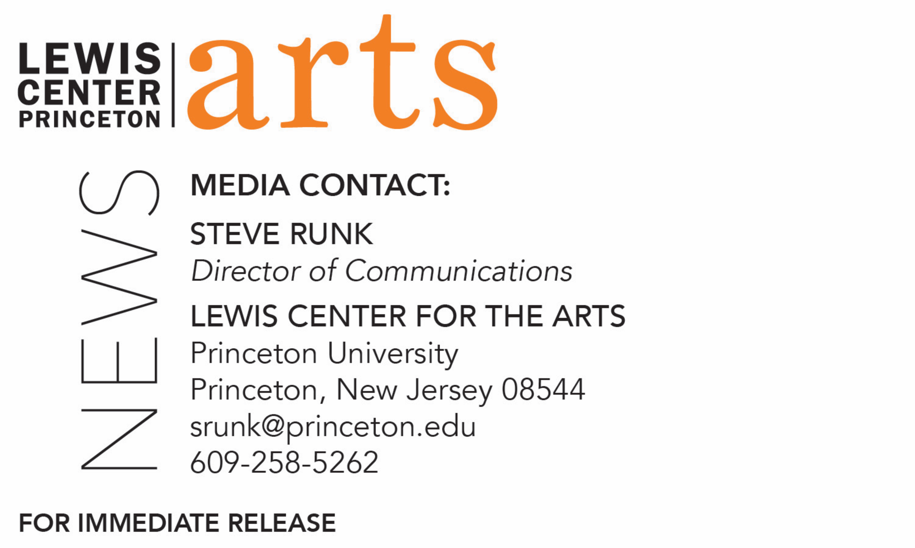

December 11, 2017

Lewis Center for the Arts’ Program in Theater presents
Princeton, Slavery and Me: Autobiographical Storytelling
New work by students from a fall course taught by Assistant Professor of Theater
Brian Herrera presented in collaboration with Arts Council of Princeton

What: Princeton, Slavery and Me: Autobiographical Storytelling, a performance of new works drawn from the historical materials unearthed by the Princeton and Slavery Project and remade into compelling autobiographical stories.
Who: Princeton students from Assistant Professor Brian Herrera’s fall course “Autobiographical Storytelling: Princeton, Slavery, and Me,” presented by Lewis Center for the Arts’ Program in Theater in collaboration with the Arts Council of Princeton
When: Wednesday, December 13 at 7:00 p.m.
Where: Arts Council of Princeton, Paul Robeson Center for the Arts, 102 Witherspoon St., Princeton
Free and open to the public, but reservations are encouraged at https://www.eventbrite.com/e/princeton-slavery-and-me-arts-council-of-princeton-community-stage-tickets-39226596807

(Princeton, NJ) The Lewis Center for the Arts’ Program in Theater in collaboration with the Arts Council of Princeton will present a performance of work created by Princeton students from Assistant Professor in Theater Brian Herrera’s fall course, “Autobiographical Storytelling: Princeton, Slavery, and Me.” In this performance students will use an array of storytelling modes to bring to life the historical materials unearthed by the Princeton & Slavery Project. The event will take place on Wednesday, December 13 at 7:00 p.m. at the Paul Robeson Center for the Arts at 102 Witherspoon Street in Princeton. The event is free, but reservations are encouraged.

The work grew out of Herrera’s fall course which engaged directly with the research developed through the ongoing Princeton and Slavery Project. Through field trips and workshops with guest artists, students learned to use a variety of storytelling genres to craft lived experiences into autobiographical storytelling and created their own original work.

The Princeton and Slavery Project, led by historian and Princeton faculty member Martha Sandweiss, investigates the University’s involvement with the institution of slavery. It explores the slave-holding practices of Princeton’s early trustees and faculty members, considers the impact of donations derived from the profits of slave labor, and looks at the broader culture of slavery in the state of New Jersey, which did not fully abolish slavery until 1865. It also documents the southern origins of many Princeton students during the ante-bellum period and considers how the presence of these southern students shaped campus conversations about politics and race. Drawn from University archives and many other sources, the Project has compiled a robust body of research for scholars, artists and others to drawn upon.

“The students’ work focuses on the stories we do and don’t tell about ourselves, as well as the stories we do and don’t tell about Princeton University,” said Herrera. “In this ‘work demo,’ the students will showcase some of the methods and techniques we’ve used over the course of the semester, as they also share some of the personal stories they’ve developed along the way. Not all of the stories will engage the materials archived in the Princeton & Slavery Project, but all reckon with what it means to have Princeton University, with all its contradictions, as a central part of one’s personal history.”

Senior Gaby Escalante, one of the students in the course, said, “Our stories explore the contingent ‘privilege’ of being a Princeton student, and what ‘being a Princeton student’ means when you’re also a person of color.” Kwame Emaning, a sophomore in the class adds, “We want to share some insight into the experience of being a Princeton student, and how it effects our identity and our outlook.”

“By sharing our stories, we hope to invite a connection between the University and the surrounding community,” explains junior Jess Goehring. “I hope our stories can begin a conversation and help to develop a connection between us as Princeton students and the greater Princeton community,” adds senior Sam Davies.

Herrera is a writer, teacher and scholar and an assistant professor of theater at Princeton. His work, both academic and creative, examines the history of gender, sexuality, and race within and through U.S. popular performance. His first book, Latin Numbers; Playing Latino in Twentieth-Century U.S. Popular Performance (University of Michigan Press, 2015 was recognized with the George Jean Nathan Award for Dramatic Criticism. His work has also been published in many scholarly journals including Modern Drama, Theatre Journal, Ecumenica, Comparative Drama and The Gay and Lesbian Review; he also served as Guest Editor for a special section of The Journal of Dramatic Theory and Criticism. Herrera recently completed terms of service on the Executive Committee for the American Society for Theatre Research and on the Steering Committee for the American Theatre Archive Project. He currently serves as Chair of the Executive Committee for Modern Language Association's Drama Division and as member of the Advisory Committee for the Latino/a Theatre Commons for which he authored The Latina/o Theatre Commons 2013 National Convening: A Narrative Report. Herrera's autobiographical solo show I Was the Voice of Democracy premiered in 2010 in Albuquerque. In 2013, he launched two new storywork shows, Boy Like That and Touch Tones. Herrera holds degrees from Brown University, the University of New Mexico and Yale University, where he earned his Ph.D in American Studies. He was awarded fellowship recognition from the Ford Foundation, the Smithsonian Institute, and the John Randolph & Dora Haynes Foundation. From 2007 to 2012, Herrera taught undergraduate and graduate courses in World Theatre History and Performance Theory in the Department of Theatre and Dance at the University of New Mexico (UNM) where he was recognized four times by The Project for New Mexico Graduates of Color as an Outstanding Faculty Member and, in 2010, the Weekly Alibi annual reader's poll named Herrera Albuquerque's "Best Post-Secondary School Professor or Instructor." In 2014, he was named a Donald P. Harrington Faculty Fellow at the University of Texas at Austin. Herrera is presently at work on two new book projects: Starring Miss Virginia Calhoun, a narrative portrait of a deservedly obscure early 20th century actress/writer/producer, and Casting — A History, a historical study of the material practices of casting in U.S. popular performance.

The performances are being presented as part of the Arts Council of Princeton’s Community Stage series held in collaboration with local artistic groups and organizations. Community stage programming enables the Arts Council’s Solley Theater to act as an accessible space for community partnerships and high-quality artistic experiences.

The performance is free, but advance registration is recommended at https://www.eventbrite.com/e/princeton-slavery-and-me-arts-council-of-princeton-community-stage-tickets-39226596807. Priority will be given to those who have registered in advance.

To learn more about this event, the Program in Theater, and the over 100 performances, exhibitions, readings, screenings, concerts and lectures presented each year by the Lewis Center, most of them free, visit arts.princeton.edu.

###

