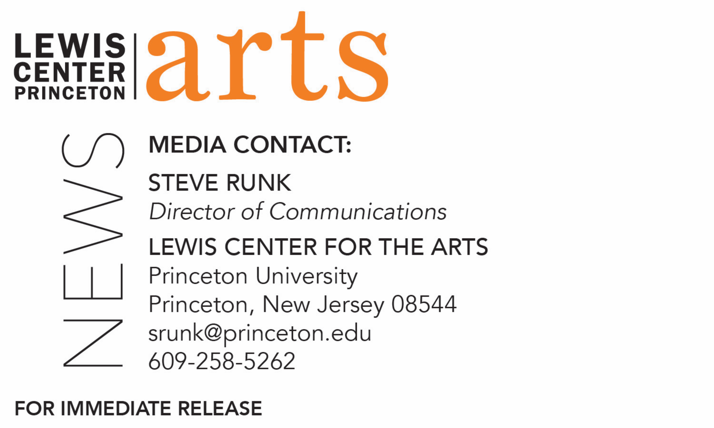

January 29, 2018

The Lewis Center for the Arts’ Program in Theater presents
Fly by Trey Ellis and Ricardo Khan
Senior thesis explores the history of the Tuskegee Airmen, the first
African-American Army Air Corps fighters

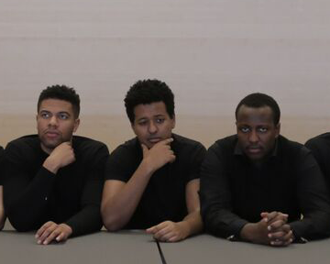
Photo caption: Senior Nemo Teferi (center) with two fellow cast members of Fly, seniors Isaiah Dolcee (left) and Brandon McGhee.
Photo credit: Justin Goldberg

What: Fly, a play inspired by the story of the Tuskegee Airmen, the first African-American Army Air Corps fighters who flew over the skies of Europe and North Africa during World War II. Written by Trey Ellis and Ricardo Khan, Fly dramatizes the historic contributions made by the Tuskegee Airmen to the desegregation of the American military and the furthering of civil rights as they face segregation, racism, and a world war with courage, humor, and humanity.
Who: Presented by Lewis Center for the Arts’ Program in Theater, featuring senior Nemo Teferi and directed by guest director Whitney White.
When: February 8, 9 and 10 at 8:00 p.m. An audience talkback follows the February 10 performance.
Where: Matthews Acting Studio at 185 Nassau St. on the Princeton campus
Free and open to the public, with advance tickets available at http://arts.princeton.edu/events/fly-by-trey-ellis-ricardo-khan/all/ and at the door the dates of performances.

(Princeton, NJ) The Lewis Center for the Arts’ Program in Theater at Princeton University will present an exploration of the play, Fly, written by Trey Ellis and Ricardo Khan, on February 8, 9 and 10 at 8:00 p.m. in the Matthews Acting Studio at 185 Nassau Street on the Princeton campus. The production features Princeton senior Nemo Teferi and is directed by guest director Whitney White. An audience talkback will follow the February 10 performance. The show is free and open to the public with tickets available in advance and at the door just prior to performances.

Fly is inspired by the story of the Tuskegee Airmen, the first African-American Army Air Corps fighters who flew over the skies of Europe and North Africa during World War II. The play dramatizes the historic contributions made by the Tuskegee Airmen to the desegregation of the American military and the furthering of civil rights as they face segregation, racism, and a world war with courage, humor, and humanity. The play incorporates music, some of which is dictated in the script and some chosen by the director, as well as dance and movement, choreographed by Princeton senior Peyton Smith.

Teferi, who plays the role of Chet in Fly, is majoring in politics at Princeton and pursuing a certificate in the Program in Theater. His experience in theater began at Princeton in his freshman year with a course in acting. His professor encouraged him to further explore theater and to apply for the certificate program. He appeared this past fall in a production of Jiehae Park’s Peerless.

“The stories like Fly don’t usually make it in the history books,” said Teferi. “I wanted to bring this narrative to Princeton and share this ‘othered’ history. I wanted to do something for the culture.”

Guest director Whitney White is a director and musician based in Brooklyn, New York. Her original musical, Lover I’ll Bring You Back to Life, was part of Ars Nova’s 2016 ANT Fest, and her musical adaption of Macbeth: Macbeth in Stride has been workshopped at Chautauqua (2016), Trinity Rep (2017), and Judson Memorial (2017). This year White developed work at New York Theater Workshop, 59E59, The Roundabout, Luna Stage, The Drama League, South Oxford, Jack, The Tank, New York Musical Festival, The Lark, and elsewhere. This year she also assisted Sam Gold on Othello (New York Theatre Workshop) and The Secret Life of Bees (New York Stage and Film); Dan Sullivan on If I Forget (Roundabout); and Anne Kaufman on Marvin’s Room (Broadway). White is the inaugural 2017 Roundabout Directing Fellow and will be a 2050 Fellow at New York Theatre Workshop.

The rest of the ensemble cast includes seniors Sergio Cruz, Sam Davies, Isaiah Dolcee, and Brandon McGhee, sophomore Kwame Amaning, and freshmen Fergus Binnie and Peter Foster. The production is stage managed by freshman Nora Aguiar assisted by junior Jasmeene Burton.

Tickets for Fly are free with advance tickets available through University Ticketing online at tickets.princeton.edu or calling 609.258.9220, or at the Frist Campus Center or Lewis Arts complex ticket offices. Tickets will also be available at the door prior to performances.

To learn more about this event, the Program in Theater, and the more than 100 other performances, exhibitions, readings, screenings, concerts, and lectures presented by the Lewis Center, most of them free, visit arts.princeton.edu.

###

