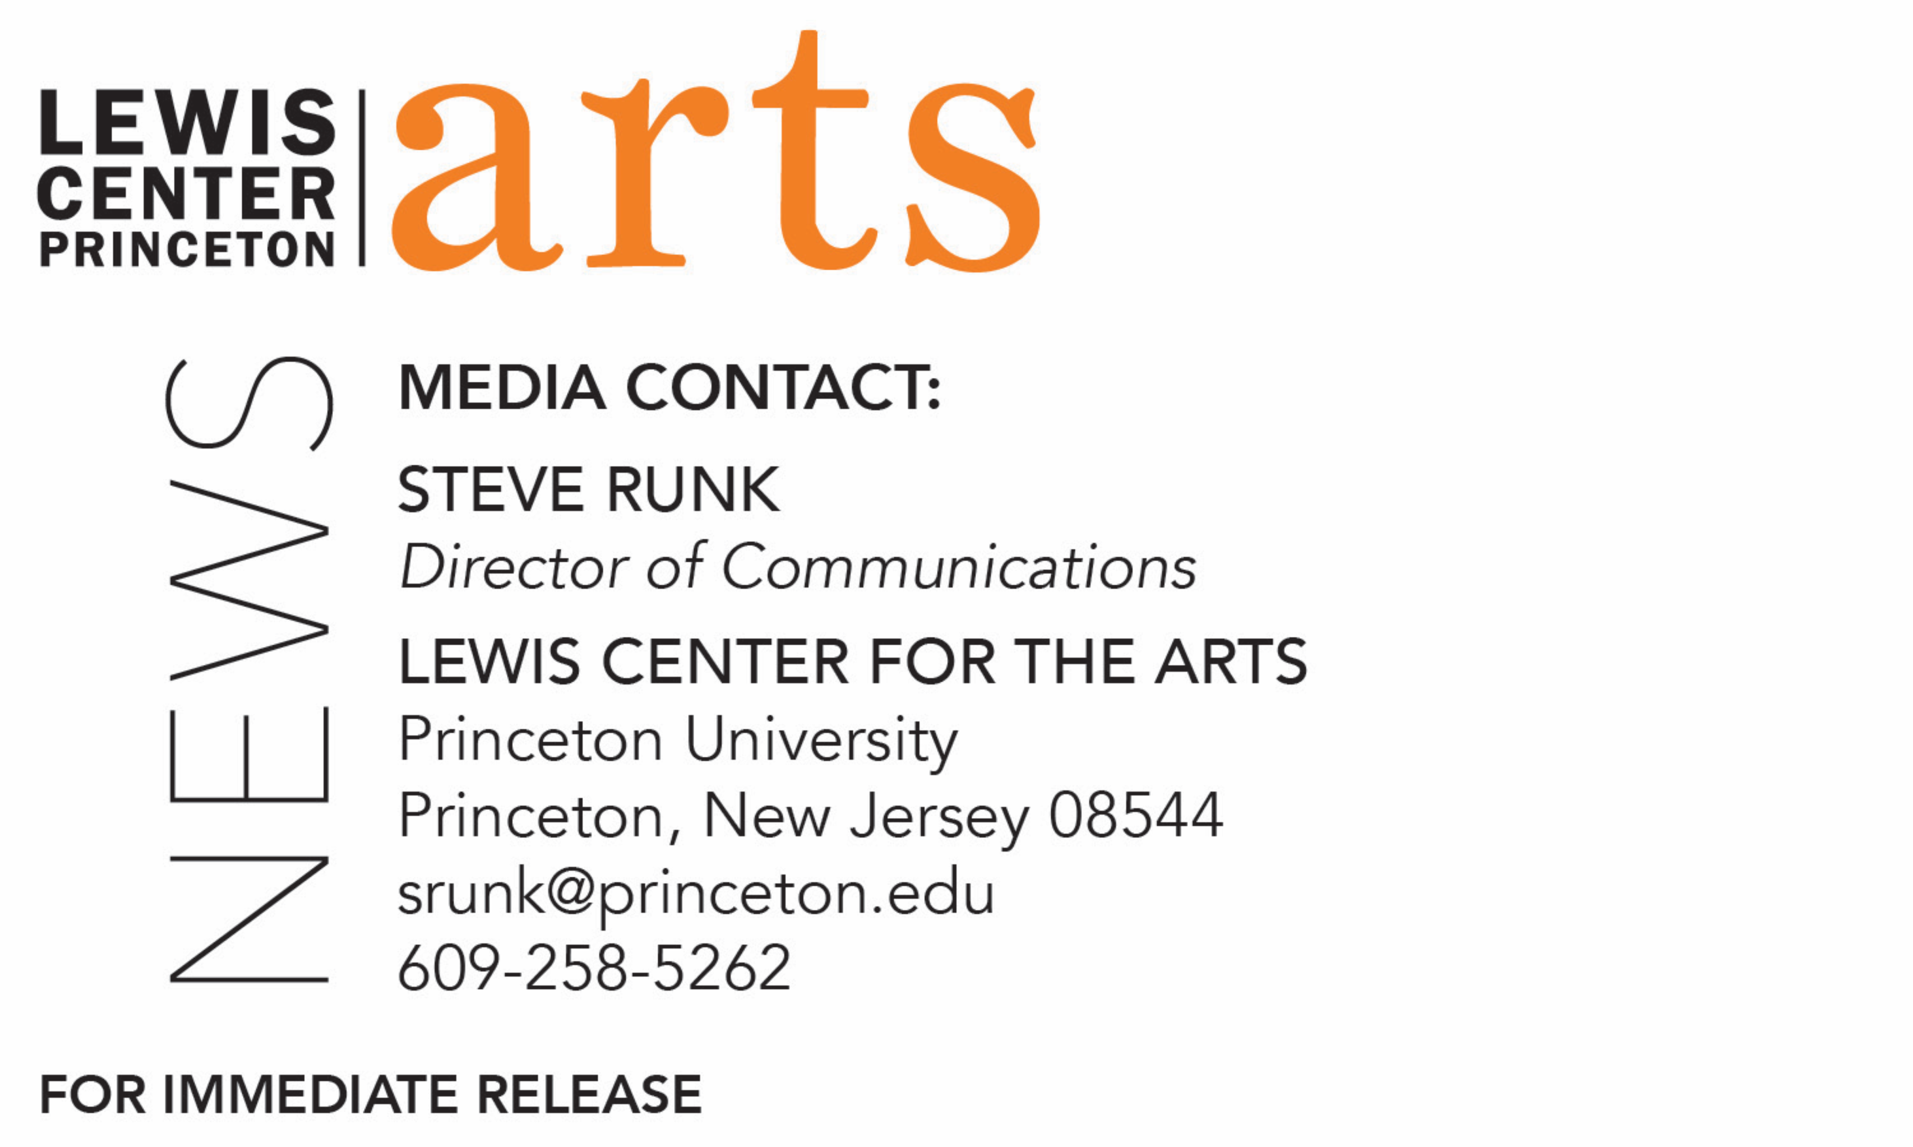

February 15, 2018

Princeton University’s Fund for Irish Studies presents
A reading by Pulitzer Prize-winning poet Paul Muldoon with appearances by acclaimed singer Iarla Ó Lionáird and
award-winning composer Dan Trueman
Celebrates release of Muldoon’s Lamentations and performance of the three artists’ recent collaboration with Eighth Blackbird, Olagón: a Cantata in Doublespeak

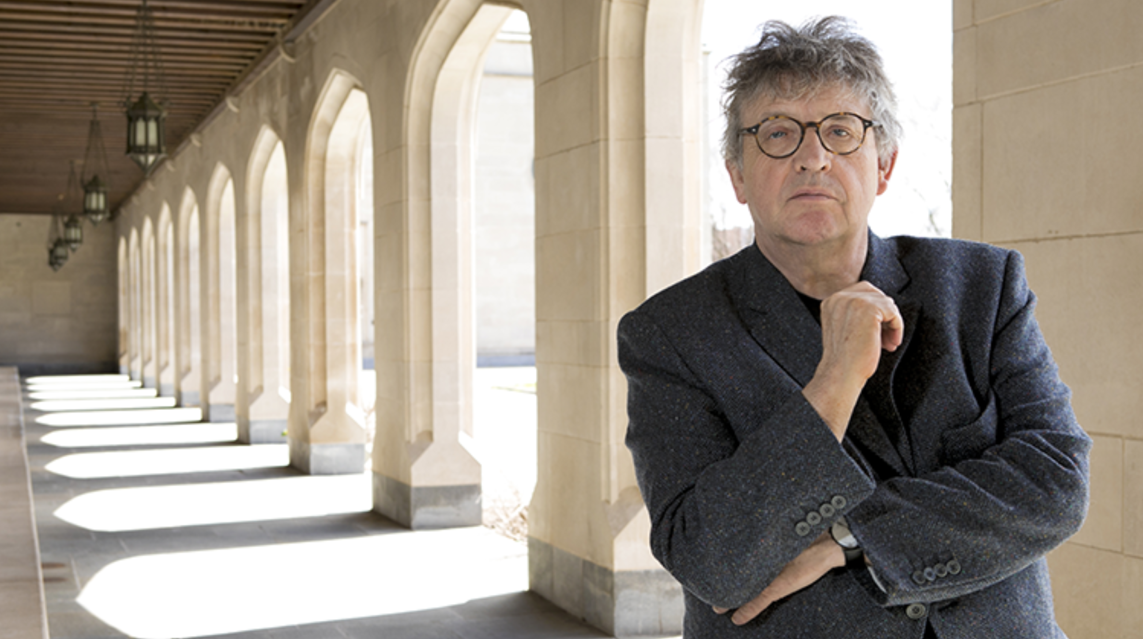
Photo caption: Pulitzer Prize-winning poet Paul Muldoon
Photo credit: Denise Applewhite

Who: Pulitzer Prize-winning poet Paul Muldoon, acclaimed singer Iarla Ó Lionáird, and award-winning composer and fiddler Dan Trueman
What: A reading by Paul Muldoon from his new volume Lamentations and his Selected Poems 1968-2014 and from the three artists’ recent collaboration with Eighth Blackbird, Olagón: A Cantata in Doublespeak, presented by Princeton University’s Fund for Irish Studies
When: Friday, February 23 at 4:30 p.m.
Where: Wallace Theater at the Lewis Arts complex on the Princeton campus

(Princeton, NJ) Pulitzer Prize-winning poet Paul Muldoon will present a reading from his recent poetry collections joined by acclaimed singer Iarla Ó Lionáird and composer Dan Trueman, in celebration of Muldoon’s latest volume Lamenations and the three artists’ collaboration with Eighth Blackbird, Olagón: a Cantata in Doublespeak. The reading, presented by Princeton University’s Fund for Irish Studies, will take on place on Friday, February 23 at 4:30 p.m. in the Wallace Theater located at the Lewis Arts complex on the Princeton campus. This event is free and open to the public. Performances of Olagón are being presented on February 22 through 24.

Muldoon will be reading from his recently published collection Lamentations, which presents a translation of a classic Irish poem from the 18th-century and re-envisions the haunted narratives within. He will also read from his lauded Selected Poems 1968-2014, work selected from the past 45 years and drawn from 12 individual collections by the poet, hailed by Nobel Laureate Seamus Heaney as "one of the era's true originals."

The reading will include appearances by two of Muldoon’s recent collaborators on Olagón: a Cantata in Doublespeak. This new work is an evening-length collaboration between the Grammy Award-winning sextet Eighth Blackbird, Muldoon, Ó Lionáird, and Trueman. With text written by Muldoon in both English and Irish and based on the classic Irish tale Táin Bó Cúailnge, the cantata paints a narrative of hardship in contemporary Ireland with traditional music, such as sean nós, performed by Ó Lionáird and with stage direction by Mark DiChiazza. Performances will be held on February 22, 23 and 24 at 8:00 p.m. also in the Wallace Theater. Hosted by the Princeton Department of Music, Eighth Blackbird will be in residence at Princeton Sound Kitchen from February 20 through 26.

Paul Muldoon was born in 1951 in County Armagh, Northern Ireland, and educated in Armagh and at the Queen's University of Belfast. From 1973 to 1986 he worked in Belfast as a radio and television producer for the British Broadcasting Corporation. Since 1987 he has lived in the United States, where he is now Howard G. B. Clark '21 Professor at Princeton University and was founding chair of the Peter B. Lewis Center for the Arts. In 2007 he was appointed Poetry Editor of The New Yorker. Between 1999 and 2004 he was Professor of Poetry at the University of Oxford, where he is an honorary Fellow of Hertford College. A Fellow of the Royal Society of Literature, the American Academy of Arts and Sciences and the American Academy of Arts and Letters, Muldoon was given an American Academy of Arts and Letters award in literature for 1996. Other awards include the 1994 T. S. Eliot Prize, the 1997 Irish Times Poetry Prize, the 2003 Pulitzer Prize, the 2003 Griffin International Prize for Excellence in Poetry, the 2004 American Ireland Fund Literary Award, the 2004 Shakespeare Prize, the 2005 Aspen Prize for Poetry, and the 2006 European Prize for Poetry. He has been described by The Times Literary Supplement as “the most significant English-language poet born since the second World War.”

Iarla Ó Lionáird has carved a long and unique career in music in Ireland. From his iconic early recording of the vision song Aisling Gheal as a young boy to his groundbreaking recordings with Dublin’s Crash Ensemble, he has shown a breadth of artistic ambition. He has worked with a number of composers internationally, including Nico Muhly, Donnacha Dennehy, Dan Trueman, Gavin Bryars and David Lang, and he has performed and recorded with such artists as Peter Gabriel, Robert Plant, Nick Cave and Sinead O’Connor. His unique singing style has carried him to stages and concert halls all over the world, from New York’s Carnegie Hall and Lincoln Center to the Sydney Opera House, London’s Royal Albert Hall and beyond. His film credits extend from The Gangs of New York to Hotel Rwanda and most recently as featured vocalist in the film Calvary starring Brendan Gleeson and the film adaptation of Colm Tóibín’s Brooklyn starring Saoirse Ronan. Ó Lionáird was a 2016-17 Belknap Fellow in the Humanities Council and Department of Music at Princeton.

Dan Trueman is a professor of music composition in Princeton’s Department of Music, Director of the Princeton Sound Kitchen, and a noted fiddler and electronic musician. He co-founded the Princeton Laptop Orchestra, the first ensemble of its size and kind that has led to the formation of similarly inspired ensembles across the world. His compositional work reflects this complex and broad range of activities, exploring rhythmic connections between traditional dance music and machines, for instance, or engaging with the unusual phrasing, tuning and ornamentation of the traditional Norwegian music while trying to discover new music that is singularly inspired by, and only possible with, new digital instruments that he designs and constructs. In addition to Olagón, his current projects include a double-quartet for Sō Percussion and the JACK Quartet, commissioned by the Barlow Foundation; the Prepared Digital Piano project; a collaborative dance project with choreographer and Princeton dance faculty member Rebecca Lazier and Professor of Mechanical and Aerospace Engineering Naomi Leonard; ongoing collaborations with Irish fiddler Caoimhín Ó Raghallaigh and guitarist Monica Mugan (Trollstilt); and a new collaborative work with Mark DeChiazza for the PRISM saxophone quartet. Trueman is the recipient of a 2016 Bessie Award, a 2015 American Council of Learned Societies Fellowship, a 2014 Barlow Commission, a 2010 Fulbright Fellowship, a 2008 MacArthur Foundation “Digital Innovations” Grant, and a 2015 Guggenheim Fellowship.

The Fund for Irish Studies, chaired by Princeton professor Clair Wills, affords all Princeton students, and the community at large, a wider and deeper sense of the languages, literatures, drama, visual arts, history, politics, and economics not only of Ireland but of “Ireland in the world.” The series is co-produced by the Lewis Center for the Arts. The spring 2018 edition of the series is organized by Fintan O’Toole, visiting lecturer in the Program in Theater in the Lewis Center for the Arts and acting chair of the Fund for Irish Studies.

Information about the Fund for Irish Studies series events can be found at fis.princeton.edu. Other events scheduled in the current series include:
- Theater critic and scholar Fintan O’Toole gives the Robert Fagles Memorial Lecture, titled “Brexit, Ireland and the Rise of English Nationalism,” on March 2
- Award-winning writer Sally Rooney reads from her debut novel Conversations with Friends on March 9
- Acclaimed filmmaker Pat Collins screens and discusses his documentary Song of Granite on April 6
- Sir Richard Lodge Professor of History at the University of Edinburgh, Alvin Jackson, presents the lecture “John Redmond and Edward Carson: Bloodshed, Borders and the Union State” on April 27

The Fund for Irish Studies is generously sponsored by the Durkin Family Trust and the James J. Kerrigan, Jr. ’45 and Margaret M. Kerrigan Fund for Irish Studies.

To learn more about the more than 100 public performances, exhibitions, readings, screenings, concerts, lectures and special events, most of them free, presented each year by the Lewis Center for the Arts, visit arts.princeton.edu.

###

