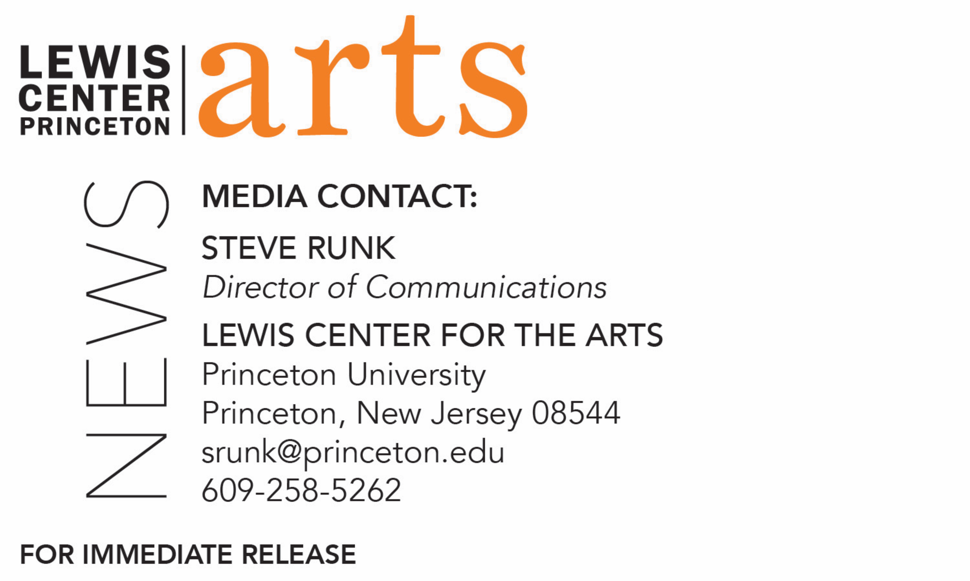

February 27, 2018

Lewis Center for the Arts presents Performance Lab
New interdisciplinary work created by students, mentored by faculty

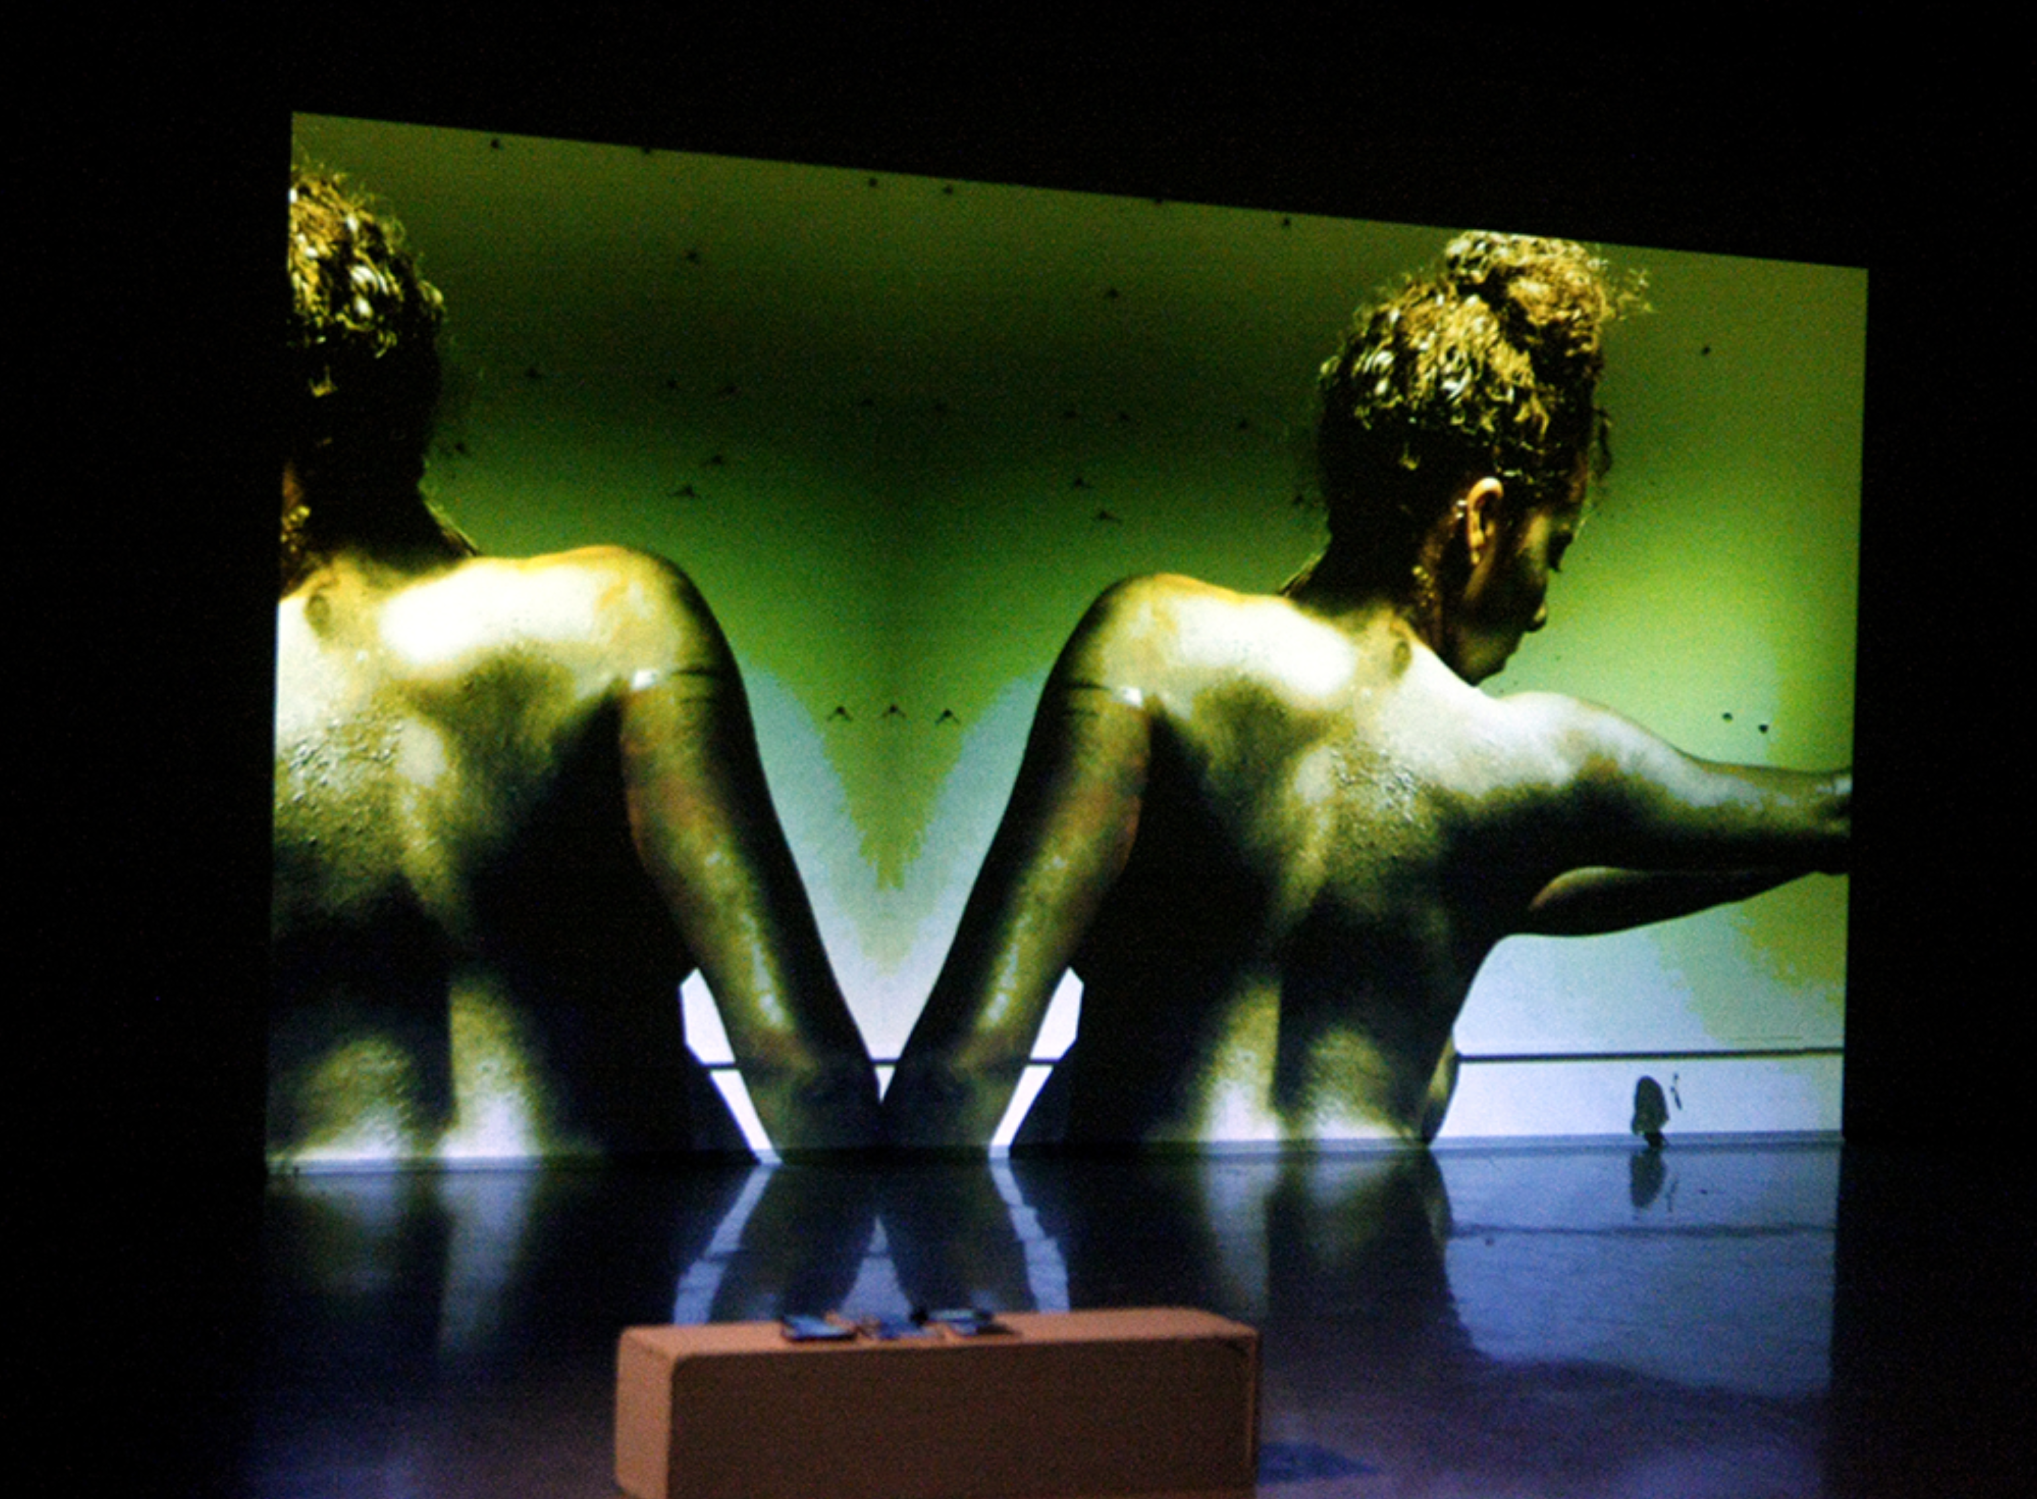
Photo caption: One of the student-created works presented in last year’s Performance Lab
Photo credit: Frank Wojciechowski

What: Performance Lab, presented by Lewis Center for the Arts’ Program in Dance
Who: Students working in dance, writing, theater, music, musical theater, and/or visual art present new interdisciplinary work developed through collaboration with other artists and mentorship from dance faculty in Performance Lab. Each performance followed by an audience talkback discussion.
When: Thursday and Friday, March 8 and 9 at 7:00 p.m.
Where: Hearst Dance Theater at Lewis Arts complex on the Princeton University campus
Free and open to the public

(Princeton, NJ) The Lewis Center for the Arts’ Program in Dance at Princeton University will present Performance Lab, showcasing nine new works created by thirteen Princeton students, on Thursday and Friday, March 8 and 9 at 7:00 p.m. in the Hearst Dance Theater at the new Lewis Arts complex on the Princeton campus. Each performance will be followed by a talkback. The event is free and open to the public.

Performance Lab provides an opportunity for students working in dance, creative writing, music, musical theater, theater, and/or visual art to showcase their new interdisciplinary work developed through discussion with other artists and mentorship from dance faculty. Through one-on-one meetings over the past several months, students have looked at the ways that structure, intent, and theatrical elements can support their artistic creation. The independent student projects showcased at this event are the product of this mentored creative process.

This year's Performance Lab includes experiments and narratives about identity, racism, and the college experience itself, as well as many other explorations.

“It’s been wonderful seeing this group find new ideas and ways of working,” said Aynsley Vandenbroucke, the dance faculty member who coordinates the program. “One of the students even created a brilliant spreadsheet they called ‘PLab Tinder.’ This was a way for students to find collaborators by easily seeing the skills and questions other participants brought to the table.”

Michelle Yeh, a junior comparative literature major, explores the concepts of memory and identity, both in an individual and in a nation. This multimedia solo performance utilizes visual and audio material she collected over the summer while doing independent research in Taiwan and aims to explore an interdisciplinary form of storytelling.

Ayodele Foster-McCray, a sophomore, presents a short visual experience that she describes as “both familiar and healing for black women in our daily fight against misogyny and racism.” According to the artists, this creative experiment “pays homage to the warriors among us who fight just by pushing forward another day.”

In Katie Massie’s exploration she asks, “How do our storylines intersect and how do we live in our own heads while we interact with others?” Massie questions how stories can be the same even when they seem dissimilar and how the close physical proximity of college life enhances conflicting and heartbreaking experiences. Massie is a first year student.

First year student Abbie Minard, sophomore Tim Ruszala, and senior Rachel Schwartz collaborated to create a multimedia piece exploring the ease with which one can escape reality in the age of the all-encompassing internet. They investigate the feeling of “stuckness” that results from technological freedom, questioning the common experience of college students who are often unable to escape the temptation of technology for what seems like hours. Minard is a writer, Ruszala a musician, and Schwartz a visual artist and choreographer.

Students submitted application letters to Program in Dance faculty and then got to know each other through a series of gatherings in the fall. Vandenbroucke has been mentoring the students in development of their pieces, which will be performed by other Princeton students.

The Program in Dance, led by award-winning choreographer Susan Marshall, offers Princeton undergraduates a wide range of opportunities in dance. Students can enroll in a single course, pursue a certificate in dance (similar to a minor), or participate in co-curricular classes. Studio-based courses taught by dance professionals range from modern and contemporary to ballet, to experimental, urban and African dance, and include the creation of original work, study of master repertory, and rigorous technical training. Frequent performance opportunities are provided including the annual Princeton Dance Festival, a senior thesis collaborative concert, and informal showings.

For more information on this event, the Program in Dance, or any of the more than 100 public performances, exhibitions, readings, screenings, concerts and lectures presented annually by the Lewis Center for the Arts, most of them free, visit: arts.princeton.edu

###

