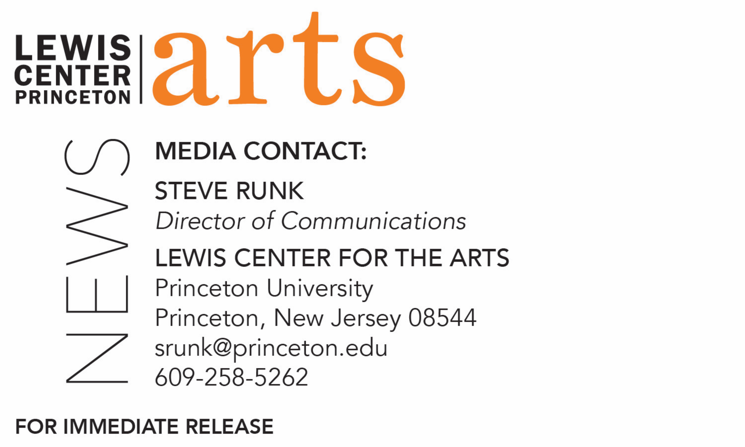
March 6, 2018

Choreographers Ralph Lemon, Karen Sherman, and Abigail Zbikowski in Conversation at Lewis Center for the Arts
Inaugural artists in Program in Dance’s new Hearst Choreographers in Residence program

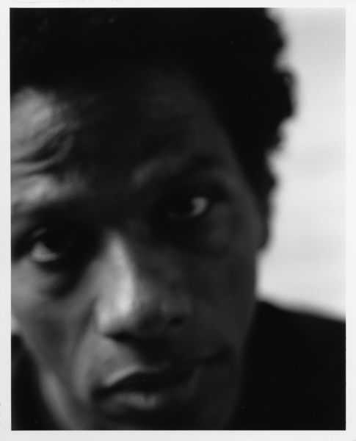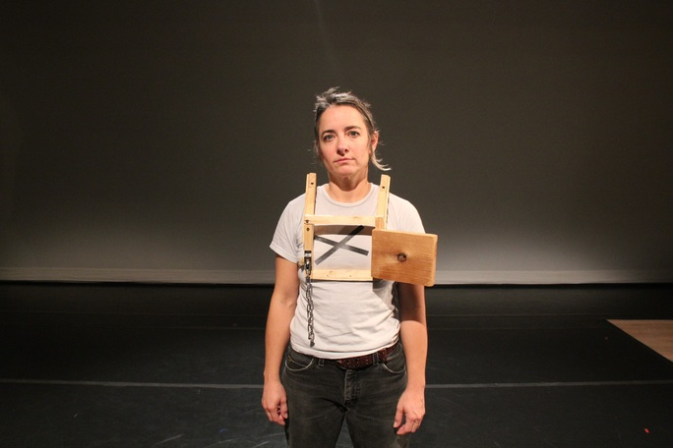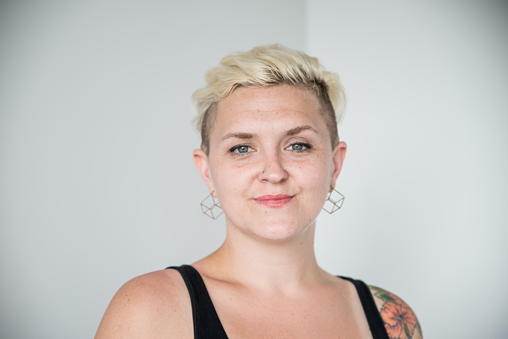
Photo Captions: Choreographers (left to right) Ralph Lemon, Karen Sherman, and Abigail Zbikowski
Photo Credits: (left to right) Tara Fallaux, Aaron Rosenblum, and Effy Falck

What: Series of conversations with the inaugural Caroline Hearst Choreographers-in-Residence about their creative processes and recent work, including new commissions by the Lewis Center for the Arts

Who: Abigail Zbikowski
When: March 9 at 4:30 p.m.
Where: Ellie's Dance Studio at Lewis Arts complex

Who: Ralph Lemon
When: March 15 at 8:00 p.m.
Where: Roberts Dance Studio at Lewis Arts complex

Who: Karen Sherman
When: April 20 at 3:00 p.m.
Where: Ellie’s Dance Studio at Lewis Arts complex

Free and open to Princeton students, faculty and staff

(Princeton, NJ) The Lewis Center for the Arts’ Program in Dance will present a series of conversations with choreographers Ralph Lemon, Karen Sherman, and Abigail Zbikowski, the three inaugural Caroline Hearst Choreographers-in-Residence, as they discuss their works-in-progress, creative processes, and reflections on past work. The talks, being held between March 9 and April 20 at the Lewis Arts complex on the Princeton campus, are free and open to Princeton students, faculty, and staff.

The Caroline Hearst Choreographer-in-Residence program, gifted by Margaret C. and William R. Hearst, III, is designed to foster the Program in Dance’s connections with the dance field. It provides selected professional choreographers with resources and a rich environment to develop their work and offers opportunities for students, faculty and staff to engage with diverse creative practices. For the inaugural year, the program is commissioning new dance works from Lemon, Sherman, and Zbikowski, and these artists are sharing their work and processes with the Princeton community through workshops, residencies, open rehearsals, and performances. The new program is designed to be flexible enough to create meaningful interaction between artists and students. Each artist will develop engagement activities to suit the interests of the students, and students will create projects that involve the selected artists.

“During their time on campus for these presentations, the Hearst choreographers will also be integrated into our classes,” said Susan Marshall, Director of the Program in Dance. “Our students will have multiple chances to engage with these artists and become familiar with their work in advance of seeing them perform the commissioned works next year at the Lewis Arts complex. We are excited to not only support these exceptional choreographers as they make their work, but also to share their processes and thinking with our students.”

On March 9 Zbikowski and Fiona Lundie, a core member of Zbikowski’s company Abby Z, will share recent explorations of Zbikowski’s new work-in-progress, Radioactive Practice, as well as her recent work abandoned playground. She will discuss her use of movement, aesthetic influences, methods of training, and her desire to create rigorous, inclusive works that speak to multiple communities simultaneously. The lecture will take place at 4:30 p.m. in Ellie’s Dance Studio at the Lewis Arts complex.

Zbikowski is a choreographer, assistant professor of dance at the University of Illinois, Urbana-Champaign, and faculty member at the American Dance Festival. Her choreographic work with her company, Abby Z and the New Utility, has been presented by the Gibney Dance Center, Movement Research at Danspace Project, and most recently the Abrons Arts Center, where the company had a sold out run of its latest evening-length piece, abandoned playground. Zbikowski has been an Artist-in-Residence as part of the nEW Festival in Philadelphia, the American Dance Festival, and the Bates Dance Festival. She has studied intensively at Germaine Acogny's L'École de Sables in Senegal and holds a B.F.A. in dance from Temple University and an M.F.A. in dance from Ohio State University, where she worked closely with mentors Bebe Miller and Vickie Blaine. As a performer, Zbikowski has worked with Charles O. Anderson/Dance Theater X, Vincent Mantsoe, and the Baker & Tarpaga Dance Project. She has been on faculty at Ohio State University and has taught technique and creative process abroad at the Academy of Culture in Riga, Latvia, as part of Global Practice Sharing, sponsored by Movement Research.

On March 15 at 8:00 p.m. Lemon will merge live performance, storytelling, and film in Ceremonies Out of the Air to invoke his long-standing exploration of the American South, uncovering the complexity of geography, history, and memory. The lecture will take place in the Roberts Dance Studio at the Lewis Arts Complex.

Lemon, whose career spans over 30 years, is a director, choreographer, writer, visual artist and curator, and the artistic director of Cross Performance, a company dedicated to the creation of cross-cultural and cross-disciplinary performance and presentation. In 2016 he was awarded the National Medal of Arts by President Barack Obama. He is known for developing intellectually rigorous and experimental performances that are as socially and politically resonant as they are personal. This approach is evident in his multimedia collaboration How Can You Stay in the House All Day and Not Go Anywhere? (2008-2010), a work utilizing live performance, film and visual art. Other recent works include the innovative dance/film project Four Walls (2012); a commission for the Lyon Opera Ballet, Rescuing the Princess (2009); and the epic cycle, The Geography Trilogy (1997-2004). His honors include two "Bessie" Awards, an Alpert Award in the Arts, a Creative Capital Award, a U.S.A. Fellowship, a Guggenheim Fellowship, the American Choreographers Award, and one of the first Doris Duke Foundation Performing Artist Awards. Lemon has been an IDA Fellow at Stanford University; artist-in-residence at Temple University; Miller Endowment Visiting Artist at the Krannert Center; Fellow of the Humanities Council and Program in Theater and Dance at Princeton University; Associate Artist at Yale Repertory Theatre; a Visiting Critic at the Yale School of Art’s Sculpture Department; and the 2013-14 Annenberg Fellow at the Museum of Modern Art, where he curated a series of “performance essays,” titled Value Talks.

The final event in the series on April 20 will feature Sherman, an award-winning performer and choreographer whose work draws upon her background in dance, writing, theater, and the “handyman arts.” She will present a conversation about her current project Soft Goods, a dance/performance work created in collaboration with an ensemble of stage technicians and dancers that examines “work, aliveness, death, disappearance, and occupational self-obliteration.” Sherman will also discuss the work she will create during her residency. The lecture will take place at 3:00 p.m. in Ellie’s Dance Studio at the Lewis Arts complex.

Sherman, a 2016-17 Hodder Fellow at the Lewis Center, is a freelance stage technician, carpenter, and sound and scenic designer who incorporates this background in her performance work. Her work has been presented nationally by Walker Art Center, PS 122, Fusebox Festival, Movement Research, ODC/Dance, Portland Institute for Contemporary Art, and The Chocolate Factory Theater, among many others. Her awards include a 2007 “Bessie” Award for her performance in Morgan Thorson's Faker, multiple McKnight Foundation Fellowships in Choreography and Dance, a Bush Foundation Fellowship, two MacDowell Colony Fellowships, and residencies with Vermont Performance Lab, Movement Research, Studio 206, and the Bogliasco Foundation in Liguria, Italy.

For more information on the Program in Dance and the more than 100 other performances, exhibitions, readings, screenings, concerts and lectures offered each year by the Lewis Center for the Arts, most of them free, visit arts.princeton.edu.

###

