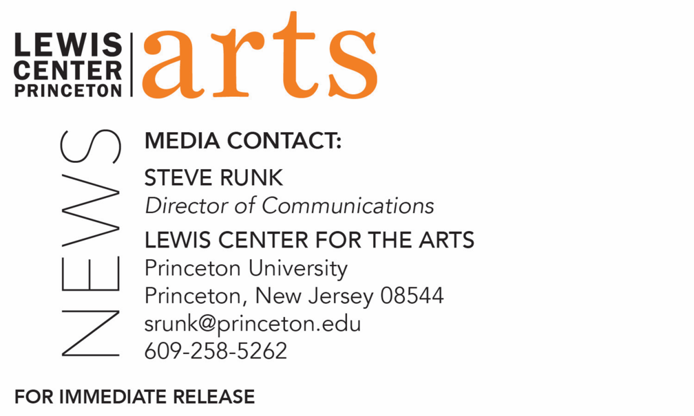

September 21, 2018

Writer Hermione Hoby reads with Five Seniors in
Princeton’s Creative Writing Program October 5
The C.K. Williams Reading Series is organized by Princeton students
in collaboration with Labyrinth Books

Photo caption: Writer Hermione Hoby
Photo credit: Nina Subin

What/Who: Reading by novelist, journalist and cultural critic Hermione Hoby and five seniors in Princeton's Program in Creative Writing, part of the C. K. Williams Reading Series
When: Friday, October 5 at 6:00 p.m.
Where: Labyrinth Books, 122 Nassau St., Princeton
Free and open to the public

(Princeton, N.J.) British author, journalist, and cultural critic Hermione Hoby and five seniors in the Lewis Center for the Arts’ Program in Creative Writing at Princeton University will read from their work at 6:00 p.m. on Friday, October 5 at Labyrinth Books, 122 Nassau Street. The reading is part of the C. K. Williams Reading Series, named in honor of the Pulitzer Prize and National Book Award-winning poet who served on Princeton’s creative writing faculty for 20 years.

The series showcases senior thesis students of the Program in Creative Writing alongside established writers as special guests. Featuring student writers Sonia Joseph, Simi Prasad, Jordan Salama, Carson Welch and Max West, the event is free and open to the public.

Hermione Hoby’s debut novel, Neon in Daylight, published earlier this year by Catapult in the United States and Weidenfeld & Nicolson in the United Kingdom, was called “a radiant first novel” by The New York Times. Hoby grew up in south London and graduated from the University of Cambridge in 2007 with a double first (first-class honors undergraduate degree) in English Literature. After working on the Observer’s New Review section for a few years, she moved to New York and has lived in Brooklyn since 2010. She writes about culture, especially books, film, music and gender, for the Guardian, The New Yorker, The New York Times, the Times Literary Supplement, and others. She has interviewed hundreds of actors, writers, pop stars and other cultural figures including Toni Morrison, Meryl Streep, Naomi Campbell, Laurie Anderson, Debbie Harry and Genesis Breyer P-Orridge. She teaches in the creative writing department at Columbia University.

The five seniors, who are pursuing a certificate in creative writing in addition to their major areas of study, will read from their senior thesis projects. Each is currently working on a novel, a screenplay, translations, or a collection of poems or short stories as part of a creative thesis for the certificate. Thesis students in the Program in Creative Writing work closely with a member of the faculty, which includes Aleksandar Hemon, Jhumpa Lahiri, Yiyun Li, Paul Muldoon, Kirstin Valdez Quade, James Richardson, Tracy K. Smith, Susan Wheeler, and a number of distinguished lecturers.

Upcoming guests in the 2018-19 C. K. Williams Series include Tony Tulathimutte, Julian Talamantez Brolaski, Tina Chang, Hala Alyan and Danez Smith.

In addition, the Program in Creative Writing presents the Althea Ward Clark W’21 Reading Series, also free and open to the public, on Wednesday evenings on the Princeton campus. Upcoming guests in that series include Robin Coste Lewis and Sheila Heti (October 17), Guy Maddin and Caryl Phillips (November 14), Layli Long Soldier and Jacob Shores-Argüello (February 6), Frank Bidart and Yuri Herrera-Gutierrez (March 6), and Han Kang and Ngũgĩ wa Thiong’o (April 17).

To learn more about these reading series, the Program in Creative Writing, and the more than 100 public performances, exhibitions, readings, screenings, concerts and lectures presented each year by the Lewis Center for the Arts, most of them free, visit arts.princeton.edu.

###

