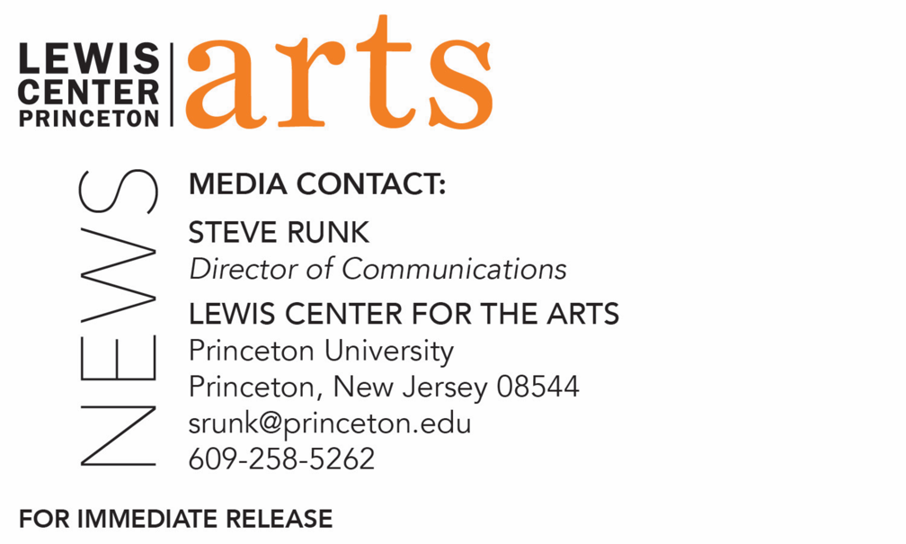

September 13, 2018

Lewis Center for the Arts’ Program in Creative Writing presents
A Reading with Li-Young Lee and Lynn Nottage
Award-winning writers open Althea Ward Clark W’21 Reading Series at Princeton

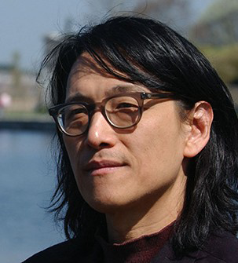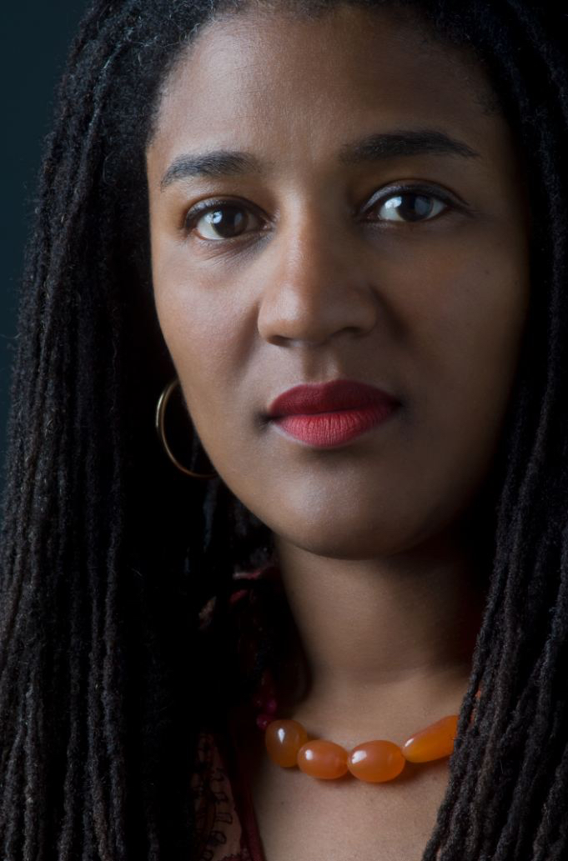
Photo caption 1: Poet Li-Young Lee
Photos credit 1: Courtesy of Li-Young Lee
Photo caption 2: Playwright Lynn Nottage
Photos credit 2: Courtesy of Lynn Nottage

Who: Reading by award-winning poet and memoirist Li-Young Lee and Pulitzer Prize-winning playwright Lynn Nottage
What: First reading in the 2018-19 Althea Ward Clark W’21 Reading Series
When: Wednesday, September 26 at 7:30 p.m.
Where: Wallace Theater at Lewis Arts complex on the Princeton University campus
Free and open to the public

(Princeton, N.J.) On Wednesday, September 26, award-winning poet and memoirist Li-Young Lee and Pulitzer Prize-winning playwright and screenwriter Lynn Nottage will read from their work as part of the Althea Ward Clark W’21 Reading Series of the Program in Creative Writing at the Lewis Center for the Arts. The reading, beginning at 7:30 p.m. in the Wallace Theater at the Lewis Arts complex on the Princeton University campus, is free and open to the public. In response to audience feedback, all readings for this year’s series will move from 4:30 p.m. to a 7:30 p.m. evening time slot.

Li-Young Lee is the author of five books of poetry, including his newest collection, The Undressing, which is forthcoming this year. His earlier collections are Behind My Eyes; Book of My Nights; Rose, winner of the Delmore Schwartz Memorial Award; The City in Which I Love You, the 1990 Lamont Poetry Selection; and a memoir entitled The Winged Seed: A Remembrance, which received an American Book Award from the Before Columbus Foundation. Lee’s honors include fellowships from the National Endowment for the Arts, The Lannan Foundation, and the John Simon Guggenheim Memorial Foundation, as well as grants from the Illinois Arts Council, the Commonwealth of Pennsylvania, and the Pennsylvania Council on the Arts.

Lee will be introduced by Monica Youn, Lecturer in the Program in Creative Writing, whose poetry collection Blackacre won the William Carlos Williams Award of the Poetry Society of America, was longlisted for the National Book Award, and was named one of the best poetry collections of the year by The New York Times and the Washington Post.

Lynn Nottage is a Pulitzer Prize-winning playwright and a screenwriter. Her plays have been produced widely in the United States and throughout the world. Her most recent play, Mlima's Tale, premiered at the Public Theater in May 2018. In the spring of 2017, Sweat, recipient of the 2017 Pulitzer Prize for Drama, an Obie Award, Susan Smith Blackburn Prize, a Tony nomination, and Drama Desk nomination, moved to Broadway after a sold-out run at The Public Theater. It premiered and was commissioned by Oregon Shakespeare Festival American Revolutions History Cycle/Arena Stage. Her other award-winning plays include By The Way, Meet Vera Stark; Ruined, winner of the 2009 Pulitzer Prize for Drama; Intimate Apparel, recipient of both American Theatre Critics and New York Drama Critics’ Circle Awards for Best Play, recently produced at McCarter Theatre; Fabulation, or The Re-Education of Undine, winner of an OBIE Award; Crumbs from the Table of Joy; Las Meninas; Mud, River, Stone; Por’knockers; and POOF!. She developed This is Reading, a performance installation based on two years of interviews, at the Franklin Street, Reading Railroad Station in Reading, PA, in July 2017. She is working with composer Ricky Ian Gordon on adapting her play Intimate Apparel into an opera, commissioned by The Met/LCT. She is currently an artist-in-residence at the Park Avenue Armory. Nottage is currently writing the book for the world premiere musical adaptation of Sue Monk Kidd's novel The Secret Life of Bees, with music by Duncan Sheik and lyrics by Susan Birkenhead. It will premiere at the Atlantic Theatre Company in May 2019, directed by Sam Gold. She is the co-founder of the production company, Market Road Films, whose most recent projects include The Notorious Mr. Bout directed by Tony Gerber and Maxim Pozdorovkin; First to Fall; and Remote Control, recipient of a 2013 New Currents Award. Over the years, she has developed original projects for HBO, Sidney Kimmel Entertainment, Showtime, This is That, and Harpo Productions. She is writer/producer on the Netflix series She's Gotta Have It, directed by Spike Lee. Nottage is the recipient of numerous awards include a MacArthur "Genius Grant" Fellowship, PEN/Laura Pels Master Playwright Award, Merit and Literature Award from The Academy of Arts and Letters Letters, Doris Duke Artist Award, the inaugural Horton Foote Prize, Helen Hayes Award, and the Jewish World Watch iWitness Award. She is an Associate Professor in the Theatre Department at Columbia School of the Arts. Nottage has also taught in the Program in Theater at Princeton and was an Artist-in-Residence for Princeton’s Department of African American Studies.

Nottage will be introduced by A.M. Homes, Lecturer in the Program in Creative Writing and author of five novels including her most recent, May We Be Forgiven, which won the prestigious Women’s Prize for Fiction (formerly known as the Orange Prize).

The Lewis Center’s Program in Creative Writing annually presents the Althea Ward Clark W’21 Reading Series, which provides an opportunity for students, as well as all in the greater Princeton region, to hear and meet the best contemporary writers. All readings are at 7:30 p.m. in venues in the Lewis Arts complex and are free and open to the public. Other readings scheduled in the 2018-2019 series include:
- Robin Coste Lewis and Sheila Heti on October 17 in the Hearst Dance Theater
- Guy Maddin and Caryl Phillips on November 14 in the Wallace Theater
- Layli Long Soldier and Princeton Hodder Fellow Jacob Shores-Argüello on February 6 in the Hearst Dance Theater
- Frank Bidart and Yuri Herrera-Guitierrez on March 6 in the Donald G. Drapkin Studio
- Han Kang and Ngũgĩ wa Thiong’o on April 17 in the Hearst Dance Theater

The series will also include readings of new work in December and May by selected students in Creative Writing courses and readings in May by seniors in the Program from the novels, collections of short stories, poems or translations, or screenplays written as their senior theses under mentorship by the Creative Writing faculty.

To learn more about this event, the Program in Creative Writing, and the more than 100 other performances, exhibitions, readings, screenings, concerts, and lectures presented each year by the Lewis Center, most of them free, visit arts.princeton.edu.

###

