November 21, 2014

Lewis Center for the Arts presents Amid the Noise
Concert by Princeton Arts Fellow Jason Treuting, Sō Percussion, and guests

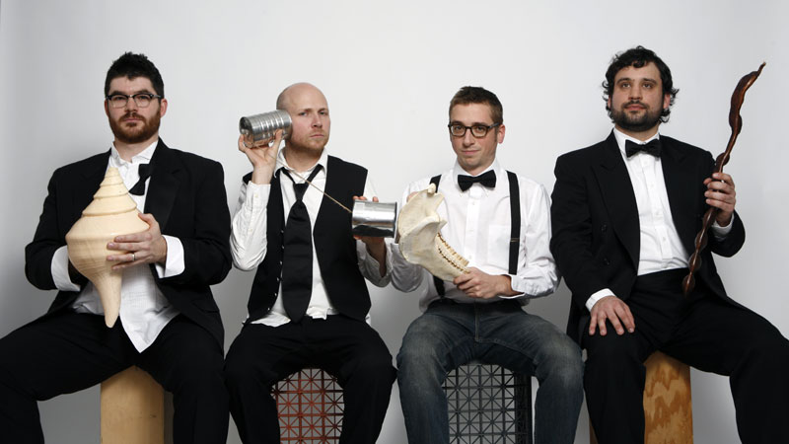
Photo caption: Princeton Arts Fellow Jason Treuting (second from left) and members of Sō Percussion
Photo credit: Photo by Janette Beckman

What: Amid the Noise, an evening-length work combining music and video
Who: Princeton Arts Fellow Jason Treuting, joined by his percussion ensemble and the Department of Music’s Edward T. Cone Ensemble-in-Residence Sō Percussion, the Princeton Laptop Orchestra led by Jeff Snyder, members of the newly formed Princeton Percussion Ensemble, Cenk Ergun, Beth Meyers, Grey McMurray, and five undergraduate student musicians who make up the core of the concert performers: Divya Farias, Noah Fishman, Logan Roth, Spencer Hadley, and Nikhilesh Sigatapu.
When: Wednesday, December 3 at 8:00 p.m.
Where: Marie and Edward Matthews ’53 Acting Studio at 185 Nassau Street, Princeton
Free and open to the public

(Princeton, NJ) The Lewis Center for the Arts will present Amid the Noise, a re-orchestration of an evening-length multimedia work composed by Princeton Arts Fellow Jason Treuting with video by Jenise Treuting. The work will be performed by five undergraduate student musicians who make up the core of the concert performers, Treuting’s ensemble Sō Percussion, the Princeton Laptop Orchestra led by Jeff Snyder, members of the newly formed Princeton Percussion Ensemble, Cenk Ergun on laptop, Beth Meyers on viola, and Grey McMurray on guitar. The performance will begin at 8:00 p.m. in the Marie and Edward Matthews ’53 Acting Studio at 185 Nassau Street and is free and open to the public.

As a composer, performer, and improviser, Treuting creates pieces that translate numbers and letters into patterns of sound. He has performed and recorded in venues as diverse as the Brooklyn Academy of Music, the Andy Warhol Museum, Zankel Hall, Lincoln Center, DOM in Moscow, and Le National in Montreal. In addition to his work with Sō Percussion, Treuting performs improvised music with Simpl, a laptop ensemble led by artist/composer Cenk Ergun; Alligator Eats Fish with guitarist Grey McMurray; Little Farm, with guitarist/composer and Princeton Professor Steve Mackey; QQQ (a quartet consisting of hardinger fiddle, viola, guitar and drums); and Big Farm (a foursome led by Rinde Eckert and Steve Mackey).

Treuting has been called “genre-busting” by The New York Times, and his music has been called “rich and engrossing” by Time Out New York. His work has been featured on NPR’s Weekend Edition and WNYC’s Soundcheck and Evening Music. His first album with Sō Percussion, Amid the Noise, was chosen as a top ten album of the year by All About Jazz and “Spring” from QQQ’s Unpacking the Trailer was selected as track of the week by USA Today. Treuting received his Bachelor in Music and the Performer’s Certificate at the Eastman School of Music, and subsequently his Masters in Music along with an Artist Diploma from Yale University, where he studied percussion with Robert Van Sice. Treuting also traveled to Japan to study marimba with Keiko Abe and to Bali to study gamelan with Pac I Nyoman Suadin.

Jenise Treuting, who created the video for this piece and is Jason’s sister, has made videos for many other Sō Percussion projects, including Music Trains and Imaginary City. Treuting earned her B.A. in mass communication from California State University before moving to Japan, where she earned a master’s degree in journalism from Doshisha University in Kyoto. In her work, Treuting often explores cross-cultural issues through documentary.

The undergraduate students who make up the core of the ensemble for the concert are Divya Farias ’15, Noah Fishman ’16, Logan Roth ’15, Spencer Hadley ’17, and Nikhilesh Sigatapu ’15.

For over a decade, Sō Percussion has redefined and expanded the boundaries for modern percussion ensembles, pushing its voice to the forefront of American musical culture. Praised by The New Yorker for its “exhilarating blend of precision and anarchy, rigor and bedlam,” Sō has produced 16 albums and an array of collaborative projects. The ensemble tours nationally and internationally, runs several educational programs, and keeps up a steady output of original music. In the years since its first major new work, the 36-minute, three movement piece entitled, the so-called laws of nature, Sō has commissioned some of the greatest American composers to build a new repertoire, including Steve Reich, Steve Mackey, Paul Lansky, Martin Bresnick, and many others. Sō has been featured at many major venues in the U.S., including Carnegie Hall, Lincoln Center, and the Brooklyn Academy of Music. A recent residency at London’s Barbican Centre, as well as tours to western Europe, South America, Russia, and Australia have brought the ensemble international acclaim.

Sō Percussion is also heavily involved in mentoring young musicians. As the newly appointed Edward T. Cone Ensemble-in-Residence in the Department of Music at Princeton University, the ensemble works with both Princeton-affiliated composers and the broader university community. In 2009, Sō created the annual Sō Percussion Summer Institute on the campus of Princeton University. The Institute is an intensive two-week chamber music seminar for college-age percussionists featuring the four members of Sō as faculty in rehearsal, performance, and discussion of contemporary music for students from around the world.

Amid the Noise was one of the first pieces created by Treuting for Sō Percussion, and it later coalesced into an album. Treuting says that many of the pieces were born out of the process of scoring a film created by his sister Jenise called Invitations and Ultimatums. The title Amid the Noise comes from “Desiderata,” a 1927 prose poem by Max Ehrmann, which begins, “Go placidly amid the noise and haste.” This quote accompanies a photograph taken by Jenise that hangs on the wall of Jason’s home and has served as an artistic touch stone for Jason over many years.

Though Amid the Noise was originally scored mostly for percussion, Treuting is re-orchestrating the piece for this event to include many additional forms.

To learn more about this event and the over 100 events presented each year by the Lewis Center for the Arts, visit arts.princeton.edu.

###

