November 11, 2014

Open Studios November 18 at Princeton University
Junior and senior visual artists share and discuss their recent works-in-progress

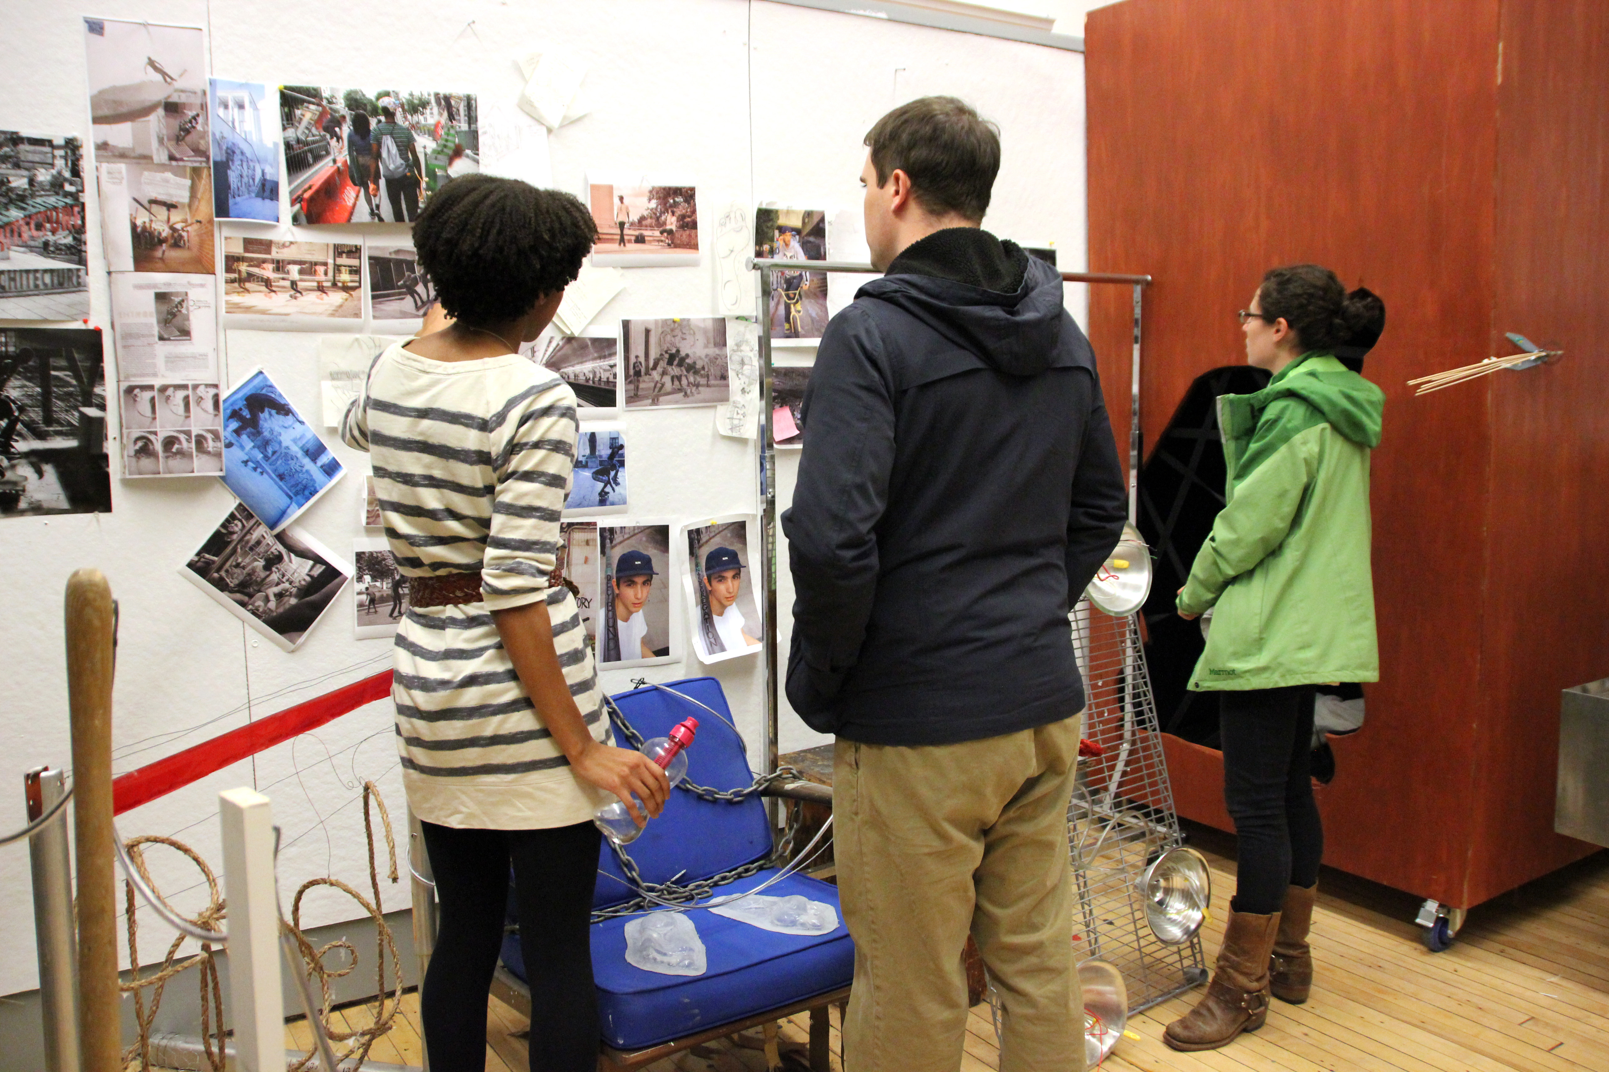
Photo caption: Guests view work by student artist Cara Michell (left) at the 2013 Open Studios event.
Photo credits: M. Teresa Simao

What: Open Studios at Lewis Center the Arts at Princeton University
Who: Juniors and seniors in the Program in Visual Arts invite the public into their art studios to see work in progress.
When: Tuesday, November 18, from 4:30 p.m. to 6:00 p.m.
Where: 185 Nassau St., Princeton
Free and open to the public

(Princeton, NJ) Juniors and seniors in the Program in Visual Arts at Princeton University’s Lewis Center for the Arts will open their studios to share and discuss their recent work and work in progress on Tuesday, November 18, from 4:30 to 6:00 p.m. at the Lewis Center, 185 Nassau Street. The event is free and open to the public.

The evening of open studios will feature work by students in a wide range of media including photography, sculpture, painting, drawing, graphic design, scenic design, and film. Students will be on hand to show and discuss their work.

“Our students often remark that their peers and the public don’t necessarily know what goes on inside 185 Nassau Street,” notes Joe Scanlan, Director of the Program in Visual Arts. “Having open studios offers the entire Princeton community a chance to see creativity in action and to chat with the students behind the work. The students benefit greatly from sharing what they are working on while they are still in the midst of the creative process.”

The open studios event will begin at 4:30 p.m. with junior studios on the fourth floor and will continue at 5:15 p.m. with the senior studios on the second floor.

The studio of Hodder Fellow Miko Veldkamp will also be open with the artist on hand to discuss his work. The Dutch artist, in residence at the Lewis Center for the 2014-15 academic year, combines everyday scenes, personal memories or sentiments with a vigorous painterly handwriting. His paintings have the immediate readability of a pictogram, but despite their flatness and naive style there is a sense of spatial depth and motion. Central in his practice is the question: what can a painter see, that photography and digital media cannot?

Refreshments will be served throughout the evening.

Also opening in the Lucas Gallery at 185 Nassau Street on November 18 is an exhibition of work by students in fall painting and sculpture courses, and running through December 3. Upcoming exhibitions include artist books created by juniors in the Program in Visual Arts along with work by students in fall photography, video and graphic design courses running January 14 through February 10; a reception will be held on February 4 from 4:00 to 5:00 p.m. with an accompanying film screening of fall semester student work from 4:30 to 7:00 p.m. in the James Stewart Theater, also at 185 Nassau Street.

Between exhibitions the gallery is being used throughout the fall as a lab with different classes moving in to create work in the space. In a recent lab Scanlan and the students in his course, “Contemporary Art and the Amateur,” collaboratively reenacted a drawing by the legendary conceptual artist Sol LeWitt on the walls of the gallery.

To learn more about the Program in Visual Arts and over 100 other events presented annually at the Lewis Center visit princeton.edu/arts.

###

