December 19, 2015

MADMAN, a dramatic reading of Nikolai Gogol’s “Diary of a Madman” as performed by the actor Jake Robertson
Classic Russian story with a twist explores the art of performing itself

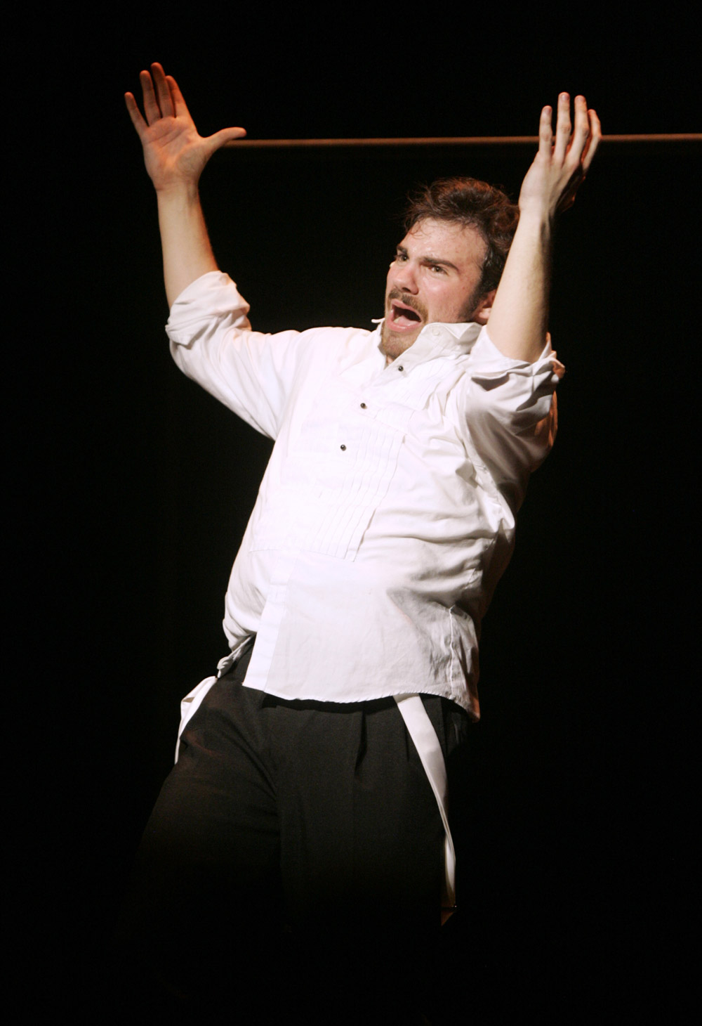
Photo Caption: Jake Robertson, a senior in the Lewis Center for the Art’s Program in Theater at Princeton, as Max Bialystock in last season’s production of The Producers
Photo Credit: Frank Wojciechowski

What: MADMAN, a dramatic reading of Nikolai Gogol’s “Diary of a Madman” as performed by the actor Jake Robertson
Who: Presented by the Lewis Center for the Arts’ Program in Theater, directed by faculty member R.N. Sandberg, and featuring senior theater certificate student Jake Robertson
When: January 8 at 8:00 p.m., January 9 at 8:00 p.m. and 11:00 p.m. and January 10 at 2:00 p.m. and 8:00 p.m.
Where: Class of 1970 Theater at Whitman College on the Princeton campus
Free and open to the public; no reservations required

(Princeton, NJ) The Lewis Center for the Arts’ Program in Theater will present MADMAN, a dramatic reading of Nikolai Gogol’s “Diary of a Madman” as performed by the actor Jake Robertson or more briefly titled, MADMAN/Robertson. This new one-man theatrical adaptation of the classic Russian short story with a twist, featuring senior theater certificate student Jake Robertson and directed by faculty member R.N. Sandberg, explores the act of performing itself as Robertson assumes all the characters in story. Performances will take place in the Class of 1970 Theater at Whitman College on January 8th at 8:00 p.m., January 9th at 8:00 p.m. and 11:00 p.m., and January 10th at 2:00 p.m. and 8:00 p.m.

“Diary of a Madman,” the farcical short story on which this piece is based, follows Poprishchin, a disenchanted civil servant living in Russia during the repressive era of Czar Nicholas I, and whose immense financial and personal struggles lead him to vent his frustrations in his diary. Entries shift from belittling reports of his superiors, to his obsession with his boss’s daughter, to a suspicion that dogs can talk. When Poprishchin reads that the King of Spain has died without an heir, he realizes his destiny and declares himself King Ferdinand VIII. The story follows Poprishchin’s gradual descent into madness after a string of failures in life and love.

In this innovative and highly personal adaptation, Robertson explores the characters in the story, as well as the art of performing itself. MADMAN/Robertson investigates how much true difference there is between a nineteenth century clerk, an obsessive 21-year-old contemporary actor, and the heir to the throne of Spain. As the performance progresses and the madness takes over, this production addresses the question, “How do we know who we really are?”

Robertson is majoring in Slavic Languages and Literatures in addition to pursuing a certificate in theater, for which this production is his senior thesis project. Having read the Gogol story in a course, he found parallels between the main character’s descent into madness and the demand on actors to completely become the characters they inhabit. As an actor, Robertson has taken on a wide range of characters in Lewis Center productions including Max Bialystock in the musical The Producers, “Him” in Marina Carr’s drama Woman and Scarecrow, Serebriakov in Chekov’s classic Uncle Vanya, and Judge Brack in Ibsen’s Hedda Gabler. He has also performed the role of King Lear, among others, with Princeton Shakespeare Company, is artistic director of the student improv group Quipfire!, performed with Theater Intime, has written and performed for the legendary Triangle Club, and writes for and co-hosts the web-broadcast late night student talk show All-Nighter. Robertson’s post-graduation plans include applying for prospective fellowships to study acting in the U.K. and, generally, pursuing a career in the theater.

Both a director and a playwright, Sandberg directed recent Lewis Center productions including Uncle Vanya, A Steady Rain, A Broad Abroad, and Fires in the Mirror, as well as Princeton Summer Theater productions of Gaslight and The Heidi Chronicles. His play, Roundelay, premiered at Passage Theater in 2013. His plays have been seen in Australia, Canada, England, Japan, Panama, and South Korea, as well as at theaters throughout the U.S. including the Barter, Dallas Children’s Theater, Providence Black Rep, Stages Repertory Theatre and Yale Cabaret. He has been commissioned by, among others, George Street Playhouse, McCarter Theatre, Metro Theater Company, and Seattle Children’s Theatre. Sandberg is a Princeton alumnus and in 2014 received the University’s President's Distinguished Teaching Award.

Nikolai Gogol was a Russian dramatist, novelist, and short story writer. Many of his works satirized political corruption in the Russian Empire—a trend that eventually led to his exile. Gogol’s novel Dead Souls and his short story “The Overcoat” are recognized as the foundations of the great 19th-century tradition of realism. “Diary of a Madman” is widely considered to be one of Gogol’s greatest short stories and is his only work written in the first person. Near the end of his life, Gogol himself struggled with severe depression and other mental illnesses. Not only did he refuse to eat, he burned his manuscripts and blamed the incident on a demonic prank. Gogol’s prose is characterized by imaginative power and linguistic playfulness, and he is remembered as a great exposer of the grotesque in human nature.

“Diary of a Madman” has been adapted for the stage several times before, including once by David Holman, Geoffrey Rush, and Neil Armfield for the Belvoir St. Theatre in Sydney, Australia.

Admission for MADMAN/Robertson is free; no advance reservations are required. Seating is on a first-come, first-seated basis.

To learn more about this event, the Program in Theater, and the over 100 other activities presented at the Lewis Center visit arts.princeton.edu.

###

