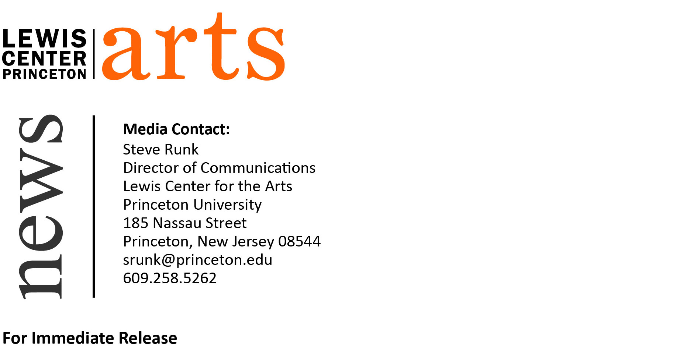

January 26, 2015

“MEDIA STUDIES” focus of Lewis Center for the Arts exhibition and screening of student work from fall semester classes in
the Program in Visual Arts

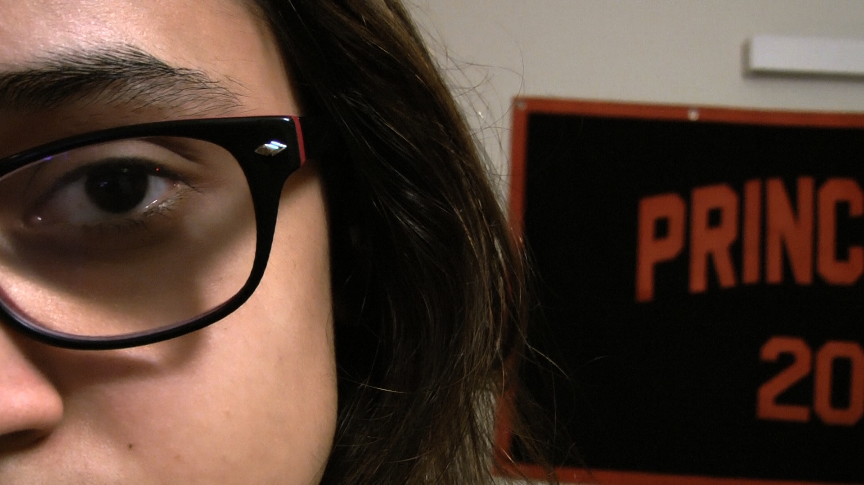
Caption: A still from “Gutted,” an experimental narrative film by Angélica Viélma, one of the students in Keith Sanborn’s course “Introductory Film and Video Production.” The film concerns a student’s inner struggle with supporting her family by drug trafficking, one of the short films to be screened as part of the exhibition.
Credit: Angélica Viélma

What: “MEDIA STUDIES” an exhibition of new work in a wide array of mechanical and electronic media
Who: Work by students in the Lewis Center for the Arts’ Program in Visual Arts curated from a dozen fall courses in experimental and documentary film production, analog and digital photography, typography, graphic design and desktop publishing, and consumer media and DIY culture
When: reception February 4 at 4:30 - 6:00 p.m.; screening February 4 at 5:30 p.m.
Where: Exhibition in Lucas Gallery and screening in James M. Stewart ’32 Theater, both at 185 Nassau St. on the Princeton campus
Dates: February 2 - 10
Gallery Open: Monday - Friday from 10:00 a.m. to 4:30 p.m.
Free and open to the public
(Princeton, NJ) The Lewis Center for the Arts’ Program in Visual Arts will present “MEDIA STUDIES,” an exhibition of new student work from fall 2014 visual arts classes in a wide array of mechanical and electronic media. The work was curated from a dozen courses in experimental and documentary film production, analog and digital photography, typography, graphic design and desktop publishing, and consumer media and DIY culture. Most of the work will be on view in the Lucas Gallery from February 2 through 10, with documentary films screened on February 4 at 5:30 p.m. in the James M. Stewart ’32 Theater. Both venues are located at 185 Nassau Street. An opening reception will be held on February 4 from 4:30 to 6:00 p.m. Both the exhibition and screening are free and open to the public.
The exhibition will feature work created over the past four months by undergraduate students at all levels, some of whom are focusing on a degree or certificate in visual arts and others majoring in a range of other disciplines who are exploring the arts through a course or two. Fall courses represented in “MEDIA STUDIES” include “Contemporary Art and the Amateur”; photography classes such as “Black & White Photography” and “Digital Photography”; graphic design classes in typography and visual form; an interdisciplinary dance/video class, “Dance on Camera”; and the senior film seminar. Additionally, student-produced short works from an “Introductory Video and Film Production” class will be screened on monitors in the gallery during the exhibition.

All of the courses from which the work has been drawn are designed to engage students in creative processes in which the artist rarely comes into direct physical contact with his or her artworks – at least not until it comes out of an inkjet printer, gets projected onto a screen, or is scrolled across a smartphone or iPad. Many works in the exhibition are digital files that exist solely in the virtual habitat of the Internet.

“What’s important to notice in this exhibition,” notes Joe Scanlan, Director of the Program in Visual Arts and curator of the show, “is that, for all their mechanical and electronic ephemerality, all of these works retain the charm of human creation. These days, an artwork’s ability to be accessed, copied, and shared can betray its humanity as much as the material sensibilities and manual skills of its maker.”

The screening will present three documentary films produced by students in a “Documentary Filmmaking” course. This course gave students an introduction to documentary film and video production, with a special emphasis on the practical challenges of producing films in the real world. The films that will be screened include “Less Than” about a Princeton student who returns to campus after experiencing a traumatic event; “Sakha,” which tells a story about finding love; and “Passion with White Chocolate,” about a Haitian baker and his craft.

Adds Scanlan: “The great German literary critic Walter Benjamin, in his landmark essay ‘The Work of Art in the Age of Mechanical Production,’ foresaw a future in which the merging of technology, aesthetics, and politics would cause the work of art to lose the auratic mystery of originality and be able to move more freely and democratically through the world. In these classes, with these professors and students, it would appear that future has come.”

To learn more about these events, the Program in Visual Arts, and the more than 100 public events presented each year by the Lewis Center visit www.princeton.edu/arts.

###

