January 29, 2014

Evie Shockley and Meg Wolitzer Read at Lewis Center for the Arts
Award-winning writers next in Althea Ward Clark W’21 Reading Series

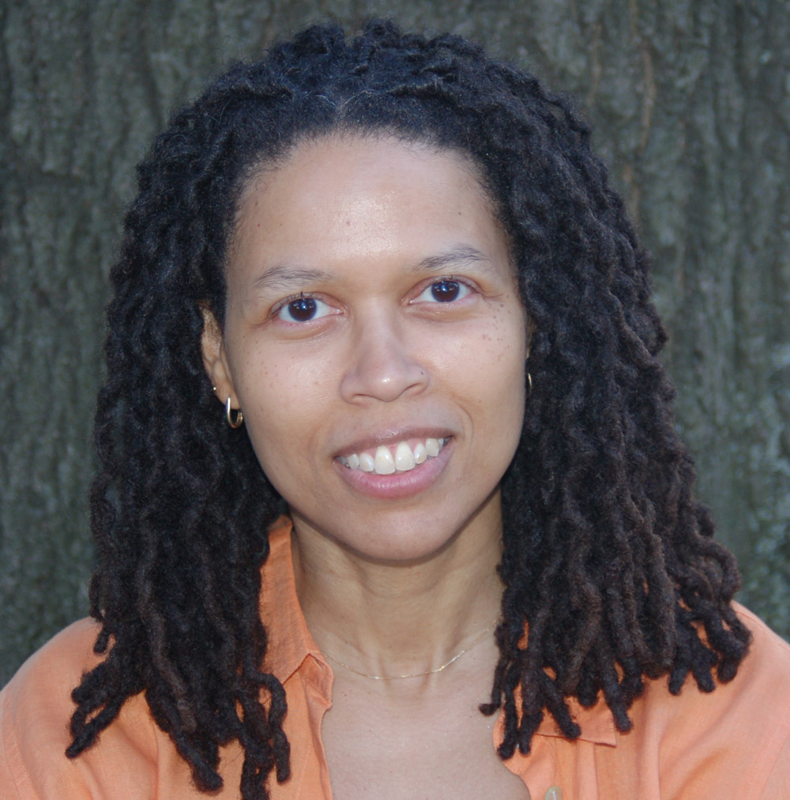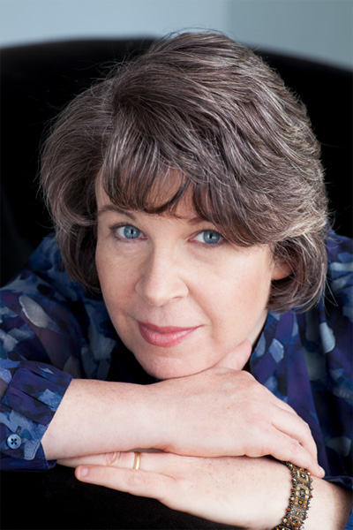
Photo Caption 1: Poet Evie Shockley
Photo Credit 1: Photo courtesy Evie Shockley
Photo Caption 2: Writer Meg Wolitzer
Photo Credit 2: Nina Subin

What: Reading - Althea Ward Clark W’21 Reading Series
Who: Poet Evie Shockley and novelist Meg Wolitzer
When: Wednesday, February 11 at 4:30 p.m.
Where: Berlind Theatre at McCarter Theatre Center
Free and open to the public

(Princeton, NJ) On Wednesday, February 11, poet Evie Shockley and novelist Meg Wolitzer will read from their works as part of the Althea Ward Clark W’21 Reading Series of the Program in Creative Writing at the Lewis Center for the Arts. The reading, beginning at 4:30 p.m. at the Berlind Theatre at the McCarter Theatre Center, is free and open to the public.

Evie Shockley is an award-winning poet and critic whose publications include two collections of poetry, the new black (2011) and a half-red sea (2006), and the critical volume Renegade Poetics: Black Aesthetics and Formal Innovation in African American Poetry (2011). Shockley’s honors include fellowships from Cave Canem, the Millay Colony for the Arts, the American Council of Learned Societies, and the Schomburg Center for Research in Black Culture of the New York Public Library. She is the recipient of the 2012 Holmes National Poetry Prize awarded by the Lewis Center for the Arts’ Program in Creative Writing. She teaches African American Literature and Creative Writing at Rutgers University-New Brunswick, where she received a Faculty Scholar-Teacher Award for 2013-2014.

Shockley will be introduced by Susan Wheeler, a National Book Award in Poetry finalist and Professor and Director of the Program in Creative Writing at the Lewis Center.

Meg Wolitzer’s novels include The Interestings (2013); The Uncoupling (2011); The Ten-Year Nap (2008); The Position (2005); and The Wife (2003). She is also the author of a novel for young readers, The Fingertips of Duncan Dorfman (2011). Wolitzer's short fiction has appeared in The Best American Short Stories and The Pushcart Prize. In fall 2013, along with singer-songwriter Suzzy Roche, Wolitzer was a guest artist in the Princeton Atelier program at the Lewis Center. She has also taught writing at the University of Iowa Writers' Workshop and at Skidmore College.

Wolitzer will be introduced by Colson Whitehead, who is a recipient of a MacArthur Fellowship and a Lecturer in Creative Writing at the Lewis Center.

The Lewis Center’s Program in Creative Writing is sponsoring this event as part of the Althea Ward Clark W’21 Reading Series which provides an opportunity for students, as well as all in the greater Princeton region to hear and meet the best writers of contemporary poetry and fiction. All readings are free and open to the public and take place on select Wednesdays at 4:30 p.m. at the Berlind Theatre at McCarter Theatre Center.

Other upcoming readings in the series include A.E. Stallings and Akhil Sharma on March 11 and Rachel Kushner and John Yau on April 15. Students in creative writing courses during the spring semester will read from their recent work on April 29, and seniors in the program will read from the novels, screenplays, translations and collections of poems and short fiction created as part of their senior thesis projects on May 4 and 6.

To learn more about the Program in Creative Writing, the Reading Series, and the more than 100 events offered annually by the Lewis Center visit arts.princeton.edu.

###

