February 16, 2015

Oscar-nominated filmmaker Andrew Jarecki at Lewis Center for the Arts
Screening of his HBO documentary series The Jinx: The Life and Deaths of Robert Durst followed by Conversation with Lewis Center Chair Michael Cadden

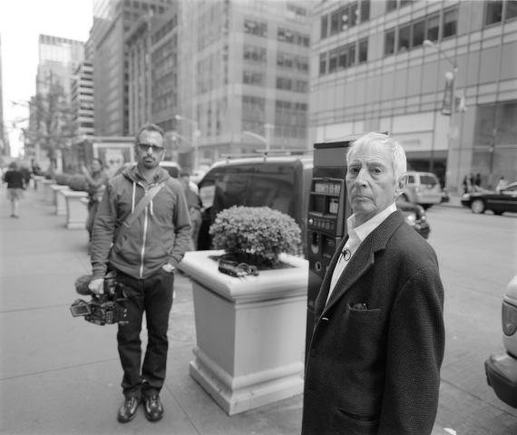
Photo caption: Andrew Jarecki ’85 and Robert Durst
Photo credit: Courtesy HBO Studios/Andrew Jarecki

Who: Princeton alumnus Andrew Jarecki ’85 visits Princeton
What: Screening of Episodes 1 and 2 of the HBO Documentary Series, The Jinx: The Life and Deaths of Robert Durst, and a conversation with Jarecki and Lewis Center Chair Michael Cadden, presented by the Lewis Center for the Arts
When: Friday, February 20 at 6:00 pm
Where: James M. Stewart ’32 Theater at 185 Nassau St.
Admission is free and open to the public but advance reservations are recommended

(Princeton, NJ) The Lewis Center for the Arts will welcome Oscar-nominated alumnus Andrew Jarecki ’85 back to campus for a screening and discussion of his new HBO documentary series, The Jinx: The Life and Deaths of Robert Durst, on Friday, February 20, at 6:00 p.m. in the James M. Stewart ’32 Theater at 185 Nassau Street. The event begins with a reception and is free and open to the public.

Jarecki directed and produced the landmark documentary film Capturing the Friedmans (2003), which was nominated for an Academy Award and won 18 major international prizes including the Grand Jury Prize at the Sundance Festival, and the New York Film Critics Circle Award. He graduated from Princeton University with a degree in English literature and a certificate in the Program in Theater and Dance. He also directed and produced the narrative feature All Good Things (2010), starring Ryan Gosling, Kirsten Dunst, and Frank Langella, and produced the acclaimed documentary Catfish, also released in 2010. He is executive producer of Catfish, the television series, and has co-written and performed music for film and television including Felicity and Silver Linings Playbook. Jarecki also founded Moviefone and served as Chief Executive until he sold the company to America Online in 1999. He is a member of the advisory board of The Marshall Project and of the Director’s Advisory Council of the Sundance Institute. The Jarecki Family Foundation is devoted to supporting efforts to improve the criminal justice system. He is also a member of the Lewis Center for the Arts’ Advisory Council.

Now premiering on HBO, The Jinx: The Life and Deaths of Robert Durst is a six-part series that tracks the strange history of Robert Durst, scion of a New York City’s billionaire real estate family, who has been accused of three murders over the past 30 years but never convicted. Durst’s story was also the inspiration for Jarecki’s All Good Things. Brilliant and reclusive, Durst has not spoken publicly – until now. The show, which debuted on HBO on February 8, exposes long-buried information discovered during Jarecki and his partner Marc Smerling’s ten-year investigation of a series of unsolved crimes, and was made with the cooperation of the man suspected of being at their center. “Over the decade in which we pursued the story through all its unexpected revelations, uncovering the truth became an obsession,” says Jarecki. “Now the audience can watch it unfold in front of them as it did for us.”

“We are incredibly pleased to bring Andrew to Princeton to talk about this project and his work as a storyteller,” notes Michael Cadden, Chair of the Lewis Center. “Many people are not aware of the many film and television artists who have come out of Princeton, including Winnie Holzman ’76, creator of the series My So-Called Life; Ethan Coen ’79 of the Oscar-winning Coen Brothers; Alex Gansa ’84 and Howard Gordon ’84, the team behind Homeland and 24; producer and screenwriter David E. Kelley ’79 (The Practice, Ally McBeal, Boston Legal); and Jennie Snyder Urman, the creative force behind this year’s groundbreaking CW Network series Jane the Virgin. The Lewis Center takes pride in how Princeton has nurtured these artists and looks forward to growing in ways that will empower the next generation to use film, television and media yet to be invented to tell their stories.”

Following the screening of Episodes 1 and 2 of The Jinx, at approximately 8:15 p.m. Cadden will engage Jarecki in a discussion about the series and his work as a filmmaker. The audience will have an opportunity to ask questions.

Admission is free but advance ticket reservations are recommended and can be made online at arts.princeton.edu or directly through EventBrite.

To learn more about this event and the more than 100 other events presented each year by the Lewis Center for the Arts visit: arts.princeton.edu

###

