February 18, 2015

Lewis Center for the Arts screens Stories of Our Lives
exploring the queer experience in Kenya
Kenyan filmmakers Jim Chuchu and George Gachara
discuss the making of the film, part of the John Sacret-Young ’69 Lecture Series

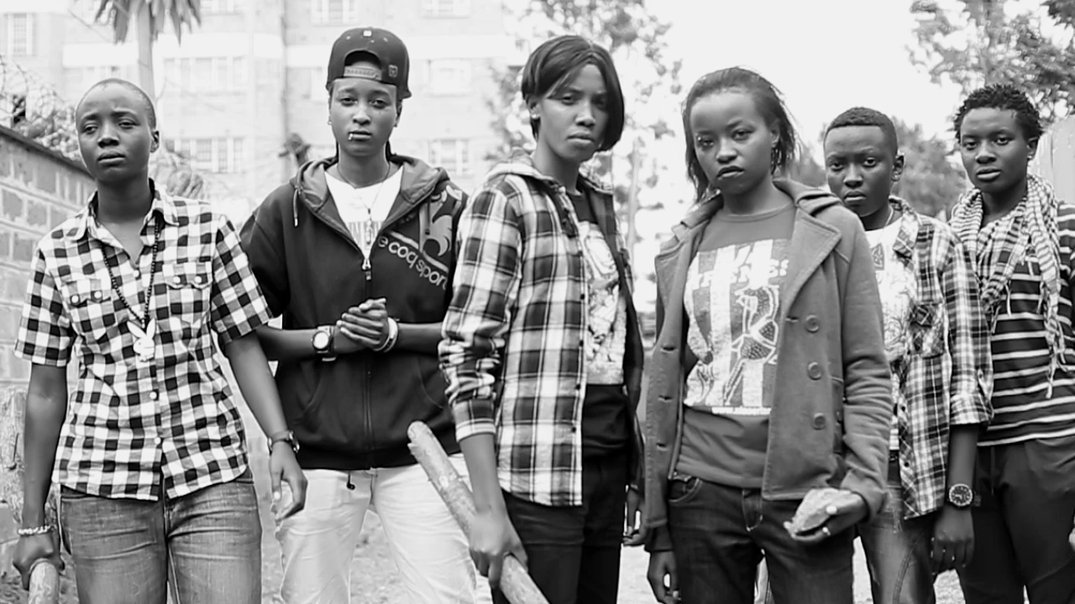
Photo caption: Still from Stories of Our Lives on the gay, lesbian, bisexual, transgender and intersex community in Kenya
Photo credit: The NEST Collective

What: Screening of the film Stories of Our Lives exploring the gay, lesbian, bisexual, transgender and intersex community in Kenya followed by a talk by the filmmakers, part of the John Sacret-Young ’69 Lecture Series
Who: Film produced by The NEST Collective with a talk by director and screenwriter Jim Chuchu and executive producer George Gachara presented by the Lewis Center for the Arts’ Program in Visual Arts
When: February 25 at 4:30 p.m.
Where: James M. Stewart ’32 Theater at Lewis Center for the Arts, 185 Nassau St., Princeton
Free and open to the public

(Princeton, NJ) Lewis Center for the Arts’ Program in Visual Arts at Princeton University will screen The NEST Collective’s recent film, Stories of our Lives, a film about the queer community in Kenya. The screening will be followed by a talk with the film’s director and screenwriter Jim Chuchu and executive producer George Gachara, part of the John Sacret-Young ’69 Lecture Series. The event will take place on Wednesday, February 25 at 4:30 p.m. in the James M. Stewart ’32 Theater at 185 Nassau Street and is free and open to the public.

The creation of Stories of Our Lives began in June 2013 when the members of The NEST Collective began collecting and archiving the stories of persons identifying as gay, lesbian, bisexual, transgender, and intersex from Kenya, often unheard stories that characterize the queer experience in Kenya. After several months of touring and collecting hundreds of vivid, compelling stories, the Collective decided to turn some of these stories into short films. The scripts were based on a number of the stories the filmmakers recorded, and they shot the films over the course of eight months. The resulting shorts were edited together into Stories of Our Lives. It is the Collective’s first feature film in partnership with Uhai/EASHRI and Big World Cinema, and was screened at the Internationale Filmfestspiele Berlin, as well as the Toronto International Film Festival, where it was a 2014 Official Selection. The film is currently being screened at the Museum of Modern Art as part of the Documentary Fortnight series.

The NEST Collective is a multidisciplinary collaborative of ten Kenyans working collectively since 2012 with the aim of exploring their modern identities, re-imagining their pasts, and inhabiting mythical African futures. The Collective seeks to create work within the fields of film, visual arts, music, and fashion that begin conversations and generate dialogue among their communities and audiences. The group lives and works in Nairobi. The group notes that it finds itself exploring, dissecting, and subverting the layers of how, “Africans are seen and unseen, what Africans can and cannot do, where Africans can and cannot go, and what Africans can and cannot say.”

The film is being screened as part of a spring Lewis Center film course, “Special Topics in Film History: World Cinema in a Global Context” being taught by film scholar Michael Cramer. Through a survey of 21st-century world cinema, the course examines the institutional and theoretical frameworks that inform film’s production ranging from “art” films to popular cinema and the relationship between global/local markets and audiences, cinematic constructions of national or post-national identity in a global age, evolving approaches to reception and interpretation, and shifts in representation and distribution brought about by new media.

The creators of Stories of Our Lives will participate in a discussion of their film following the screening. Gachara is the co-founder and Head of Program Design at The NEST Collective and served as executive producer of the film. He was recently at the forefront of a clash with the Kenya Film Classification Board and the Department of Film Services over the film’s content. He was arrested on behalf of the entire team and charged with filming without a license. He was later released on bail and awaits a hearing of his case in March 2015. Chuchu is a co-founder and Creative Director at The Collective. He is also a visual artist, filmmaker, and musician and served as the film’s director, co-writer, and editor and created music for the film’s score. His first short film Homecoming premiered at the 2013 Toronto International Film Festival and was screened at the Rotterdam, Santa Barbara, Seattle, and Durban film festivals.

John Sacret Young, for whom the lecture series is named, is a 1969 graduate of Princeton and an author, producer, director, and screenwriter. Young has been nominated for seven Emmy Awards and seven Writers Guild of America (WGA) Awards, winning two WGA Awards. He is perhaps best known for co-creating, along with William F. Broyles Jr., China Beach, the critically acclaimed ABC-TV drama series about medics and nurses during the Vietnam War, and for his work on the television drama The West Wing. Young has also received a Golden Globe and a Peabody Award, and his original mini-series about the Gulf War, Thanks of a Grateful Nation, was honored with his fifth Humanitas Prize nomination.

To learn more about this event, the Program in Visual Arts, and the more than 100 events offered annually by the Lewis Center visit arts.princeton.edu.

###

