March 23, 2015

Black Balance opens at the Lewis Center for the Arts
Exhibition of photographs by senior Amber Stewart examines the Black experience in domestic and international contexts

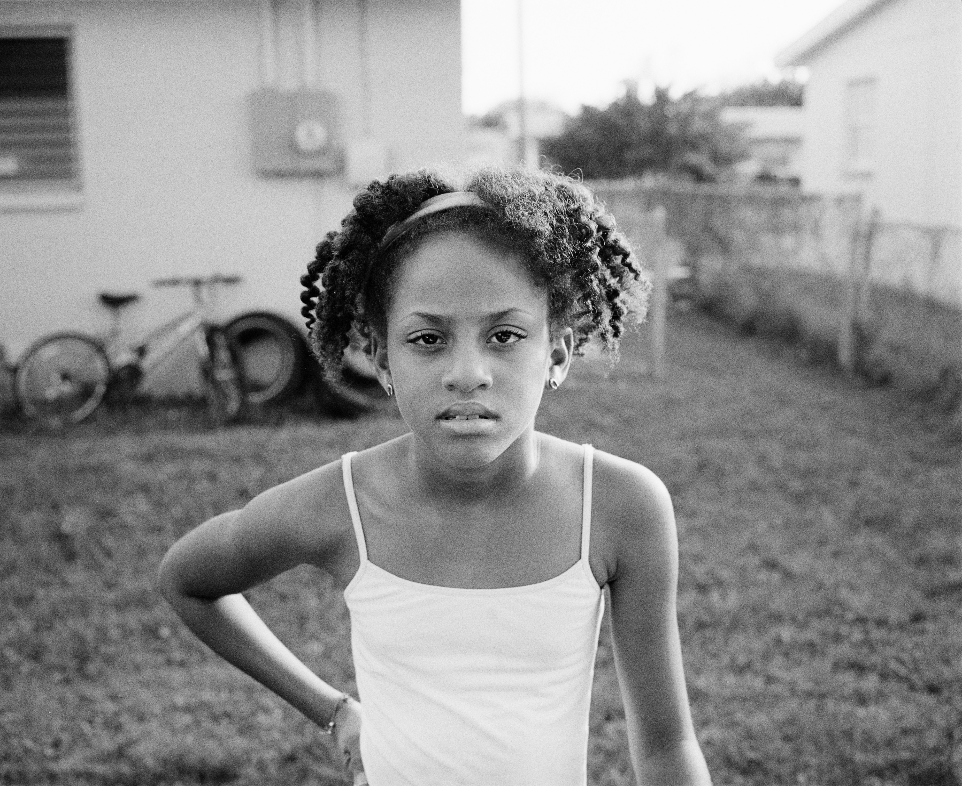
Caption: “Ain’t Nobody Got Time for This,” one of the photographs in senior Amber Stewart’s exhibition, Black Balance.
Photo credit: Amber Stewart

What: Black Balance, an exhibition of large photographic prints examining the Black experience in domestic and international contexts
Who: Created by senior in the Lewis Center’s Program in Visual Arts Amber Stewart
When: March 30-April 3; opening reception Wednesday, April 1 from 6:00 to 7:30 p.m.; Gallery open Monday-Friday, 10:00 a.m. to 4:30 p.m.
Where: Lucas Gallery at 185 Nassau St.
Free and open to the public

(Princeton, NJ) The Lewis Center for the Arts’ Program in Visual Arts at Princeton University will present Black Balance, an exhibition of large photographic prints by senior Amber Stewart. The project examines the Black experience through images by the artist captured in the U.S., Guyana, and Australia. The work will be on view March 30 through April 3 in the Lucas Gallery at 185 Nassau Street. A reception will be held on Wednesday, April 1 from 6:00 to 7:30 p.m. The exhibition and reception are free and open to the public.

Stewart is majoring in visual arts through a collaborative program between Princeton’s Department of Art and Archaeology and the Lewis Center’s Program in Visual Arts, which enables students to focus on studio practice. The Melbourne, Florida native is also pursuing a certificate in the Program in Gender and Sexuality Studies and has taken courses in the Center for African American Studies.

Stewart began her Princeton career with the intention of majoring in chemistry. However a photography course in fall of her sophomore year with the late Sarah Charlesworth, a former member of the Visual Arts faculty, inspired her to pursue photography.

For her upcoming senior thesis exhibition, Stewart travelled to her family’s homeland of Guyana in South America last April. “My experiences in Guyana opened a Pandora’s box of questions about how Blackness exists around the world in different landscapes and contexts.” Shortly after returning from Guyana, Stewart read an article about the Aboriginal people of Australia, and her interest was piqued. She says she knew immediately that she wanted to see what life was like for these members of the Black community on the other side of the planet. She spent the 2014 fall semester abroad in Australia learning about Aboriginal Australians through Princeton’s Study Abroad program.

“There may exist similarities in the lives of Black peoples globally, because the social, historical, and cultural meanings ascribed to their shared Black skin,” states Stewart. “Through a combination of photography, video installations, and text, I intend to demonstrate how oppression blurs divisions, transgresses international waters, and takes dissimilar, yet familiar, forms.” Her use of the familiar to speak to larger, global issues demonstrates her interest in the relationship between micro and macro frameworks, and her interest in testing the limits of how much the experiences of every day people can speak to larger trends.

“Because the different oppressions and abuses are rooted in the same place, Black as Other,” explains Stewart, “they may have musical notes or melodies reminiscent of one another. These are the snippets of sound I am trying to pull together into a unified song with my show. The song isn't intended to be perfect, it will be cacophonous and off-beat and too loud and sometimes jarring and missing lines, but it will have style. As Nikki Giovanni says, ‘Style has profound meaning to Black Americans.’”

Photographs were taken using both film and digital formats and in both color and black and white.

Appropriated materials accompanying the photographs will present quotes from not only sociological, anthropological and philosophical texts, but also pop culture icons that informed her project.

The Lucas Gallery is open Monday through Friday from 10:00 a.m. to 4:30 p.m. Admission is free.

To learn more about exhibitions at the Lucas Gallery, the Program in Visual Arts, and the over 100 other events presented each year at the Lewis Center visit arts.princeton.edu.

###

