March 31, 2015

Lewis Center for the Arts Announces Recipient of the Holmes National Poetry Prize
Poet Matt Rasmussen Selected for Prestigious Award

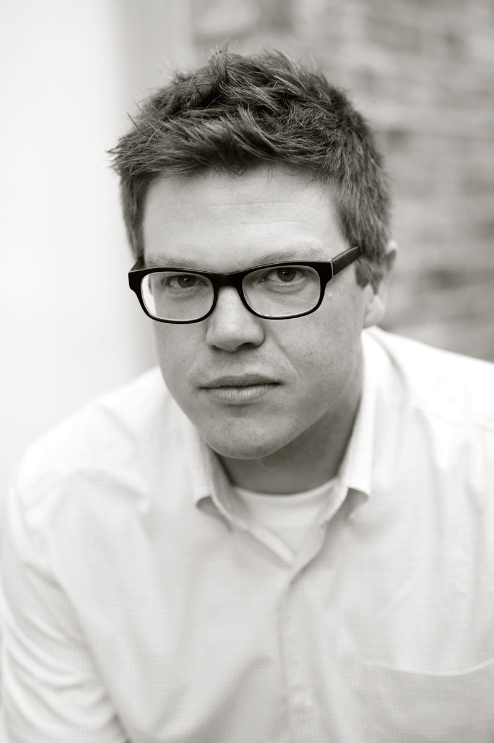
Photo caption: Matt Rasmussen, recipient of the Theodore H. Holmes ’51 and Bernice Holmes National Poetry Prize awarded by the Lewis Center for the Arts’ Program in Creative Writing at Princeton University.
Photo credit: Photo by Stephanie Colgan

(Princeton, NJ) Poet Matt Rasmussen has been selected as the latest recipient of the Theodore H. Holmes ’51 and Bernice Holmes National Poetry Prize awarded by the Lewis Center for the Arts’ Program in Creative Writing at Princeton University.

The Holmes National Poetry Prize was established in memory of Princeton 1951 alumnus Theodore H. Holmes and is presented each year to a poet of special merit as selected by the faculty of the Creative Writing Program, which includes writers Jeffrey Eugenides, Chang-rae Lee, Paul Muldoon, Joyce Carol Oates, James Richardson, Tracy K. Smith, Susan Wheeler, and Edmund White. The award currently carries a prize of $5,000, and was first made to Mark Doty in 2011. The Prize’s candidates are nominated by faculty in the Creative Writing Program.

Matt Rasmussen was born in International Falls, Minnesota in 1975. He earned his B.A. from Gustavus Adolphus College and an M.F.A. from Emerson College. He is the author of Black Aperture, which won the 2013 Walt Whitman Award, the 2014 Minnesota Book Award for Poetry, and was a National Book Award Finalist. Rasmussen’s poems have been published in The Literary Review, Gulf Coast, Water~Stone Review, Paper Darts, Poets.org, and elsewhere. He is the recipient of grants and residencies from the McKnight Foundation, Bush Foundation, Minnesota State Arts Board, Jerome Foundation, The Anderson Center, The Loft Literary Center, and The Corporation of Yaddo. He received a 2014 Pushcart Prize and is a founder and editor of the independent poetry press Birds, LLC. A former Peace Corps Volunteer (Papua New Guinea 1999-2001), Rasmussen now lives in Robbinsdale, Minnesota.

“Through the generosity of the Holmes family, this award is a tremendous opportunity for us to recognize exceptional work, and our recent focus on poets early in their careers means that the award can make a real difference in poets’ perennial seeking of time for writing,” notes Susan Wheeler, Director of the Program in Creative Writing.
To learn more about the Lewis Center for the Arts and the Program in Creative Writing visit arts.princeton.edu.

###

