March 5, 2015

Lewis Center for the Arts’ Program in Dance presents
A Screening of Ze’eva Cohen: Creating A Life In Dance
The recent documentary on founder of the Program in Dance along with a screening of the short film Passing It On: Four Princeton Alumni Look Back and panel discussion on dance in higher education

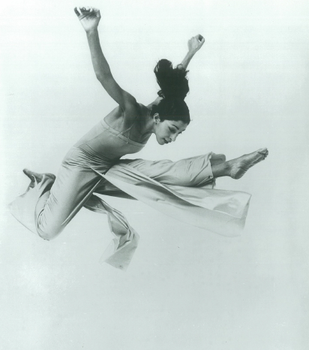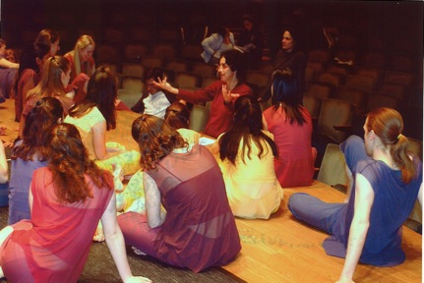
Photo caption 1: Ze’eva Cohen performing in The One of No Way
Photo credit 1: Jack Mitchell
Photo caption 2: Ze’eva Cohen talking with students in rehearsal for a Spring Dance Festival
Photo credit 2: Denise Applewhite

What: A screening of recent documentary film Ze’va Cohen: Creating A Life In Dance, along with a screening of Passing It On: Four Princeton Alumni Look Back, both directed and edited by Sharon Kaufman.
Who: Featuring dancer, choreographer, Professor of Dance Emerita, and founder of the Program in Dance Ze’eva Cohen. Following the screening, a panel discussion between Cohen, Professor of Dance at Swarthmore College Sharon Friedler, and Professor of Dance at Montclair State University Elizabeth McPherson will be moderated by Professor of Dance at Princeton Judith Hamera. Presented by the Lewis Center for the Arts Program in Dance.
When: Thursday, March 12 at 4:30 p.m.
Where: James M. Stewart ’32 Theater at 185 Nassau Street, Princeton, NJ
Free and open to the public

(Princeton, NJ) The Lewis Center for the Arts’ Program in Dance will present a screening of Ze’eva Cohen: Creating A Life In Dance, a documentary directed and edited by Sharon Kaufman, which received its world premiere at the Dance on Camera Film Festival at Lincoln Center in February. The screening of the 32-minute film on dancer, choreographer, Professor of Dance Emerita, and founder of the Program in Dance Ze’eva Cohen will take place at 4:30 p.m. on Thursday, March 12 in the James M. Stewart ‘32 Theater at 185 Nassau Street. The evening will also include a screening of the short film Passing It On: Four Princeton Alumni Look Back. Following the screenings, Princeton Professor of Dance Judith Hamera will moderate a panel discussion on dance in higher education with Cohen, Professor of Dance at Swarthmore College Sharon Friedler, and Professor of Dance at Montclair State University Elizabeth McPherson. This event is free and open to the public.

Ze'eva Cohen: Creating A Life In Dance presents a model of how an artist can survive in the dance world by carving an independent path for herself. Primarily narrated by Cohen, the documentary spans 70 years, encompassing her life as a young dancer in Israel, her work in the U.S. as a soloist, her pioneering 12-year solo repertory concerts, her choreography for diverse dance companies, as well as her educational work at Princeton, where she founded and directed the dance program from 1969 to 2009. The film was recently selected for the Dance on Camera Film Festival at Lincoln Center, where it was shown in early February.

An additional short film, Passing It On: Four Princeton Alumni Look Back, includes conversations with alumni spanning Cohen’s leadership of the dance program and reflecting on Cohen’s teaching and influence on them and their subsequent careers as dancers and choreographers. Alumni include Jose Mateo, Class of 1974, founder of the Jose Mateo Dance Theatre; David Rousseve, Class of 1981, founder and artistic director of David Rousseve/REALITY; Jill Sigman, Class of 1989, founder of jill sigman/thinkdance; and Mariah Steele, Class of 2006, artistic director of Quicksilver Dance.

Cohen is currently a freelance choreographer who has been dancing professionally from the age of sixteen. Cohen came to New York from Israel in 1963 to study at the Julliard School and perform with the Anna Sokolow Dance Company. In 1971, she initiated her pioneering and highly acclaimed solo dance repertory program, which toured throughout the United States, Canada, Europe, and Israel for twelve years. In the mid eighties she founded Ze’eva Cohen and Dancers, a company for which she developed a diverse group repertory, performing in New York and on national tours. Cohen has also choreographed works for the Boston Ballet, Munich Tanzproject, Batsheva Dance Company, Inbal Dance Theater of Israel, The Alvin Ailey Repertory Dance Company, and many other national dance companies. Since 1996, she has been choreographing, producing, and performing Negotiations and Female Mythologies, programs dealing with cultural, political, and social issues with a focus on women’s myths and lives.
In 1969, when Princeton University first admitted women undergraduates, Cohen was asked to teach and build a dance program in the context of the Program in Theater and Dance. She served as Head of Dance until June 2008. In 1971, Cohen was recruited by the International Baccalaureate Organization to assemble a committee of international artists and educators to create the curriculum and assessment criteria for dance. This has become an ongoing activity involving international teacher training workshops and overseeing the appropriate application of the assessment criteria and standards in final examinations.
Kaufman made her producing and directing debut with this film and has a long career as a film and video editor for ABC, NBC and CBS television networks including for the 1992 Winter Olympics, the PBS series Heritage: Civilization and the Jews, and many other news magazine stories and long-form documentaries. She is the recipient of numerous awards including an Emmy and The Polk Award.
Judith Hamera, who will moderate the panel discussion following the screenings, is a Professor of Dance at Princeton and an interdisciplinary scholar. Her scholarship examines the social work of aesthetics in the realms of American studies, cultural studies, and performance and dance studies. She is the author of the award-winning Dancing Communities: Performance, Difference, and Connection in the Global City, as well as other books, articles and edited volumes.
Both short films and the performances of Cohen’s works are available on DVD for purchase through The Ze’eva Cohen Dance Foundation, zcohendf@gmail.com.
For more information on the Program in Dance, or any of the more than 100 events presented annually by the Lewis Center for the Arts, visit: arts.princeton.edu.

###

