April 6, 2015
The Lewis Center for the Arts presents
Exit, A Collaborative Senior Dance Thesis Concert
featuring choreography by five Princeton seniors and performance of repertory works by Mark Morris and Lar Lubovitch and premiere of a new work by Gregory Dolbashian

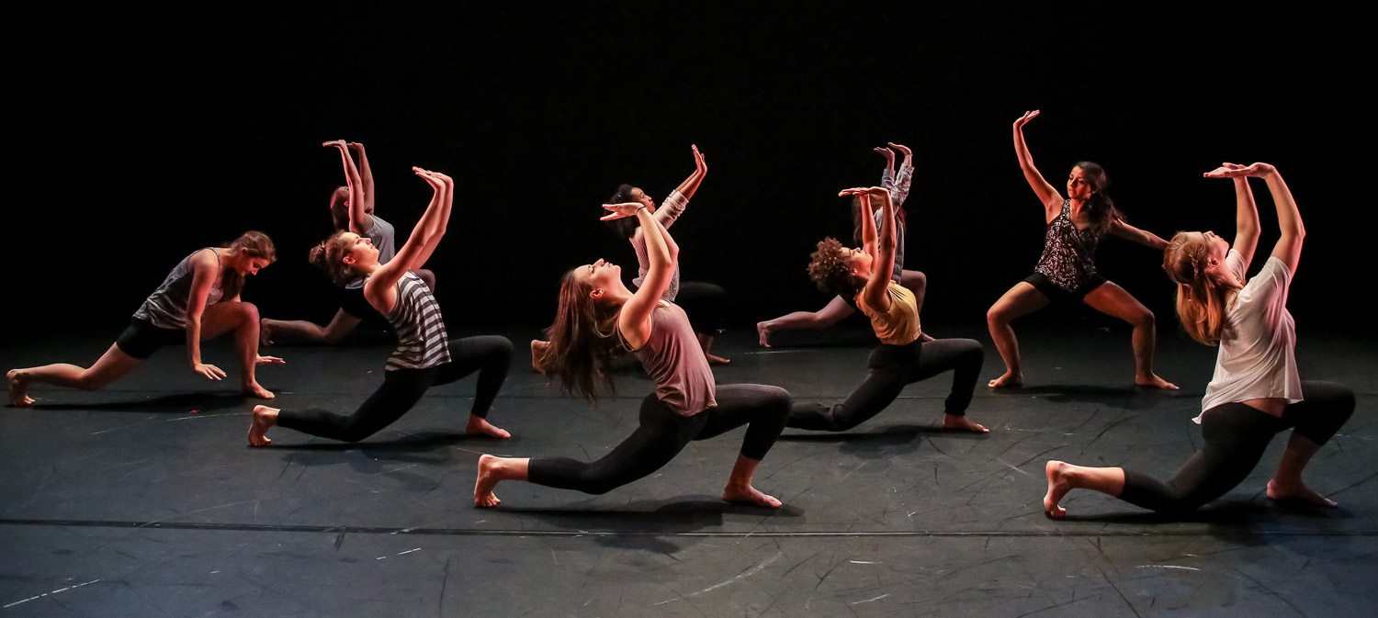
Photo caption: Students in rehearsal for Mark Morris’ New Love Song Waltzes to be performed at Exit, a collaborative senior dance thesis concert
Photo credit: Noel Valero

What/Who: Exit, a performance by Princeton Program in Dance students of five new works by seniors in the program, repertory works by Mark Morris and Lar Lubovitch, and premiere of a new work by Gregory Dolbashian
When: April 17 at 8:00 p.m. and April 18 at 2:00 and 8:00 p.m.
Where: Berlind Theatre at McCarter Theatre Center
Tickets: $15 general admission/$10 students, available through McCarter Box Office at 609-258-2787

(Princeton, NJ) The Lewis Center for the Arts’ Program in Dance will present Exit, a collaborative senior dance thesis concert showcasing new choreography by five seniors in the program, as well as the performance of repertory and new works by guest choreographers, on Friday, April 17 at 8:00 p.m. and Saturday, April 18 at 2:00 p.m. and 8:00 p.m. in the Berlind Theatre at McCarter Theatre Center. Students will perform works by acclaimed choreographers Mark Morris and Lar Lubovitch, premiere a new work by award-winning founder of the DASH Ensemble Gregory Dolbashian, and perform new dances by seniors Emily Hogan, Silvia Lundgren, Asawari Sodhi, Kalin Stovall, and Tula Strong.

The dance certificate program requires students to undertake a rigorous course of study that can include courses in modern, contemporary, ballet, experimental, urban and African dance techniques, choreography, and dance theory and history, along with performance opportunities that include the annual Dance Festival. The dance certificate is in addition to a student’s major area of study. Exit is an opportunity for seniors to collaborate on producing their own choreography and to work with professional choreographers and professional lighting and costume designers to bring their vision to life.

Morgan Nelson, a Slavic Languages major, will perform a solo, “Pardon my Affection,” by Lar Lubovitch, excerpted from Thus is All and set to arias of Wolfgang Amadeus Mozart. Lubovitch has been hailed by The New York Times as "one of the ten best choreographers in the world," and Lar Lubovitch Dance Company has been called a "national treasure" by Variety. The solo was staged and coached by former Lubovitch dancer Katarzyna Skarpetowska. This is the first time a Lubovitch work has been staged by the Program in Dance.

Gregory Dolbashian's new work, Break away, explodes, twists and deconstructs the parameters of the physical and spatial possibilities of movement and perception. Assisted by DASH company members Lauren Santos and Lilja Ruriksdottir, Dolbashian created a dance work that “offers an eclectic accounting of a new universe painted with texture and intimacy." This new work is being performed by seniors Jessica Berry and Allison Metts, both psychology majors.

Work created by students includes a two-segment piece by Emily Hogan, entitled Psyche and Echoes, which address the concept of memory. The segments serve as an exploration of the communal experience and how it affects the essence of one’s beginnings. Psyche investigates how a memory evolves over time in clarity, selection of detail, and identity. Developed in collaboration with dancers through the physicalization of strong images and qualities, Psyche is a split-second walk through one's mind in the present moment. Echoes investigates the following questions: Do time and space distort or amplify thoughts of the past? How does a memory evolve when you peel away the presentational and the excess? Hogan is a politics major pursuing certificates in political economy and dance.

The End/Zone, choreographed by Silvia Lundgren, a history major, finds its genesis in questions about the relationship between music and dance. Which comes first? How does the audible landscape inform the visual landscape, and vice versa? “I began the choreographic process with these questions in mind,” explains Lundgren, “exploring the interaction between sound and my dancers' improvised movements. I let the process happen naturally, and somehow I ended up taking a detour with the Iggy Azalea song, ‘Fancy.’” The work also reflects her interest in creating moments of absurdity in a world that is mysterious and abnormal, yet reminiscent of images and events encountered every so often. Lundgren selected and created the soundtrack for the piece in order to stay true to her goal of informing the discovery of movement through the exploration of sound.

Asawari Sodhi’s Cat’s Cradle explores shifting rituals in human interaction. Inspired in great measure by the writings of Kurt Vonnegut, Jr. and concepts from social theory, the piece uses derivatives of games like Dragon Ball Z, Pac-Man, and rock/paper/scissors to generate experiences, both exhilarating and painful, on stage. This work was created in collaboration with the dancers and di Mura. Sodhi is a politics major pursuing a certificate in dance.

In Suspension, Kalin Stovall and her dancers aim to transport the audience into four different worlds through four different sections. The ecology and evolutionary biology major wanted her piece to showcase raw emotion through repetition, group dynamics and interaction, and individual expression. In order to source the movement material, Kalin worked in collaboration with the dancers using improvisation techniques and directives. Questions explored throughout the piece are: How does an individual create a false, but preferable reality?, Who is to blame for our mistakes?, What can I change?, and Why move forward?

To every troubled mind, by Tula Strong, is a world dictated by images of New York City street photographer Vivian Maier, the groove in Marvin Gaye’s songs of protest, and the messages lying within J. Cole’s album 2014 Forest Hills Drive. This piece, consisting of four vignettes, asks audiences to seek comfort in what cannot be understood. “I am interested in the phenomenon of experience,” explains Strong. “To every troubled mind, invites its audience to listen with their entire being: to hesitate when trying to think things through, and to acknowledge that one's body and spirit are equal sites of knowledge." This work was created in collaboration with the dancers and di Mura. To every troubled mind, will also serve as Strong’s thesis for the Department of Comparative Literature.

Each year the Program in Dance presents a work featuring all the seniors as performers. This year nine seniors will perform three excerpts from Mark Morris' New Love Song Waltzes, which his company, Mark Morris Dance Group, premiered in 1982. The dance was staged by Tina Fehlandt, Lecturer in Dance at the Lewis Center for the Arts and a founding member of Mark Morris Dance Group who performed in the original cast. The eight seniors noted above joined by senior Celina Culver, a major in the Woodrow Wilson School, will perform this work by Morris. Student musicians will provide live musical accompaniment with Johannes Brahms’ Neue Liebeslieder-Walzer, Op. 65, directed by Vince di Mura, Resident Musical Director and Composer for the Lewis Center for the Arts. In New Love Song Waltzes, Morris “makes visible the brilliant structure of his work, and every choreographic choice seems exactly right, whether it’s repetition, interruption, opposition, or unison,” according to the Santa Barbara Independent.

Tickets for Exit are $15 general admission, $10 for students, and are available through the McCarter box office at 609.258.2787 or on-line at www.mccarter.org/TicketOffice/buytickets.aspx?page_id=22 or at the theater prior to each performance.

For more information on this event, the Program in Dance, or any of the more than 100 events presented annually by the Lewis Center for the Arts, visit arts.princeton.edu.

###

