April 27, 2015

Princeton University’s Fund for Irish Studies presents

Féile Na Bealtaine: Ghost Trio
A concert of Irish songs cosponsored by the Lewis Center for the Arts and Department of Music

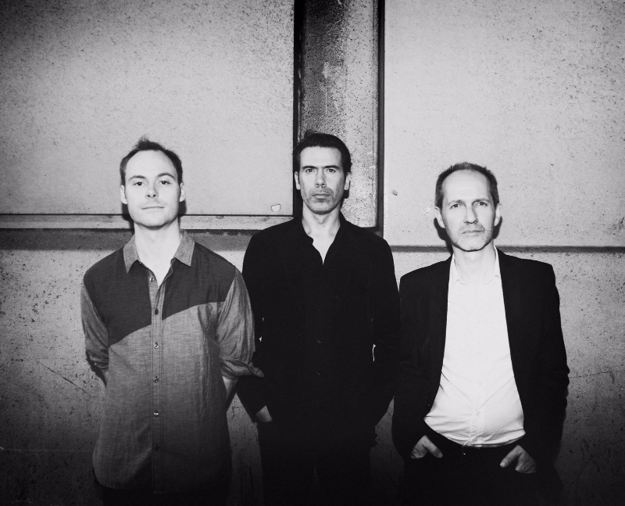
Photo caption: Ghost Trio
Photo credit: Shervin Lainez

Who: Ghost Trio: singer Iarla Ó Lionáird, fiddler Cleek Schrey, and uilleann piper Ivan Goff
What: Feile Na Bealtaine: a performance of Irish songs presented by Princeton University’s Fund for Irish Studies, Lewis Center for the Arts, and Department of Music
When: Friday, May 1 at 4:30 p.m.
Where: Taplin Auditorium in Fine Hall on the Princeton University campus
Free and open to the public

(Princeton, NJ) On Friday, May 1, Ghost Trio, comprised of singer Iarla Ó Lionáird, fiddler Cleek Schrey, and uilleann piper Ivan Goff, will perform a Féile Na Bealtaine or “May festival” concert of Irish songs at 4:30 p.m. at Taplin Auditorium in Fine Hall on the Princeton University campus. The concert, part of the Fund for Irish Studies series at Princeton University and co-sponsored by the Department of Music and Lewis Center for the Arts, is free and open to the public.

Ghost Trio is the new project featuring sean nós singer Iarla Ó Lionáird on harmonium, uilleann piper Ivan Goff, and fiddler Cleek Schrey on hardanger. The trio explores timbre in voice, pipes and strings through innovation and experimentation. All three musicians have explored musical worlds beyond their points of origin: Ó Lionáird from the Irish-speaking region of Cork where he was a virtuoso singer as a young child; Dublin-born Goff, all-Ireland champion, playing the pipes in traditional bands; and Virginia native, Schrey, whose roots are in American traditional music. They have each pushed boundaries to offer new sonic perspectives in the way we listen to music.

Born in the West Cork area in 1964 as one of twelve children, Iarla Ó Lionaird has carved a long and unique career in music in Ireland and internationally. From his iconic early recording of the vision song “Aisling Gheal” as a young boy to his groundbreaking recordings with Dublin's Crash Ensemble and Donnacha Dennehy, he has demonstrated a breadth of artistic ambition within the Irish music community. He has worked with many composers internationally including Nico Muhly, Gavin Bryars, Dan Trueman and David Lang and has performed and recorded with such luminaries as Peter Gabriel, Robert Plant, Nick Cave and Sinead O'Connor. His unique vocal style has carried him to stages and concert halls all over the world, from New York's Carnegie Hall to the Sydney Opera House. His voice has graced the silver screen also, with film credits extending from The Gangs of New York to Hotel Rwanda and most recently as featured vocalist in the films Calvary starring Brendan Gleeson and Brooklyn starring Saoirse Ronan. He is currently the vocalist with the critically acclaimed Irish-American band The Gloaming.

Ivan Goff, originally from Dublin and now based in Brooklyn, plays the uilleann pipes (Irish bellows-blown pipes), Irish wooden flute, and pennywhistles. Apart from solo work, Goff has toured with Irish traditional bands Dervish, Danú, Lúnasa, Téada, The Green Fields of America with Mick Moloney, and is a former member of the Eileen Ivers Band. He has performed duets with many traditional musicians over the years including Míchéal Ó Raghallaigh and Patrick Ourceau, and has collaborated across many genres. His music has been featured in diverse arenas, including the acclaimed experimental art film Cremaster 3 (directed by Matthew Barney), at the Guggenheim museum, and in theatrical productions such as Peter and Wendy (Mabou Mines, directed by Lee Breuer). Goff has worked as a soloist with composers throughout the world on various projects including a specially commissioned concerto for uilleann pipes with the Albany Symphony Orchestra and, more recently, a new music piece with bass clarinet and 23-piece orchestra composed by Elizabeth Hoffman. Goff has also performed in many productions including extended engagements with Riverdance (U.S. National Tour and Broadway) and Michael Flatley’s Lord of the Dance. Goff received his B.A. in music from Maynooth University, his M.A. in Computer Composition and Music Technology from Queens University, Belfast, and his M.A. in Musicology from University College Dublin. He is currently a Ph.D. candidate in music at New York University.

Described by The Irish Times as “a musician utterly at one with his instrument and his music”, Cleek Schrey is a fiddler and composer from Virginia. An active member of traditional music communities in America and Ireland he plays with the award-winning string band Bigfoot and comprises one half of a duo with the old time fiddler Stephanie Coleman, in addition to his work with Ghost Trio. The journal Sound Post has noted that Cleek “possesses a rare combination of traits: deep respect for traditional music and the people who make it, and an unbounded curiosity about new directions for sound.” He is currently pursuing a Masters in Music Composition at Wesleyan University.

Ghost Trio owes its name to Goff, who has a particular affinity for the plays of Samuel Beckett, specifically, Beckett’s play of the same name. Beckett’s play in turn, borrows its title (along with some musical fragments) from Beethoven’s Ghost Trio, which was published in 1809 and is characterized by a particularly eerie sound, which was influenced, some say, by the fact that Beethoven was at that time working on an opera based on Macbeth. This contemporary trio of musicians shares a profound interest in sound itself and their collaborative name “tips its hat to the ghosts that insinuate themselves into the fabric of Irish traditional music.”

The Fund for Irish Studies, chaired by Princeton professor and Pulitzer Prize-winning poet Paul Muldoon, affords all Princeton students, and the community at large, a wider and deeper sense of the languages, literatures, drama, visual arts, history, politics and economics not only of Ireland but of “Ireland in the world.” For more information visit fis.princeton.edu.

To learn more about the over 100 events presented each year by the Lewis Center for the Arts, visit arts.princeton.edu. To learn more about the Department of Music’s many concerts and events visit: http://www.princeton.edu/music/.

###

