April 9, 2015

All My Things Are Hymns opens at the Lewis Center for the Arts
Exhibition of watercolors by senior Kai Song-Nichols celebrates the diverse riches of the history of visual culture

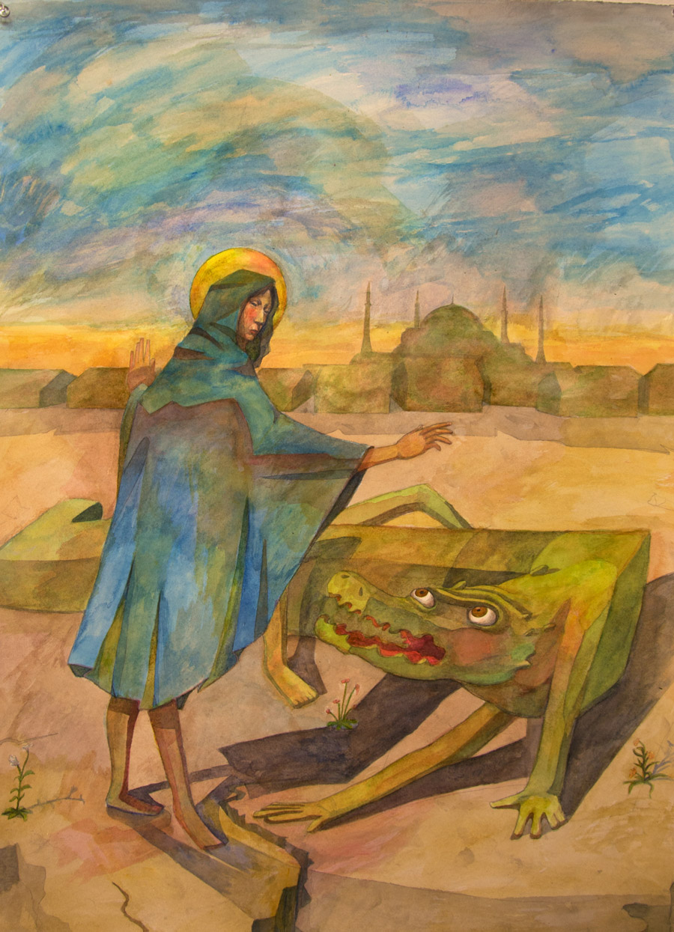
Caption: One of the watercolors in senior Kai Song-Nichol’s exhibition, All My Things Are Hymns.
Photo credit: Artwork by Kai Song-Nichols; photo by Justin Goldberg

What: All My Things Are Hymns, an exhibition of watercolors drawing from sources as diverse at Quattrocento Italian painting, medieval Byzantine painting, Japanese shin-hanga prints, and bandes dessinées that is a celebration of the riches of the history of visual culture
Who: Created by Kai Song-Nichols, a senior in the Lewis Center’s Program in Visual Arts
When: April 13-17; opening reception Thursday, April 16 from 8:00 to 9:00 p.m.; Gallery open Monday-Friday, 10:00 a.m. to 4:30 p.m.
Where: Lucas Gallery at 185 Nassau St.
Free and open to the public

(Princeton, NJ) The Lewis Center for the Arts’ Program in Visual Arts at Princeton University will present All My Things Are Hymns, an exhibition of watercolors by senior Kai Song-Nichols. The paintings draw from sources as diverse as Quattrocento Italian painting, medieval Byzantine painting, Japanese shin-hanga prints, and Franco-Belgian comics known as bandes dessinées and are intended to celebrate the extraordinary riches of the history of visual culture. The work will be on view April 13 through 17 in the Lucas Gallery at 185 Nassau Street. A reception will be held on Thursday, April 16 from 8:00 to 9:00 p.m. The exhibition and reception are free and open to the public.

Song-Nichols, from Phoenix, Arizona, is majoring in visual arts through a collaborative program between Princeton’s Department of Art and Archaeology and the Lewis Center’s Program in Visual Arts, which enables students to focus on studio practice. He is also pursuing a certificate in computer science.

The artist’s work draws from his love of figurative art and art that tells a story. Song-Nichols explains, “I copy the Italian masters, Siennese mostly. I copy the late printmakers of Japan including Hiroshige, Hasui, and Koson, who are among my favorites. I also love cartoons, so I slip them in inevitably. But my real approach is that of a straight-forward and earnest figurative painter. I want to paint stories that express what I think and how I understand the world.”

His watercolors of fantastical scenes draw freely from the global artistic canon ranging from the Italian masters of the 15th Century whose work is heavy in religious imagery to contemporary European comics. He likens his appropriation of images from masters of the past to the method through which patrons often commissioned works by those artists — choosing elements and themes from a pattern book that the artist would then combine. “My work is foremost a celebration,” he notes. “Why, at least as far as painting is concerned, does the Renaissance ever have to have ended? Why can’t I be a Renaissance painter?”

Song-Nichols’ artistic interests extend to the development and value of an artist’s skill. “It is immensely satisfying to see something done well,” he explains. “I think that it has something to do with care, with knowing that someone cared about something enough to do something well. There is something intrinsically good about caring.”

After graduation he plans to work as a computer programmer while continuing to make art.

The Lucas Gallery is open Monday through Friday from 10:00 a.m. to 4:30 p.m. Admission is free.

To learn more about exhibitions at the Lucas Gallery, the Program in Visual Arts, and the over 100 other events presented each year at the Lewis Center visit arts.princeton.edu.

###

