April 2, 2015

Disorientations opens at the Lewis Center for the Arts
Exhibition of work inspired by virtual travel across state lines and atmospheres
by senior Kemy Lin

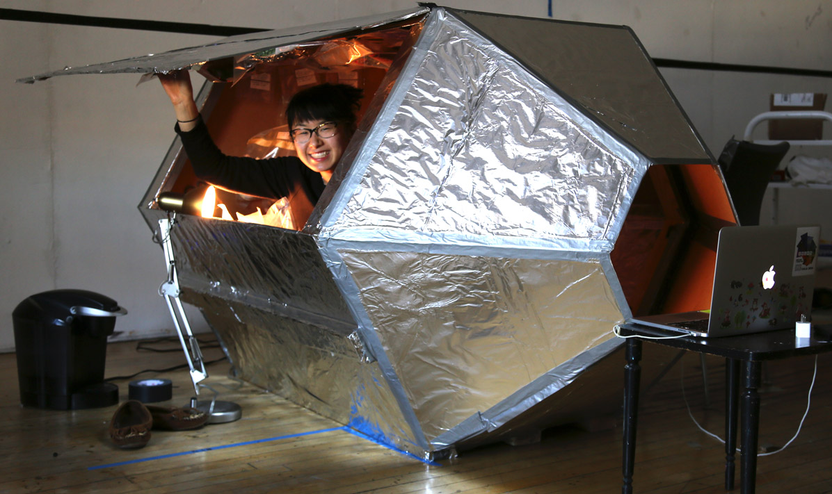
Caption: Kemy Lin preparing for her multi-day, virtual trip to the moon as part of her senior thesis project in visual arts.
Photo credit: Justin Goldberg

What: Disorientations, an exhibition of work inspired by virtual travel across state lines and atmospheres
Who: Created by Kemy Lin, senior in the Lewis Center’s Program in Visual Art
When: April 6-9; opening reception Wednesday, April 8, from 7:00 to 9:00 p.m.; Gallery open Monday-Friday, 10:00 a.m. to 4:30 p.m.
Where: Lucas Gallery at 185 Nassau St.
Free and open to the public

(Princeton, NJ) The Lewis Center for the Arts’s Program in Visual Arts at Princeton University will present Disorientations, an exhibition of work inspired by virtual travel across state lines and atmospheres by Princeton senior Kemy Lin. The work will be on view April 6 through April 9 in the Lucas Gallery at 185 Nassau Street. A reception will be held on Wednesday, April 8, from 7:00 to 9:00 p.m. The exhibition and reception are free and open to the public.

Lin, from Portland, Oregon, is majoring in visual arts through a collaborative program between Princeton’s Department of Art and Archaeology and the Lewis Center’s Program in Visual Arts, which enables students to focus on studio practice. Her senior thesis project reflects a lifelong interest in traversing distances both real and imagined, the cultural significance of the moon, her intellectual and aesthetic interest in the history of science, and the new possibilities of virtual travel created by advances in modern technology.

Lin’s interest in the moon as a source of wonder and inspiration goes back to at least the third grade, when she kept a lunar journal that she still possesses. The moon also figures significantly in her Chinese cultural heritage. Her lunar interests have grown to include criticism of nationalism, racial injustice, and gender inequality surrounding modes of travel. “Only Caucasian, American males have set foot on the moon,” she notes, “But other countries, like China, are now joining in the space race and sending rovers to the moon in preparation for manned flight. With my project, I am hopefully making headway for women of color who have been underrepresented in space travel.” As a woman of color, she hopes to expand the relatively modest sociopolitical capital available to her by asserting her claim to distant territories through the use of artistic mediums like paint, sculpture, and image manipulation.

As part of her project, Lin simulated a trip to the moon. She designed and fabricated a facsimile of a lunar spacecraft and spent three days living in the ship. She lived off a supply of food she vacuum-sealed in advance and set rules for herself that would have to be observed in space. For example, she spent most of her trip reading books and writing, and left her computer back on Earth. She live-streamed her entire “journey.”

Lin expresses fascination with people who insist the moon landings were a conspiracy, fabricated and staged by the American government in a Hollywood studio. “I love the possibility that such a grand act of travel could be faked,” she remarked. “I was inspired by their skepticism of NASA’s photographic and video coverage of the landing.”

Lin bridges the gap between real and imagined travel by presenting artifacts one would presumably acquire over the course of going to, living in, working in, or leaving a new location or space. “Through virtual, imagined, digital, and physical travel, I accrue ‘souvenirs’, ranging from vacuum-sealed meals to sediment to computer screenshots. The information, debris, waste, detritus, and samples gathered through my travels are then subjected to obsessive and absurd pseudoscientific strategies of organization and labeling,” she explains. “I painstakingly catalog and preserve minutia ranging from paper scraps (cut from an image of the Tycho Crater on the moon) to unfinished ramen broth (partially consumed in outer space) to painted gravel (shipped from my hometown). Interactions with my parents (across the country) and friends are embedded throughout my work as they observe, contribute to, and commentate upon my travels.”

How such artifacts are then presented, such as in museum displays and exhibition design, is a further area of exploration in the project. “I spent this past summer, with funding from the Peter B. Lewis Summer Fund, visiting natural history, scientific, and archaeological museums throughout Western Europe and the eastern United States,” Lin notes. In the summer of 2013, she participated in a Princeton Atelier/Global Seminar in Mpala, Kenya, taught by film faculty member Su Friedrich and Princeton alumna and filmmaker Katie Carpenter, sponsored by the Lewis Center, the Princeton Institute for International and Regional Studies, and the Princeton Environmental Institute. She was part of a team that wrote and produced a documentary film on the African wild dog. “I reflected creatively and critically on both of these experiences on my personal blog, Field Sketches.” She also credits a spring 2014 advanced visual arts course taught by Joe Scanlan, Director of the Program in Visual Arts, called “Extraordinary Processes” as inspiration for her project.

The Lucas Gallery is open Monday through Friday from 10:00 a.m. to 4:30 p.m. Admission is free.

To learn more about exhibitions at the Lucas Gallery, the Program in Visual Arts, and the over 100 other events presented each year at the Lewis Center visit arts.princeton.edu.

###

