

April 22, 2015

**The Lewis Center for the Arts presents**

**master class with New York City Ballet Principal Dancer Wendy Whelan**

*in conjunction with Whelan’s performance of “Restless Creature” at McCarter Theatre*

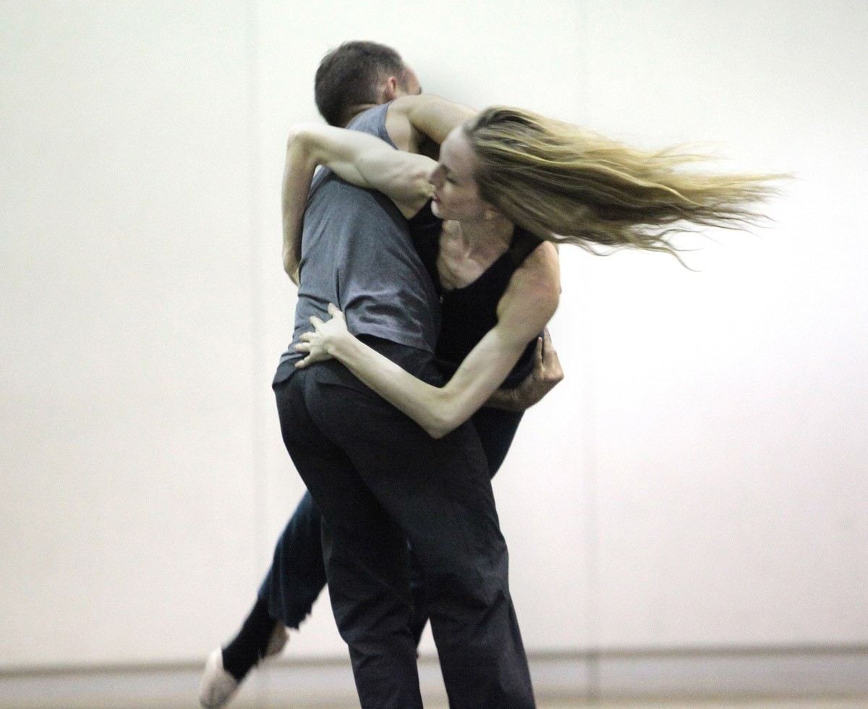

Photo caption: Wendy Whelan in rehearsal with Brian Brooks

Photo credit: Erin Baiano

Who: New York City Ballet principal dancer Wendy Whelan

What: A ballet master class for Princeton students led by Whelan

When: Monday, April 27, 2015 from 12:00 p.m. - 1:30 p.m.

Where: Patricia and Ward Hagan ’48 Dance Studio at 185 Nassau Street

Free and open to the public to observe

(Princeton, NJ) The Lewis Center for the Arts’ Program in Dance will present a master class for Princeton students with New York City Ballet principal dancer Wendy Whelan on Monday, April 27, in the Patricia and Ward Hagan ’48 Dance Studio at 185 Nassau Street from 12:00 p.m. to 1:30 p.m. This event, which is presented in conjunction with Whelan’s April 28 performance of *Restless Creature* at the McCarter Theatre, is free and open to the public to observe.

Wendy Whelan was born and raised in Louisville, Kentucky, where at the age of three she began taking dance classes at a local dance academy. At age eight, she performed as a mouse with the Louisville Ballet in its annual production of *The Nutcracker*. She began intense professional training later that year when she joined the Louisville Ballet Academy. In 1981, she received a scholarship to the School of American Ballet, the official school of New York City Ballet. She was invited to become a member of the New York City Ballet corps de ballet in 1986, and was promoted to principal dancer in 1991, where she remained a principal dancer until October 2014.

In her time at New York City Ballet, Whelan performed a wide spectrum of the Balanchine repertory and worked closely with Jerome Robbins on many of his ballets. She has performed a broad and varied repertory spanning romantic, classical and contemporary roles but has perhaps been most closely identified with the creation of new ballets. William Forsythe, Wayne McGregor, Jorma Elo, Benjamin Millepied, Twyla Tharp, Lynn Taylor-Corbett and Peter Martins, the company’s ballet master in chief, have, among many others, chosen Whelan for their pieces. She has also had strong choreographic affiliations over the last 15 years with Christopher Wheeldon and Alexei Ratmansky.

In 2007, Whelan was nominated for an Olivier Award and a Critics Circle Award for her performances with Morphoses/Wheeldon Company. She has been a guest artist with The Royal Ballet and with the Kirov Ballet. She received the 2007 *Dance Magazine* Award, and in 2009 was given a Doctorate of Arts, *honoris causa*, from Bellarmine University. In 2011, she was honored with both The Jerome Robbins Award and a Bessie Award for her Sustained Achievement in Performance.

In 2012, Whelan began developing new collaborative projects. Her inaugural project, *Restless Creature*, which premiered at Jacob’s Pillow Dance Festival in August of 2013 and will be performed at McCarter Theatre on April 28, is a suite of four duets, created by and danced with four of today’s most cutting edge contemporary dancer/choreographers: Kyle Abraham, Joshua Beamish, Brian Brooks and Alejandro Cerrudo.

Whelan was recently appointed an Artistic Associate at New York's City Center and for two years beginning November 1, 2014, City Center is her home for developing future projects.

In addition to its courses in ballet, modern, African, urban and other dance forms, the Lewis Center’s Program in Dance annually presents a series of master classes in a range of genres. To learn more about this event, the Program in Dance, and the over 100 other activities presented at the Lewis Center visit [arts.princeton.edu](http://www.arts.princeton.edu/).

###