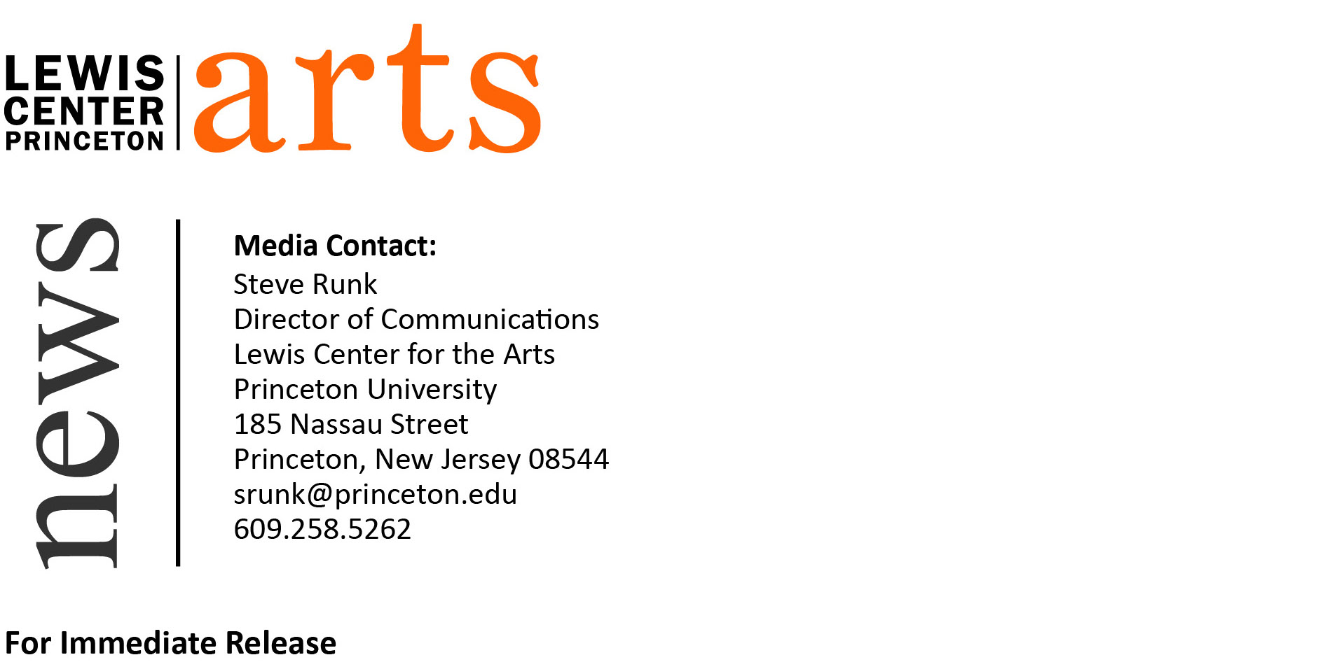
April 24, 2015

Lewis Center for the Arts presents
Readings of New Work by Students in the Creative Writing Program

What: Three Readings - Althea Ward Clark W’21 Reading Series

When: Wednesday, April 29 at 4:30 p.m.
Where: Chancellor Green Rotunda on the Princeton University campus
Who: Students in the Lewis Center for the Arts’ Program in Creative Writing read from their recent work created during the spring semester and selected by faculty
Free and open to the public

When: Monday, May 4 at 4:30 p.m.
Where: Chancellor Green Rotunda on the Princeton University Campus
Who: Seniors in the Lewis Center for the Arts’ Program in Creative Writing read from their recent work in poetry, screenwriting, and literary translation.
Free and open to the public

When: Wednesday, May 6 at 4:30 p.m.
Where: Chancellor Green Rotunda on the Princeton University Campus
Who: Seniors in the Lewis Center for the Arts’ Program in Creative Writing read from their recent work in fiction.
Free and open to the public

(Princeton, NJ) Students in the Lewis Center for the Arts’ world-renowned Program in Creative Writing will present new work in a series of readings. On April 29 at 4:30 p.m. at Chancellor Green Rotunda on the University campus, students from spring workshops in fiction, poetry, screenwriting, and literary translation will read from their work completed during the past semester. There will be two events during which seniors completing a certificate in the Program will read from their thesis work, which they completed over the course of the past academic year. On May 4 at 4:30 p.m. at Chancellor Green Rotunda, seniors will read from their recent work in poetry, screenwriting, and translation; on May 6 at 4:30 p.m. also at Chancellor Green Rotunda, seniors will read from their recent work in fiction. The readings, part of the Program in Creative Writing’s Althea Ward Clark W’21 Reading Series at the Lewis Center for the Arts, are free and open to the public.

Through the Program, students can earn a certificate in creative writing in addition to their degree in a major. They have the opportunity to pursue original work in fiction, poetry, screenwriting and translation under the guidance of 15 practicing, award-winning writers, including Jeffrey Eugenides, Chang-rae Lee, Paul Muldoon, Joyce Carol Oates, James Richardson, Tracy K. Smith, Susan Wheeler, and Edmund White. Small workshop courses, averaging eight to ten students, provide intensive feedback and instruction for both beginning and advanced writers. Each year 15 to 20 seniors work individually with a member of the faculty on a creative writing thesis, such as a novel, screenplay, or a collection of short stories, poems, or translations.

On May 4 seniors who will be presenting work in poetry are Evan Coles, Filipa Ioannou, Yessica Martinez, Emily McDonald, Susannah Sharpless, Allison Somers, and Aron Wander. Amanda Devine, Tyler Lee, and Lydia Lim will read from their work in translation, and Nonny Okwelogu will read from her work in screenwriting.

Seniors presenting work in fiction on May 6 are Chester Dubov, Jared Garland, Ben Goldman, Ava Geyer, Cosette Gonzales, Cameron Langford, Isabelle Laurenzi, Anya Lewis-Meeks, Vivian Ludford, Tom Markham, Shannon McGue, Milena Phan, and Jane Pritchard.

Graduates of the Program include such well-known writers as Jonathan Ames ’87, Jane Hirshfield ’73, Jodi Picoult ’87, Jonathan Safran Foer ’99, and Monica Youn ’93.

The Althea Ward Clark W’21 Reading Series annually brings a number of distinguished writers to campus to read and discuss their work. Writers who read from their works over the past academic year included Aleksandar Hemon, Rachel Kushner, Ben Lerner, Steven Millhauser, Hanna Pylväinen, Roger Reeves, Akhil Sharma, Evie Shockley, A.E. Stallings, Meg Wolitzer, John Yau, and Dean Young. All readings are free and open to the public.

To learn more about the Program in Creative Writing, the reading series, and the more than 100 public events offered annually by the Lewis Center for the Arts visit arts.princeton.edu.

###

