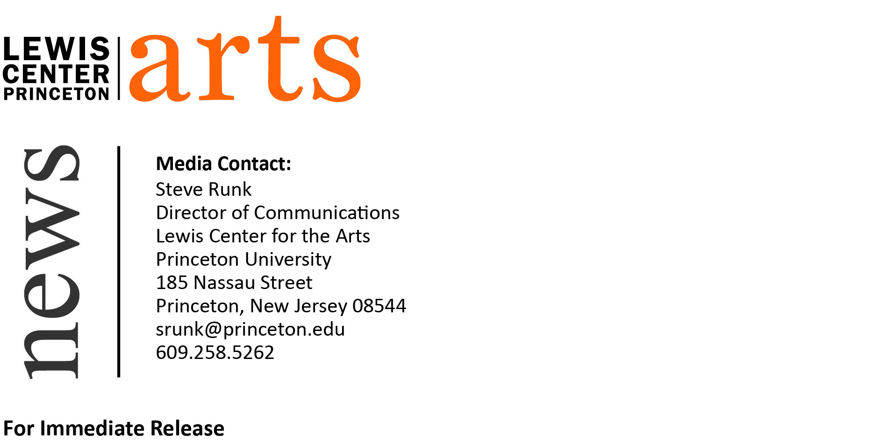
April 3, 2015

Rachel Kushner and John Yau Read at Lewis Center for the Arts
Award-winning writers next in Althea Ward Clark W’21 Reading Series

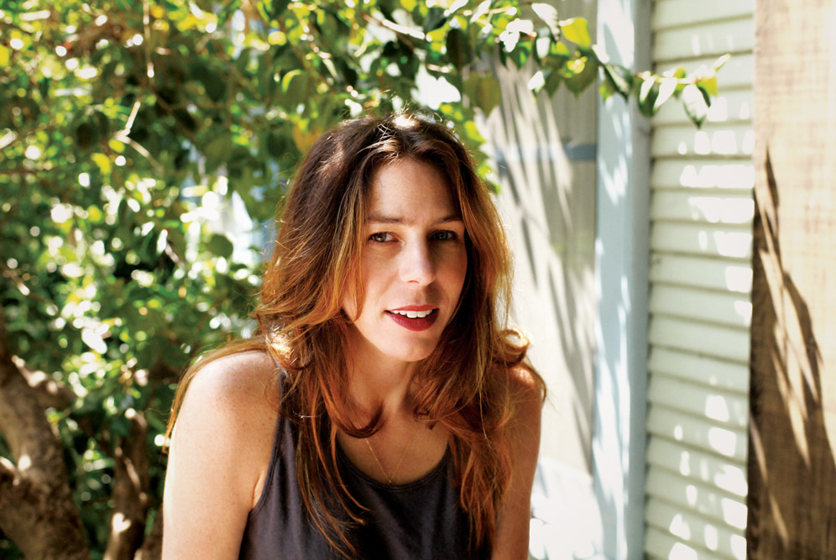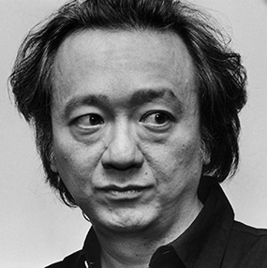
Photo Caption 1: Two-time National Book Award finalist Rachel Kushner
Photo Credit 1: Lucy Raven
Photo Caption 2: Award-winning poet, art critic and curator John Yau
Photo Credit 2: Dorothy Alexander

What: Reading - Althea Ward Clark W’21 Reading Series
Who: Fiction writer Rachel Kushner and poet John Yau
When: Wednesday, April 15 at 4:30 p.m.
Where: Berlind Theatre at McCarter Theatre Center
Free and open to the public

(Princeton, NJ) On Wednesday, April 15, bestselling fiction writer Rachel Kushner and acclaimed poet John Yau will read from their works as part of the Althea Ward Clark W’21 Reading Series of the Program in Creative Writing at the Lewis Center for the Arts. The reading, beginning at 4:30 p.m. at the Berlind Theatre at the McCarter Theatre Center, is free and open to the public.

Rachel Kushner’s novels and essays explore contemporary art, culture, revolutionary politics, modernism, and feminism. She has twice been a finalist for the National Book Award, the only writer ever to be nominated for a National Book Award in Fiction for both a first and second novel.

She is the author of The Flamethrowers (2013), which was a finalist for the 2013 National Book Award, the 2014 Folio Prize, and the James Tait Black Prize; longlisted for the 2014 Baileys Women’s Prize for Fiction; and a New York Times Top Ten Novel of 2013. The New York Times review of The Flamethrowers noted, “her prose has a poise and wariness and moral graininess that puts you in mind of weary-souled visionaries like Robert Stone and Joan Didion.” Kushner’s debut novel, Telex From Cuba (2008), was a finalist for the 2008 National Book Award and the Dayton Literary Peace Prize, winner of the California Book Award, and a New York Times bestseller and Notable Book. Kirkus Reviews called the novel, “Soundly researched and gorgeously written…An imaginative work that brings Cuban-American history to life.”

At the age of 16 Kushner enrolled at the University of California, Berkeley, where she majored in political economics. She earned her M.F.A. at Columbia University. She is a recipient of a 2013 Guggenheim Fellowship.

Kushner’s fiction and essays have appeared in The New Yorker, Harper’s, The New York Times, The Believer, Artforum, Bookforum, Fence, Bomb, Grand Street, and The Paris Review, among other places. She lives in Los Angeles.

Kushner will be introduced by Sheila Kohler, author of ten novels and winner of two O’Henry Prizes and a Lecturer in Creative Writing at the Lewis Center.

Poet, art critic, and curator John Yau has published over 50 books of poetry, fiction, and art criticism. His many collections of poetry include Corpse and Mirror (1983), selected by John Ashbery for the National Poetry Series, Edificio Sayonara (1992), Forbidden Entries (1996), Borrowed Love Poems (2002), Ing Grish (2005), Paradiso Diaspora (2006), Exhibits (2010), and Further Adventures in Monochrome (2012). Yau’s work frequently explores, and exploits, the boundaries between poetry and prose, and his collections of stories and prose poetry include Hawaiian Cowboys (1994), My Symptoms (1998), and Forbidden Entries (1996).

Born in Lynn, Massachusetts in 1950 to Chinese emigrants, Yau attended Bard College and earned an M.F.A. from Brooklyn College in 1978. His first book of poetry, Crossing Canal Street, was published in 1976. Since then, he has received acclaim for his poetry’s attentiveness to visual culture and linguistic surface. A contributor for Contemporary Poets wrote: “Yau’s poems [are] often as much a product of his visual sense of the world, as his awareness of his double heritage from both Oriental and Occidental cultures.”

Yau has received many honors and awards for his work including a New York Foundation for the Arts Award, the Jerome Shestack Award, and the Lavan Award from the Academy of American Poets. He has received fellowships from the National Endowment for the Arts, the Ingram-Merrill Foundation, and the Guggenheim Foundation, and in 2002 was named a Chevalier in the Order of Arts and Letters by France. Yau has taught at many institutions, including Pratt Institute, the Maryland Institute College of Art, School of Visual Arts, Brown University, and the University of California, Berkeley. He has also served as the arts editor of the Brooklyn Rail. He teaches at the Mason Gross School of the Arts at Rutgers University and lives in New York City.

Yau will be introduced by poet Michael Dickman, the author of Flies, winner of the 2011 James Laughlin Award, and a Lecturer in Creative Writing at the Lewis Center.

The Althea Ward Clark W’21 Reading Series provides an opportunity for students, as well as all in the greater Princeton region, to hear and meet the best writers of contemporary poetry and fiction. All readings are free and open to the public and take place on select Wednesdays at 4:30 p.m. at the Berlind Theatre at McCarter Theatre Center.

To learn more about the Program in Creative Writing, the Reading Series, and the more than 100 events offered annually by the Lewis Center visit arts.princeton.edu.

###

